Pythagorean Theorem and Its Converse ⸱ Practice

Example 1
Find the value of x.
1. 2. 3.
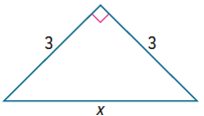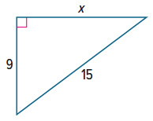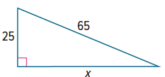

4. 5. 6.
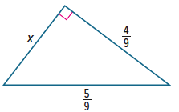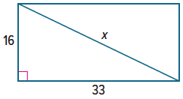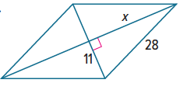

Example 2
Use a Pythagorean Triple to find the value of x.
7. 8. 9.
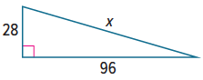
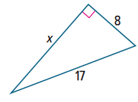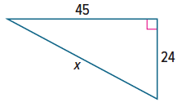

10. 11. 12.
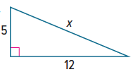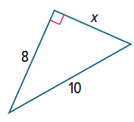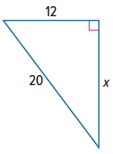

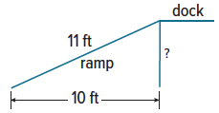
Example 3
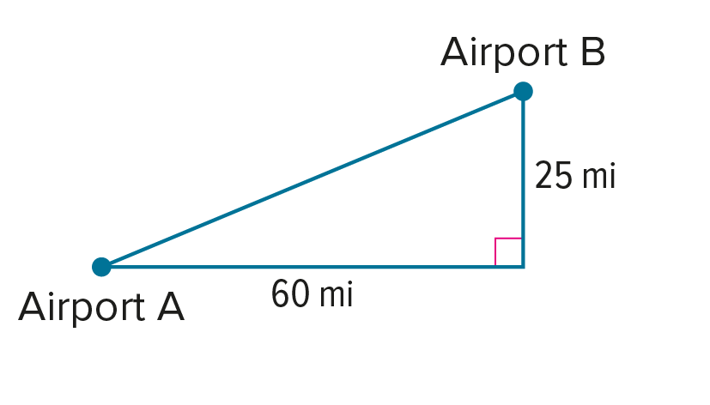
13. CONSTRUCTION The bottom end of a ramp at a warehouse is 10 feet from the base of the main dock, and the ramp is 11 feet long. How high is the dock?

14. FLIGHT An airplane lands at an airport 60 miles east and 25 miles north of where it took off. How far apart are the two airports?

Example 4
Determine whether the points X, Y, and Z can be the vertices of a triangle. If so, classify the triangle as acute, right, or obtuse. Justify your answer.
15. X(‒3, ‒2), Y(‒1, 0), Z(0, ‒1) 16. X(‒7, ‒3), Y(‒2, ‒5), Z(‒4, ‒1)

17. X(1, 2), Y(4, 6), Z(6, 6) 18. X(3, 1), Y(3, 7), Z(11, 1)
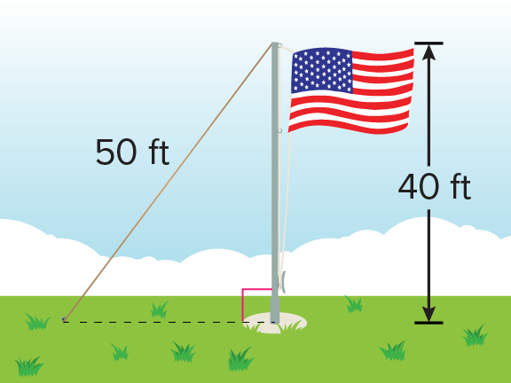

Mixed Exercises
19. TETHERS To help support a flag pole, a 50-foot-long tether is tied to the pole at a point 40 feet above the ground. The tether is pulled taut and tied to an anchor in the ground. How far away from the base of the pole is the anchor?

Determine whether each set of measures can be the measures of the sides of a triangle. If so, classify the triangle as acute, obtuse, or right. Justify your answer.
20. $\sqrt{5}$, $\sqrt{12}$, $\sqrt{13}$ 21. 2, $\sqrt{8}$, $\sqrt{12}$ 22. 9, 40, 41

PROOF Write a two-column proof to prove each theorem.
23. Theorem 9.6 24. Theorem 9.7
Given: In $△DEF$,$f^{2}<d^{2}+e^{2}$ where f Given: In $△ABC$, $c^{2}>a^{2}+b^{2}$ where c is
is the length of the longest side. the length of the longest side.
In $△LMN$, $∠M$ is a right angle. In $△TUV$, $∠V$ is a right angle.
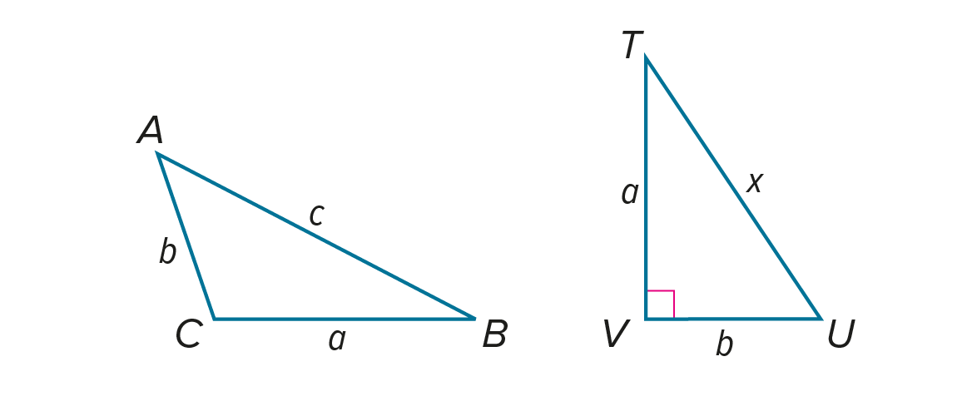
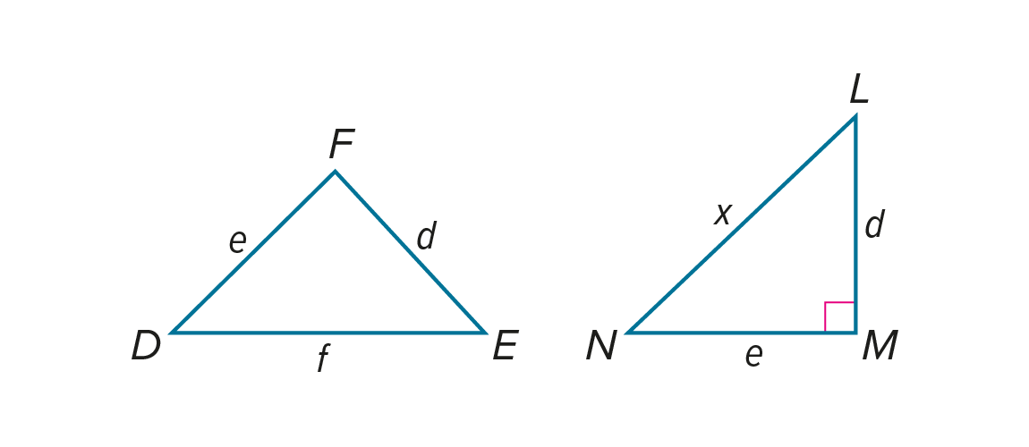
Prove: $△DEF$ is an acute angle. Prove: $△ABC$ is an obtuse triangle.

25. SIDEWALKS Construction workers are building a marble sidewalk around a park that is shaped like a right triangle. Each marble slab adds 2 feet to the length of the sidewalk. The workers find that exactly 1071 and 1840 slabs are required to make the sidewalks along the short sides of the park, not counting corner pieces. How many slabs are required to make the sidewalk that runs along the long side of the park?

Find the perimeter and area of each figure.
26. 27. 28.
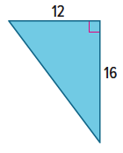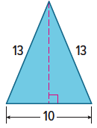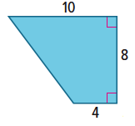

29. The sides of a triangle have measures of x, x + 5, and 25. If the measure of the longest side is 25, what value of x makes the triangle a right triangle?

30. PRECISION The sides of a triangle have measures of 2x, 8, and 12. If the measure of the longest side is 2x, what values of x make the triangle acute?

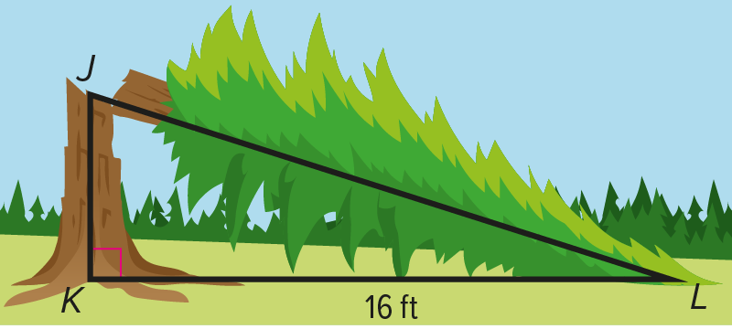
31. REASONING A redwood tree in a national park is 20 meters tall. After it is struck by lightning, the tree breaks and falls over, as shown in the figure. The top of the tree lands at a point 16 feet from the centerline of the tree. A park ranger wants to know the height of the remaining stump of the tree.
a. The ranger lets x represents the height of the stump, $\overline{JK}$. Explain how the ranger can write an expression for the length of $\overline{JL}$. Then write an equation that can be used to solve the problem.

b. Show how to solve the equation from part a to find the height of the stump.

32. CONSTRUCT ARGUMENTS Valeria and Sanjia are staking out a garden that has one pair of opposite sides measuring 30 feet and the other pair of sides measuring 40 feet. Using only a 60-foot-long tape measure, how can they be sure that their garden is a rectangle?
a. Draw a model of the garden with diagonal t. Let p = 30 and q = 40.

b. If the garden is a rectangle, what must be true about p, q, and t? Why?

c. Sanjia measures the diagonal and finds that it is 50 feet long. Is there enough information to determine whether their garden is a rectangle? Explain.

Find the value of x.
33. 34. 35.
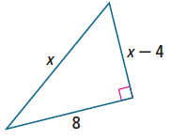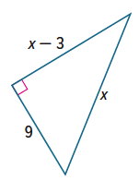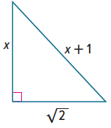

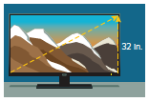
36. HDTV The screen aspect ratio, or the ratio of the width to the height, of a high-definition television is 16:9. The size of the television is given by the diagonal distance across the screen. If the height of Raj’s HDTV screen is 32 inches, what is the screen size to the nearest inch?

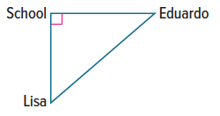
37. DISTANCE Eduardo and Lisa both leave school on their bikes at the same time. Eduardo rides due east at 18 miles per hour for 30 minutes and Lisa rides due south at 16 miles per hour for 30 minutes. Complete the diagram to represent the problem. To the nearest hundredth of a mile, how far apart are they when they stop riding their bikes?

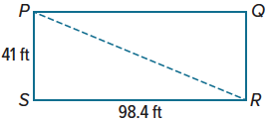
38. OFFICE PARK An office park has a rectangular lawn with the dimensions shown. Employees often take a shortcut by walking from P to R, rather than from P to S to R. What is the total distance an employee saves in a week by taking the shortcut twice a day for five days? Explain.

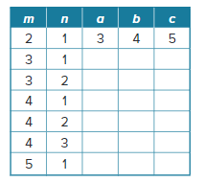
39. STRUCTURE Ms. Jones assigned her fifth-period geometry class the following problem. Let m and n be two positive integers with m > n.
Let a = $m^{2}$ – $n^{2}$, b = 2mn, and c = $m^{2}$ + $n^{2}$.
a. Show that there is a right triangle with side lengths a, b, and c.

b. Complete the table shown at the right.

c. Find a Pythagorean triple that corresponds to a right triangle with a hypotenuse 25² = 625 units long. (Hint: Use the table you completed for part b to find two positive integers m and n with
m > n and $m^{2}$ + $n^{2}$ = 625.)

40. ANALYZE True or false? Any two right triangles with the same hypotenuse have the same area. Explain your reasoning.

41. CREATE Draw a right triangle with side lengths that form a Pythagorean triple. If you double the length of each side, is the resulting triangle acute, right, or obtuse? If you halve the length of each side? Explain.

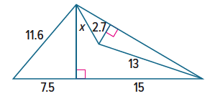
42. PERSEVERE Find the value of x in the figure at the right.

43. WRITE Research incommensurable magnitudes, and describe how this phrase relates to the use of irrational numbers in geometry. Include one example of an irrational number used in geometry.

