Coordinates in Space ⸱ Practice

Example 1
Graph a rectangular solid that contains the given point and the origin as vertices. Label the coordinates of each vertex.
1. A(2, 1, 5) 2. P(‒1, 4, 2) 3. C(‒2, 2, 2)

4. R(3, ‒4, 1) 5. H(4, 5, ‒3) 6. G(4, 1, ‒3)

Example 2
Determine the distance between each pair of points.
7. F(0, 0, 0) and G(2, 4, 3) 8. X(‒2, 5, ‒1) and Y(9, 0, 4)

9. A(4, ‒6, 0) and B(1, 0, 1) 10. C(8, 7, ‒2) and D(0, 0, 0)

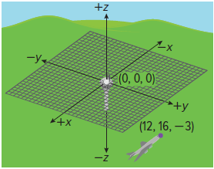
11. AIR TRAFFIC CONTROLLERS An air traffic controller knows that the most recent position of an aircraft was at the coordinates shown on the three-dimensional coordinate system to the right. If the control tower is at (0, 0, 0), then what is the distance between the aircraft and the tower if each unit on the coordinate system represents one mile? Round your answer to the nearest tenth, if necessary.

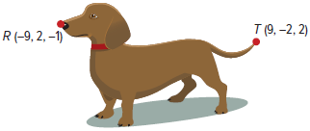
12. ANIMATORS An animator is using three-dimensional software to create the character shown. She labels the coordinates of the point R and point T. Point R represents the nose of the dog, and point T represents the tip of the dog’s tail. What is the distance between these two points of the animation? Round your answer to the nearest tenth, if necessary.

Example 3
Determine the coordinates of the midpoint M of the segment joining each pair of points.
13. K(‒2, ‒4, ‒4) and L(4, 2, 0) 14. W(‒1, ‒3, ‒6) and Z(‒1, 5, 10)

15. R(3, 3, 4) and V(5, 4, 13) 16. A(4, 6, ‒8) and B(0, 0, 0)

17. C(8, 7, 11) and D(2, 1, 8) 18. T(‒1, ‒7, 9) and U(5, ‒1, ‒6)

Mixed Exercises
REGULARITY Determine the distance between each pair of points. Then determine the coordinates of the midpoint M of the segment joining the pair of points.
19. P(‒5, ‒2, ‒1) and Q(‒1, 0, 3) 20. J(1, 1, 1) and K(‒1, ‒1, ‒1)

21. F$\left(\frac{3}{5},0,\frac{4}{5}\right)$ and G(0, 3, 0) 22. G(1, ‒1, 6) and H$\left(\frac{1}{5},-\frac{2}{5},2\right)$

23. B$\left(\sqrt{3}, 2, 2\sqrt{2}\right)$ and C$\left(-2\sqrt{3}, 4, 4\sqrt{2}\right)$ 24. S$\left(6\sqrt{3}, 4, 4\sqrt{2}\right)$ and T$\left(4\sqrt{3}, 5, \sqrt{2}\right)$

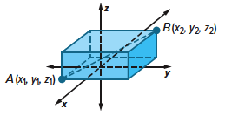
25. PROOF Write a coordinate proof of the Midpoint Formula in Space.

Given: Points A(x₁, y₁, z₁) and B(x₂, y₂, z₂);
M is the midpoint of $\overline{AB}$.
Prove: The coordinates of point M are $(\frac{x_{1}+x_{2}}{2},\frac{y_{1}+y_{2}}{2},\frac{z_{1}+z_{2}}{2})$.

26. WRITE Compare and contrast the Distance and Midpoint Formulas on the coordinate plane and in three-dimensional coordinate space.

27. FIND THE ERROR Camille and Teion were asked to find the distance between the points
A(2, 5, ‒8) and B(3, ‒1, 0). Who is correct? Explain your reasoning.
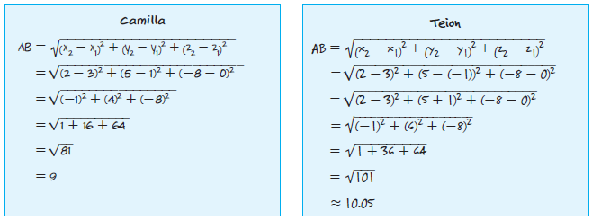

28. CREATE Graph a cube that has the following characteristics:
- the origin is one of the vertices,
- one of the edges lies on the negative y-axis, and
- one of the faces lies in the negative xz-plane.

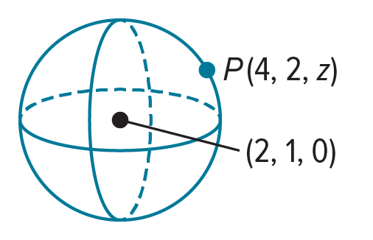
29. PERSEVERE Suppose the sphere has a radius of 9 units and passes through point P. Find the missing z-coordinate of point P.

