Special Right Triangles ⸱ Practice

Example 1
REGULARITY Find the value of x.
1. 2. 3.
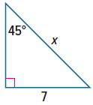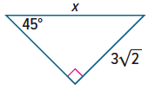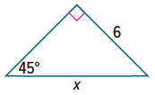

4. 5. 6.
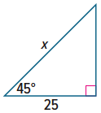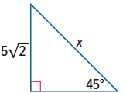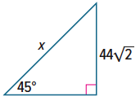

Example 2
Find the value of x.
7. 8. 9.
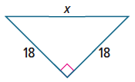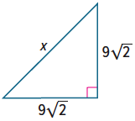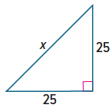

10. 11. 12.
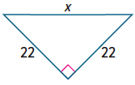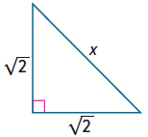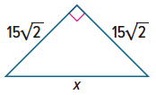

Example 3
Find the value of x.
13. 14. 15.
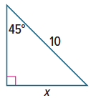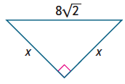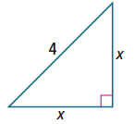

16. 17. 18.
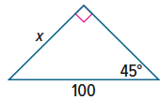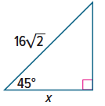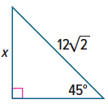

Example 4
Find the values of x and y.
19. 20. 21.
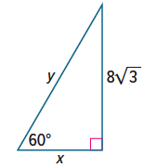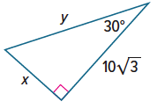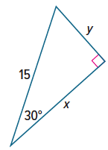

22. 23. 24.
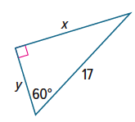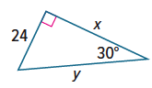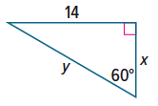
Example 5
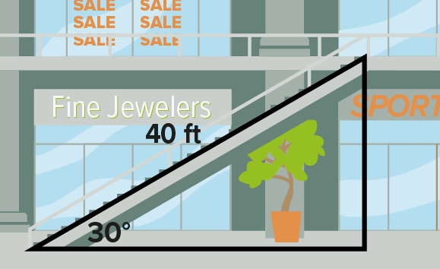
25. ESCALATORS A 40-foot-long escalator rises from the first floor to the second floor of a shopping mall. The escalator makes a 30° angle with the horizontal. How high above the first floor is the second floor?

26. WINDOWS A large stained glass window is constructed from six 30°-60°-90° triangles as shown in the figure. What is the height of the window?

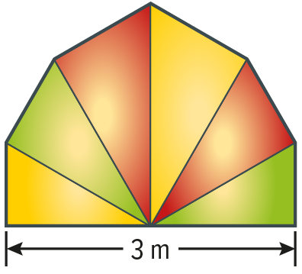
27. USE A MODEL An award certificate is in the shape of an equilateral triangle with 12-centimeter sides. Will the certificate fit in a 12-centimeter by 10-centimeter rectangular frame? Explain.


28. PRECISION A box of chocolates shaped like a regular hexagon is placed snugly inside of a rectangular box as shown in the figure. If the side length of the hexagon is 3 inches, what are the dimensions of the rectangular box?

Mixed Exercises
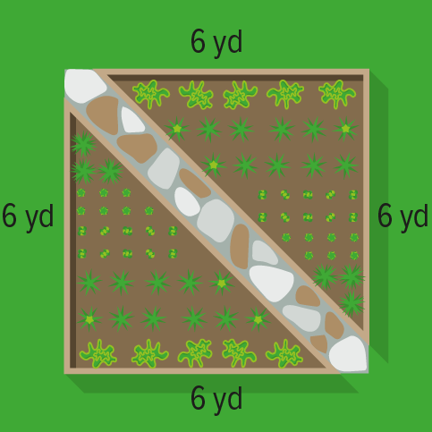
29. BOTANICAL GARDENS One of the displays at a botanical garden is an herb garden planted in the shape of a square. The square measures 6 yards on each side. Visitors can view the herbs from a diagonal pathway through the garden. How long is the pathway?

30. ORIGAMI A square piece of paper that is 150 millimeters long on each side is folded in half along a diagonal to create a triangle. What is the length of the hypotenuse of this triangle?

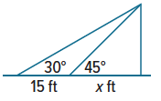
31. REASONING Kim and Yanika are watching a movie in a movie theater. Yanika is sitting x feet from the screen and Kim is 15 feet behind Yanika. The angle that Kim’s line of sight to the top of the screen makes with the horizontal is 30°. The angle that Yanika’s line of sight to the top of the screen makes with the horizontal is 45°.
a. How high is the top of the screen in terms of x?
b. What is $\frac{x+15}{x}$?
c. How far is Yanika from the screen? Round your answer to the nearest tenth.
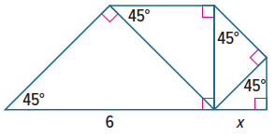

32. STRUCTURE Each triangle in the figure is a 45°-45°-90° triangle. Find the value of x.

Find the values of x and y.

33. 34. 35.
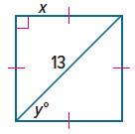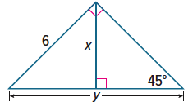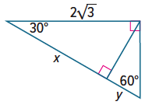

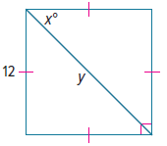
36. 37. 38.
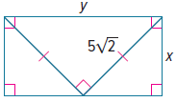
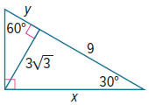

PROOF Write a paragraph proof to prove each theorem.

39. 45°-45°-90° Triangle Theorem 40. 30°-60°-90° Triangle Theorem
Given: 45°-45°-90° triangle with a leg Given: equilateral △DEF with sides of
of length $l$ and a hypotenuse of length $2x$ and an altitude of
length $h$ length $d$
Prove: The legs are congruent, and Prove: $DG=x;d=x\sqrt{3}$.
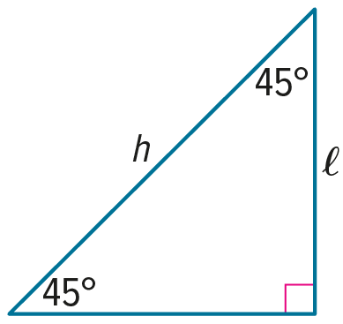
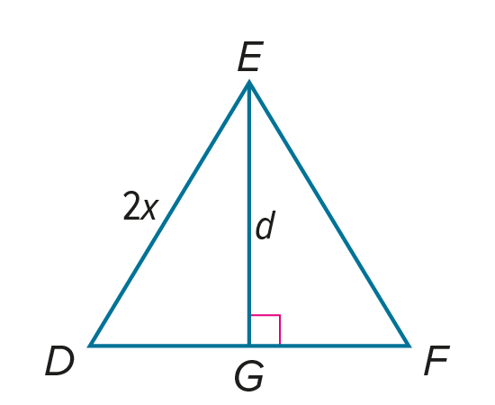
$h=l\sqrt{2}$.

41. △XYZ is a 45°-45°-90° triangle with right angle Z. Find the coordinates of X in Quadrant I for
Y(‒1, 2) and Z(6, 2).

42. △EFG is a 30°-60°-90° triangle with m∠F = 90°. Find the coordinates of E in Quadrant III for
F(‒3, ‒4) and G(‒3, 2). $\overline{FG}$ is the longer leg.

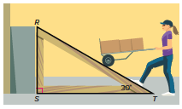
43. USE TOOLS Melody is in charge of building a ramp for a loading dock. According to the plan, the ramp makes a 30° angle with the ground, as shown. The plan also states that $\overline{ST}$ is 4 feet longer than $\overline{RS}$. Use a calculator to find the lengths of the three sides of the ramp to the nearest thousandth.

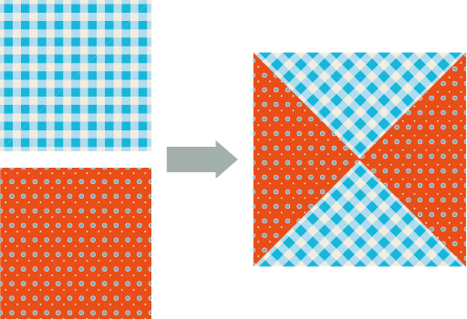
44. STATE YOUR ASSUMPTION Liling is making a quilt. She starts with two small squares of material and cuts them along the diagonal. Then she arranges the four resulting triangles to make a large square quilt block. She wants the large quilt block to have an area of 36 square inches.
a. What side lengths should Liling use for the two small squares of material? Explain.

b. Explain any assumption that you make to answer part a.

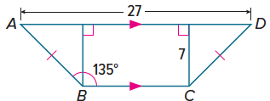
45. PERSEVERE Find the perimeter of quadrilateral ABCD. Round your answer to the nearest tenth.

46. WRITE Why are some right triangles considered special?

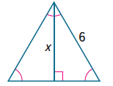
47. FIND THE ERROR Carmen and Audrey want to find x in the triangle shown. Who is correct? Explain your reasoning.
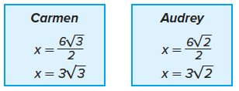

48. ANALYZE The ratio of the measure of the angles of a triangle is 1:2:3. The length of the shortest side is 8. What is the perimeter of the triangle? Round your answer to the nearest tenth.

49. CREATE Draw a rectangle that has a diagonal twice as long as its width. Then write an equation to find the length of the rectangle.

