Trigonometry ⸱ Practice

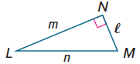
Example 1
Find sin L, cos L, tan L, sin M, cos M, and tan M. Express each ratio as a fraction and as a decimal to the nearest hundredth.
1. $l$ = 15, m = 36, n = 39 2. $l$ = 12, m = 12$\sqrt{3}$, n = 24

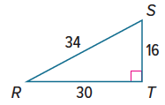
3. Find sin R, cos R, tan R, sin S, cos S, and tan S. Express each ratio as a fraction and as a decimal to the nearest hundredth.

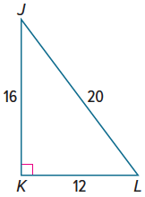

4. Find sin J, cos J, tan J, sin L, cos L, and tan L. Express each ratio as a fraction and as a decimal to the nearest hundredth if necessary.

Example 2
Use a special right triangle to express each trigonometric ratio as a fraction and as a decimal to the nearest hundredth if necessary.
5. sin 30° 6. tan 45° 7. cos 60°

8. sin 60° 9. tan 30° 10. cos 45°

Example 3
Find the value of x. Round to the nearest hundredth.
11. 12. 13.
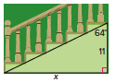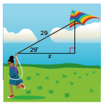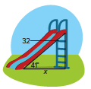
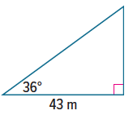
14. GEOLOGY Shan used a surveying tool to map a region of land for his science class. To determine the elevation of a vertical rock formation, he measured the distance from the base of the formation to his position and the angle between the ground and the line of sight to the top of the formation. The distance was 43 meters and the angle was 36°. What is the height of the formation to the nearest meter?

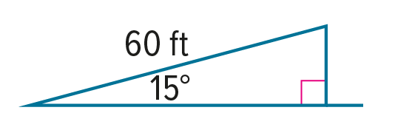
15. RAMPS A 60-foot ramp rises from the first floor to the second floor of a parking garage. The ramp makes a 15° angle with the ground. How high above the first floor is the second floor? Express your answer to the nearest tenth of a foot.

Example 4
Use a calculator to find m∠B to the nearest tenth.
16. 17. 18.
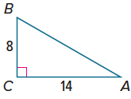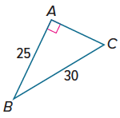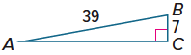

Use a calculator to find m∠T to the nearest tenth.
19. 20. 21.
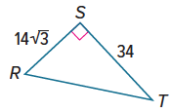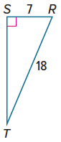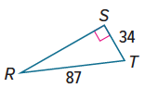

Example 5
Solve each right triangle. Round side measures to the nearest tenth and angle measures to the nearest degree.
22. 23. 24.
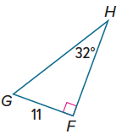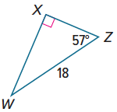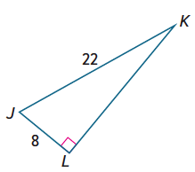

25. 26. 27.
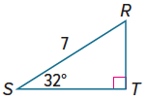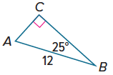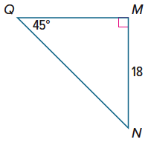

Mixed Exercises
Find each angle measure to the nearest tenth of a degree using the Distance Formula and an inverse trigonometric ratio.
28. m∠K in right triangle JKL with vertices J(‒2, ‒3), K(‒7, ‒3), and L(‒2, 4)

29. m∠Y in right triangle XYZ with vertices X(4, 1), Y(‒6, 3), and Z(‒2, 7)

REASONING Find the perimeter and area of each triangle. Round to the nearest hundredth.
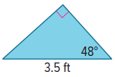
30. 31. 32.
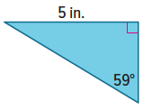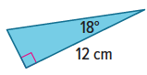

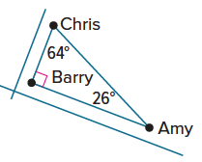
33. NEIGHBORS Amy, Barry, and Chris live in the same neighborhood. Chris lives up the street and around the corner from Amy, and Barry lives at the corner between Amy and Chris. The three homes are the vertices of a right triangle.

a. Give two trigonometric expressions for the ratio of Barry’s distance from Amy to Chris’ distance from Amy.

b. Give two trigonometric expressions for the ratio of Barry’s distance from Chris to Amy’s distance from Chris.

c. Give a trigonometric expression for the ratio of Amy’s distance from Barry to Chris’ distance from Barry.

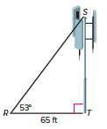
34. CONSTRUCT ARGUMENTS A cell phone tower is supported by a guy wire as shown. Chilam wants to determine the height of the tower. She finds that the guy wire makes an angle of 53° with the ground and it is attached to the ground 65 feet from the base of the tower.

a. Let the height of the tower be x. Which trigonometric ratio should you use to write an equation that you can solve for x? Justify
your choice.

b. Write and solve an equation for the height of the tower. Round to the nearest tenth of a foot.

c. Suppose Chilam had wanted to find the length of the guy wire. What would you have done differently to solve the problem? Justify your argument.

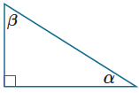
35. COMPLEMENTARY ANGLES In the right triangle shown, sin α = 0.6428 and cos α = 0.7660. Find sin β and cos β and explain your reasoning.

Find the values of x and y. Round to the nearest tenth.
36. 37.
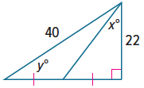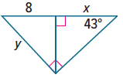

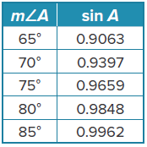
38. STRUCTURE Explain how you can use only the table at the right to find the value of cos 20°.

39. FIND THE ERROR Lakasha and Treyvon were both solving the same trigonometry problem. However, after they finished their computations, Lakasha said the answer was 52 sin 27° and Treyvon said the answer was 52 cos 63°. Could they both be correct? Explain your reasoning.

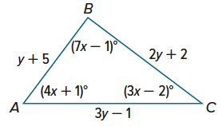
40. PERSEVERE Solve △ABC. Round each measure to the nearest whole number.

41. ANALYZE Are the values of sine and cosine for an acute angle of a right triangle always less than 1? Explain.

42. WHICH ONE DOESN’T BELONG? If the directions say to Solve the right triangle, then which of the triangles shown does not belong? Justify your conclusion.
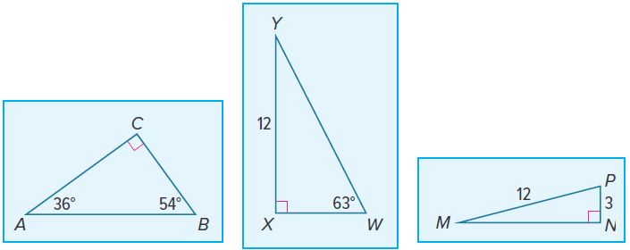

43. WRITE Explain how you can use ratios of the side lengths to find the angle measures of the acute angles in a right triangle.

44. CREATE Draw a right triangle with a tangent ratio of $\frac{3}{2}$ for one of the acute angles. Then find the measure of the other acute angle to the nearest tenth of a degree.

