Applying Trigonometry ⸱ Practice

Example 1
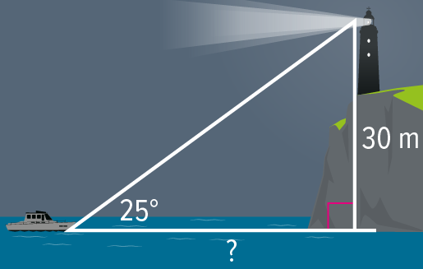
1. LIGHTHOUSES Sailors on a ship at sea spot the light from a lighthouse at an angle of elevation of 25°. The light of the lighthouse is 30 meters above sea level. How far from the shore is the ship? Round your answer to the nearest meter.

2. WATER TOWERS A student can see a water tower from the edge of a soccer field at San Lobos High School. The edge of the field is about 110 feet from the water tower and the water tower stands at a height of 32.5 feet. What is the angle of elevation if the eye level of the student viewing the tower is 6 feet above the ground? Round your answer to the nearest tenth.

3. CONSTRUCTION A roofer props a ladder against a wall so that the top of the ladder just reaches a 30-foot roof that needs repair. If the angle of elevation from the bottom of the ladder to the roof is 55°, how far is the ladder from the base of the wall? Round your answer to the nearest foot.

4. MOUNTAIN BIKING On a mountain bike trip along the Gemini Bridges Trail in Moab, Utah, Nabuko stopped on the canyon floor to get a good view of the twin sandstone bridges. Nabuko is standing about 60 meters from the base of the canyon cliff, and the natural arch bridges are about 100 meters up the canyon wall. If her line of sight is 5 meters above the ground, what is the angle of elevation to the top of the bridges? Round to the nearest tenth degree.

Example 2
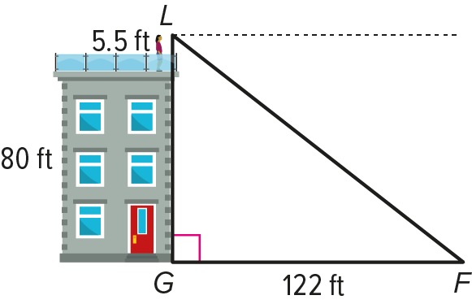
5. ROOFTOP Lucia is 5.5 feet tall. She is standing on the roof of a building that is 80 feet tall. She spots a fountain at ground level that she knows to be 122 feet away from the base of the building. What is the measure of the angle of depression formed by Lucia’s horizontal line of sight and her line of sight to the fountain? Round your answer to the nearest degree.

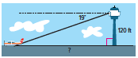
6. AIR TRAFFIC From the top of the 120-foot-high tower, an air traffic controller observes an airplane on the runway at an angle of depression of 19°. How far from the base of the tower is the airplane? Round your answer to the nearest tenth of a foot.

7. AVIATION Due to a storm, a pilot flying at an altitude of 528 feet has to land. If he has a horizontal distance of 2000 feet until he reaches the landing strip, what angle of depression should he use to land? Round to the nearest tenth degree.

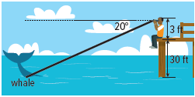
8. INDIRECT MEASUREMENT Kenneth is sitting at the end of a pier and using binoculars to watch a whale surface. The pier is 30 feet above the water, and Kenneth’s eye level is 3 feet above the pier. If the angle of depression to the whale is 20°, how far is the whale from Kenneth’s binoculars? Round your answer to the nearest tenth of a foot.

Example 3
9. GARAGE To estimate the height of a garage, Carlos sights the top of the garage at a 42° angle of elevation. He then steps back 20 feet and sights the top of the garage at a 10° angle. If Carlos is 6 feet tall, how tall is the garage to the nearest foot?
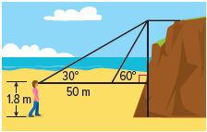

10. CLIFF Sarah stands on the ground and sights the top of a steep cliff at a 60°angle of elevation. She then steps back 50 meters and sights the top of the cliff at a 30° angle. If Sarah is 1.8 meters tall, how tall is the cliff to the nearest meter?

11. BALLOON The angle of depression from a hot air balloon to a person on the ground is 36°. When the person steps back 10 feet, the new angle of depression is 25°. If the person is 6 feet tall, how far above the ground is the hot air balloon to the nearest foot?

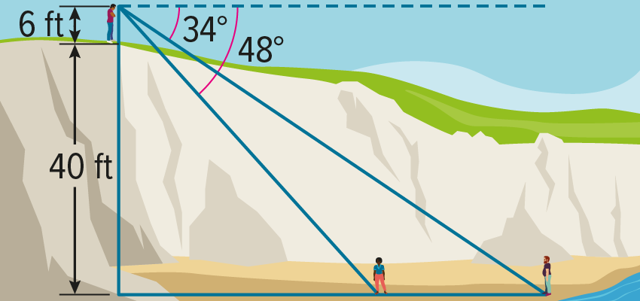
12. INDIRECT MEASUREMENT Mr. Dominguez is standing on a 40-foot ocean bluff near his home. He can see his two friends on the beach below. If his line of sight is 6 feet above the ground and the angles of depression to his friends are 34° and 48°, how far apart are his friends to the nearest foot?

Example 4
Use trigonometry to find the area of ΔABC to the nearest tenth.
13. 14. 15.
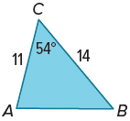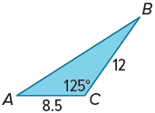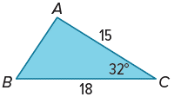

16. 17. 18.
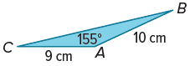
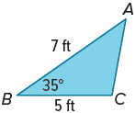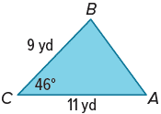

Example 5
Use trigonometry to find the area of △ABC to the nearest tenth.
19. 20. 21.
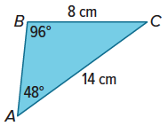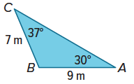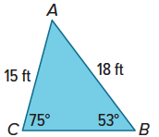

Mixed Exercises
22. USE ESTIMATION The angle of elevation to an airplane viewed from the air traffic control tower at an airport is 7°. The tower is 200 feet tall, and the pilot reports that the altitude of the airplane is 5127 feet.

a. Explain how you can use angles of elevation and depression to estimate the distance from the air traffic control tower to the airplane.

b. About how far away is the airplane from the air traffic control tower to the nearest foot?

23. USE ESTIMATION A hiker dropped his backpack over one side of a canyon onto a ledge below. Because of the shape of the cliff, he could not see exactly where it landed. A park ranger is located on the other side of the canyon, at the same height, 113 feet away from the hiker. The ranger sights the backpack at an angle of depression of 32°.

a. Explain how you can use angles of elevation and depression to estimate the distance that the backpack fell.

b. About how far did the backpack fall to the nearest foot.

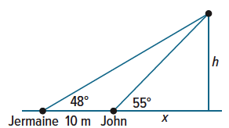
24. USE A MODEL Jermaine and John are standing 10 meters apart watching a helicopter hover above the ground.

a. Find two different expressions that can be used to find h, the height of the helicopter.

b. Equate the two expressions you found for part a to solve for x. Round your answer to the nearest hundredth.

c. How high above the ground is the helicopter? Round your answer to the nearest hundredth.

25. USE A SOURCE Go online to research the Sandia Peak Tramway in New Mexico. If you were to stand at the top terminal of Sandia Peak Tramway and look at the base of the second tower along the tramway route, what would be the angle of depression for your line of sight? Round your answer to the nearest tenth of a degree.

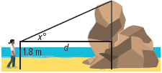
26. REGULARITY A geologist wants to determine the height of a rock formation. She stands d meters from the formation and sights the top of the formation at an angle of x°, as shown. The geologist’s height is 1.8 m. Write a general formula that the geologist can use to find the height h of the rock formation if she knows the values of d and x.

Find the area of △ABC to the nearest tenth.
27. $m∠$A = 20°, c = 4 cm, b = 7 cm 28. $m∠$C = 55°, a = 10 m, b = 15 m

29. $a=5.6\text{ ft,} c=3.7 \text{ft}, m∠A=37°\text{,} m∠C=24°$

30. $a=6.3 \text{in.,} c=7 \text{in.,} m∠A=42°\text{,} m∠C=49°$

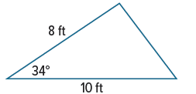
31. THEATER Albert is helping to build the set for a play. One piece of scenery is a large triangle that will be constructed out of wood and be painted to represent a mountain. Albert would like to know the area of the piece of scenery so that he can buy the right amount of paint. What is the area of this triangle? Round your answer to the nearest tenth of a foot.

32. FIND THE ERROR Terrence and Rodrigo are trying to determine the relationship between angles of elevation and depression. Terrence says that if you are looking up at someone with an angle of elevation of 35°, then they are looking down at you with an angle of depression of 55°, which is the complement of 35°. Rodrigo disagrees and says that the other person would be looking down at you with an angle of depression equal to your angle of elevation or 35°. Who is correct? Explain your reasoning.

33. CREATE A classmate finds the angle of elevation of an object, but she is trying to find the angle of depression. Write a question to help her solve the problem.

34. ANALYZE Classify the statement below as true or false. Explain your reasoning.

As a person moves closer to an object he or she is sighting, the angle of elevation increases.

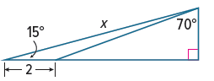
35. PERSEVERE Find the value of x. Round to the nearest tenth.

36. WRITE Describe a way that you can estimate the height of an object without using trigonometry. Explain your reasoning.

