The Law of Sines ⸱ Practice

Examples 1 and 2
Find the value of x to the nearest tenth.
1. 2. 3.
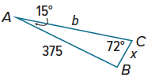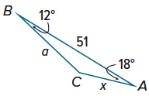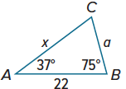

4. 5. 6.
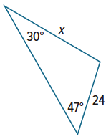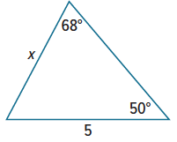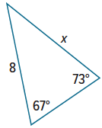

7. 8. 9.
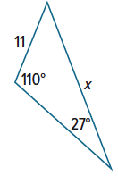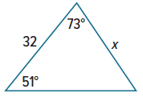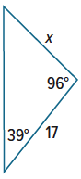

10. 11. 12.
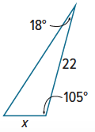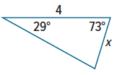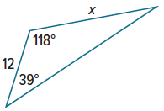

Example 3
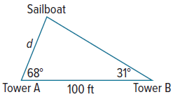
13. WILDLIFE An officer for the Department of Fisheries and Wildlife checks boaters on a lake to make sure they do not disturb two osprey nesting sites. She leaves a dock and heads due north in her boat to the first nesting site. From here, she turns 5° north of due west and travels an additional 2.14 miles to the second nesting site. She then travels 6.7 miles directly back to the dock. How far from the dock is the first osprey nesting site? Round to the nearest tenth.

14. SAILING Observers at two shoreline towers 100 feet apart measure the angles to an incoming sailboat. Using the diagram, find the distance d that the sailboat is from Tower A to the nearest tenth of a foot.

Examples 4–6
Determine whether each triangle has no solution, one solution, or two solutions. Then, solve the triangle. Round side lengths to the nearest tenth and angle measures to the nearest degree.
15. $m∠$A = 50°, a = 34, b = 40 16. $m∠$A = 24°, a = 3, b = 8 17.$m∠$A = 125°, a = 22, b = 15

18. $m∠$A = 30˚, a = 1, b = 4 19. $m∠$A = 30˚, a = 2, b = 4 20. $m∠$A = 30˚, a = 3, b = 4

21. $m∠$A = 38˚, a = 10, b = 9 22. $m∠$A = 78˚, a = 8, b = 5 23. $m∠$A = 133˚, a = 9, b = 7

24. $m∠$A = 127˚, a = 2, b = 6 25. $m∠$A = 109˚, a = 24, b = 13 26. $m∠$A = 48°, a = 11, and b = 16

Mixed Exercises
27. PROOF Justify each statement for the proof of the Law of Sines.
Given: $\overline{CD}$ is an altitude of $△$ABC.
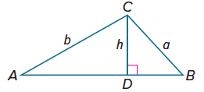
Prove: $\frac{sin A}{a}=\frac{sin B}{b}$
Proof:
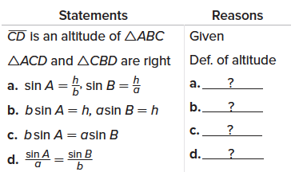

Find the perimeter of each figure. Round your answer to the nearest tenth.
28. 29. 30.
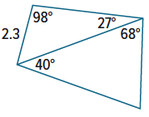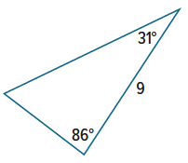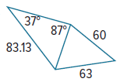

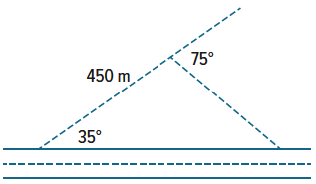
31. WALKING Alliya is taking a walk along a straight road. She leaves the road and walks on a path that makes an angle of 35° with the road. After walking for 450 meters, she turns 75° and heads back toward the road.
a. After Alliya turns $75°$, how far does Alliya walk to get back to the road?

b. When Alliya returns to the road, how far along the road is she from where she started?

32. CAMERAS A security camera is located on top of a building at a certain distance from the sidewalk. The camera revolves counterclockwise at a steady rate of one revolution per minute. At one point in the revolution it directly faces a point on the sidewalk that is 20 meters from the camera. Four seconds later, it directly faces a point 10 meters down the sidewalk.
a. How many degrees does the camera rotate in 4 seconds?

b. To the nearest tenth of a meter, how far is the security camera from the sidewalk?

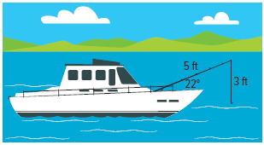
33. FISHING A fishing pole is resting against the railing of a boat making an angle of 22° with the deck. The fishing pole is 5 feet long, and the hook hangs 3 feet from the tip of the pole. The movement of the boat causes the hook to sway back and forth. Determine which angles the fishing line must make with the pole in order for the hook to be level with the boat’s deck.

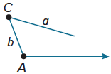
34. REASONING Angle A is obtuse. How many triangles can be formed if a = b? if a < b? if a > b?

REGULARITY Determine whether the given measures define 0, 1, or 2 triangles.
Justify your answers.
35. a = 14, b = 16, m∠A = 55$°$ 36. a = 7, b = 11, m∠A = 68$°$ 37. a = 22, b = 25, m∠A = 39$°$

38. a = 13, b = 12, m∠A = 81$°$ 39. a = 10, b = 10, m∠A = 45$°$ 40. a = 17, b = 15, m∠A = 128$°$

41. a = 13, b = 17, m∠A = 52$°$ 42. a = 5, b = 9, c = 6 43. a = 10, b = 15, m∠A = 33$°$

44. TOWERS Cell towers A, B, and C form a triangular region in one of the suburban districts of Fairfield County. Towers A and B are 8 miles apart. The angle formed at tower A is 112°, and the angle formed at tower B is 40°. How far apart are towers B and C?

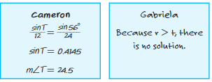
45. FIND THE ERROR In △RST, $m∠$R = 56°, r = 24, and t = 12. Cameron and Gabriela are using the Law of Sines to find $m∠$T. Who is correct? Explain your reasoning.

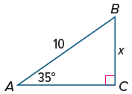
46. WRITE What two methods can be used to find the value of x in $△ABC$? Write two equations using the different methods and explain your reasoning.

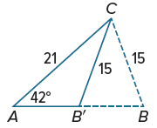
47. PERSEVERE Find both solutions for △ABC if a = 15, b = 21, m∠A = 42°. Round angle measures to the nearest degree and side measures to the nearest tenth.

- For solution 1, assume that ∠B is acute, and use the Law of Sines to find m∠B. Then find m∠C. Finally, use the Law of Sines again to find c.

- For solution 2, assume that ∠B is obtuse. Let this obtuse angle be ∠B’. Use m∠B you found in solution 1 and the diagram shown to find m∠B’. Then find m∠C. Finally, use the Law of Sines to find c.

48. ANALYZE Determine whether the statement below is true or false. Explain your reasoning.

The Law of Sines can always be used to solve a triangle if the measures of two sides and their included angle are known.

49. CREATE Give measures for a, b, and an acute ∠A that define the given number of triangles.
a. 0 triangles b. exactly one triangle c. two triangles

