The Law of Cosines ⸱ Practice

Examples 1 and 2
Find the value of x to the nearest tenth for side lengths and nearest degree for angle measures.
1. 2. 3.
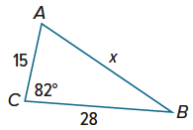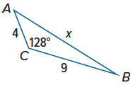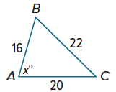
4. 5. 6.
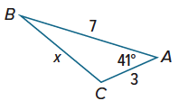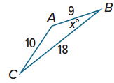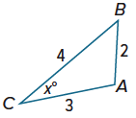

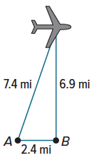
Example 3
7. RADAR Two radar stations 2.4 miles apart are tracking an airplane. The straight-line distance between Station A and the plane is 7.4 miles. The straight-line distance between Station B and the plane is 6.9 miles. What is the angle of elevation from Station A to the plane? Round to the nearest degree.

8. DRAFTING Marion is using a drafting program to produce a drawing for a client. She wants to make a triangle first. She begins a triangle by drawing a segment 4.2 inches long from point A to point B. From point B, she draws a second segment that forms a 42° angle with $\overline{AB}$, is 6.4 inches long, and ends at point C. To the nearest tenth of an inch, how long is the segment from C to A?

Examples 4 and 5
REASONING Solve each triangle. Round side lengths to the nearest tenth and angle measures to the nearest degree.
9. 10. 11.
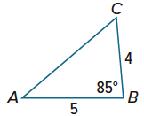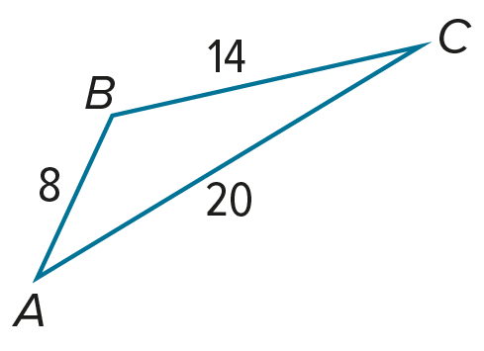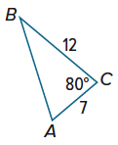

12. 13. 14.
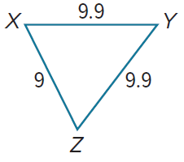
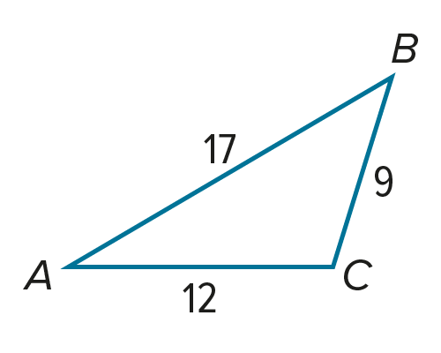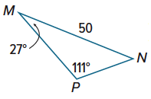

Mixed Exercises

REGULARITY Determine whether each triangle should be solved by beginning with the Law of Sines or the Law of Cosines. Then solve the triangle.
15. $m∠$A = 11˚, $m∠$C = 27˚, c = 50 16. $m∠$B = 47˚, a = 20, c = 24

17. $m∠$A = 37˚, a = 20, b = 18 18. $m∠$C = 35˚, a = 18, b = 24

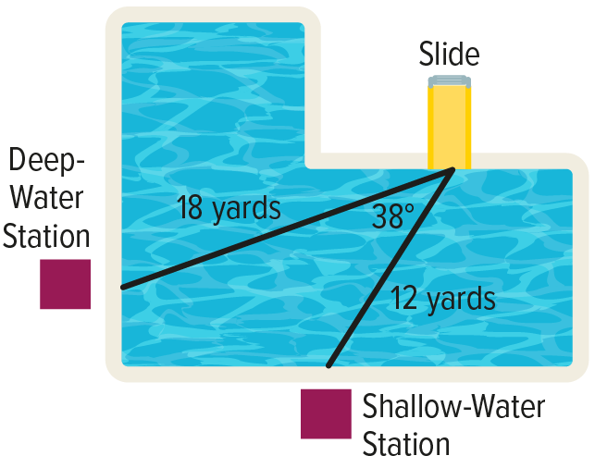
19. POOLS The Perth County pool has a lifeguard station in both the deep-water and shallow-water sections of the pool. The distance between each station and the bottom of the slide is known, but the manager would like to calculate more information about the pool setup.

a. When the lifeguards switch positions, the lifeguard at the deep-water station swims to the shallow water station. How far does the lifeguard swim?

b. If the lifeguard at the deep-water station is directly facing the bottom of the slide, what angle does she need to turn in order to face the lifeguard at the shallow water station?
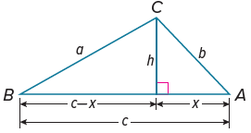

20. PROOF Write a two-column proof to prove the Law of Cosines.

Given: The altitude of $△ABC$ is h.

Prove: $a^{2}=b^{2}+c^{2}-2bc$cosA

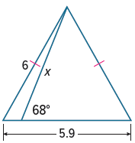
21. PERSEVERE Find the value of x in the figure at the right.

22. ANALYZE Explain why the Pythagorean Theorem is a specific case of the Law of Cosines.

23. WRITE What methods can you use to solve a triangle?

24. CREATE Draw and label a triangle that can be solved:
a. using only the Law of Sines.

b. using only the Law of Cosines.

