Circles and Circumference ⸱ Practice

Example 1
For Exercises 1-3, refer to the circle at the right.
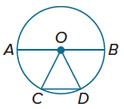
1. Name the circle.

2. Name the radii of the circle.

3. Name the chords of the circle.

For Exercises 4-8, refer to the circle at the right.

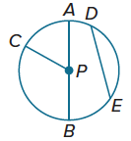
4. Name the circle.

5. Name the radii of the circle.

6. Name the chords of the circle.

7. Name a diameter of the circle.

8. Name a radius not drawn as part of a diameter.

Example 2
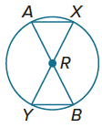
For Exercises 9-11, refer to ʘR.

9. If AB = 18 millimeters, find AR.

10. If RY = 10 inches, find AR and AB.

11. Is $\overline{AB}$ ≅ $\overline{XY}$? Explain.

For Exercises 12-14, refer to ʘL.
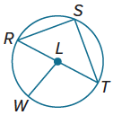
12. Suppose the radius of the circle is 3.5 yards. Find the diameter.

13. If RT = 19 meters, find LW.

14. If LT = 4.2 inches, what is the diameter of ʘL?

Example 3

15. TIRES A bicycle has tires with a diameter of 26 inches. Find the radius and circumference of each tire. Round your answer to the nearest hundredth, if necessary.

16. STATE YOUR ASSUMPTION Herman purchased a sundial to use as the centerpiece for a garden. The diameter of the sundial is 9.5 inches.

a. Find the radius of the sundial.

b. Find the circumference of the sundial to the nearest hundredth.

c. Explain any assumptions that you make while solving this problem.

Example 4
Find the diameter and radius of a circle to the nearest hundredth with the given circumference.

17. C = 40 in. 18. C = 256 ft

19. C = 15.62 m 20. C = 9 cm

21. C = 79.5 yd 22. C = 204.16 m

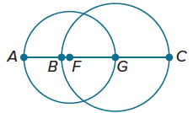
Example 5
The diameters of ⨀F and ⨀G are 5 and 6 units, respectively. Find each measure.

23. BF 24. AB

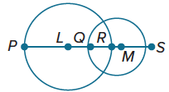
The diameters of ⨀L and ⨀M are 20 and 13 units, respectively, and QR = 4. Find each measure.

25. LQ 26. RM

Mixed Exercises
The radius, diameter, or circumference of a circle is given. Find each missing measure to the nearest hundredth.

27. d = $8\frac{1}{2}$ in., r = _?_, C = _?_ 28. r = $11\frac{2}{5}$ ft, d = _?_, C = _?_

29. C = 628 m, d = _?_, r = _?_ 30. d = $\frac{3}{4}$ yd, r = _?_, C = _?_

31. C = 35x cm, d = _?_, r = _?_ 32. r = $\frac{x}{8}$, d = _?_, C = _?_

Determine whether the circles in the figures below appear to be congruent, concentric, or neither.

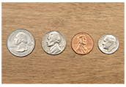


33. 34. 35.

For each circle, find the exact circumference in terms of $π$.

36. 37. 38.
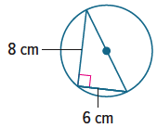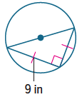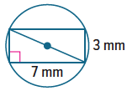

39. 40. 41.
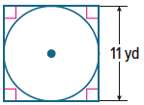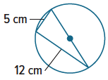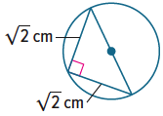

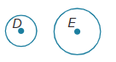
42. PROOF Write a paragraph proof to prove Theorem 10.1.
Given: $⨀D$ and $⨀E$
Prove: $⨀D∼⨀E$

43. USE A SOURCE Go online to research a famous clock face. Then use the diameter of the clock face to find the circumference. Round your answer to the nearest hundredth.

44. WHEELS Zack is designing wheels for a concept car. The diameter of the wheel is 18 inches. Zack wants to make spokes in the wheel that run from the center of the wheel to the rim. In other words, each spoke is a radius of the wheel. How long are these spokes?

45. PRECISION Kathy slices through a circular cake. The cake has a diameter of 14 inches. The slice that Kathy made is straight and has a length of 11 inches. Did Kathy cut along a radius, a diameter, or a chord of the circle?

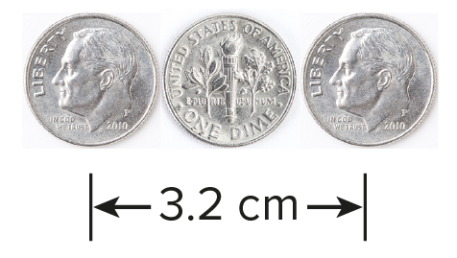
46. REASONING Three identical circular coins are lined up in a row as shown. The distance between the centers of the first and third coins is 3.2 centimeters. What is the radius of one of these coins?

47. EXERCISE HOOPS Taiga wants to make a circular loop that he can twirl around his body for exercise. He will use a tube that is 2.5 meters long.

a. What will be the diameter of Taiga’s exercise hoop? Round your answer to the nearest thousandth of a meter.

b. What will be the radius of Taiga’s exercise hoop? Round your answer to the nearest thousandth of a meter.

48. WRITE How can we describe the relationships that exist between circles and line segments?

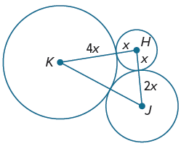
49. PERSEVERE The sum of the circumferences of circles H, J, and K shown at the right is 56π units. Find KJ.

50. ANALYZE Is the distance from the center of a circle to a point in the interior of a circle sometimes, always, or never less than the radius of the circle? Justify your argument.

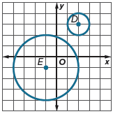

51. CREATE Design a sequence of transformations that can be used to prove that ⨀D is similar to ⨀E.

