Measuring Angles and Arcs ⸱ Practice

Example 1
Find the value of x.
1. 2. 3.
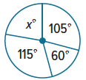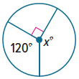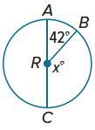

Example 2
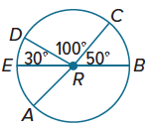
$\overline{AC}$ and $\overline{EB}$ are diameters of ⨀R. Identify each arc as a major arc, minor arc,
or semicircle. Then find its measure.
4. m$\hat{EA}$ 5. m$\hat{CB}$

6. m$\hat{DC}$ 7. m$\hat{DEB}$

8. m$\hat{AB}$ 9. m$\hat{CDA}$

Example 3
10. SURVEYS A survey asked students at 11. SPORTS The circle graph shows the favorite
Westwood High School their preference spectator sport among a group of teens at
for the new school mascot. The results are a local high school. Find m$\hat{AD}$.
shown in the circle graph. Find m$\hat{AB}$.
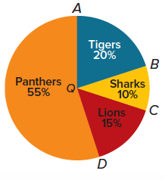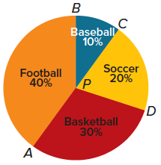

Example 4
$\overline{PR}$ and $\overline{QT}$ are diameters of ⨀A. Find each measure.
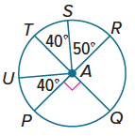
12. m$\hat{UPQ}$ 13. m$\hat{PQR}$

14. m$\hat{UTS}$ 15. m$\hat{RS}$

16. m$\hat{RSU}$ 17. m$\hat{STP}$

18. m$\hat{PQS}$ 19. m$\hat{PRU}$

Example 5
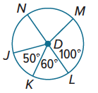
Use ⨀D to find the length of each arc to the nearest hundredth. $\overline{NL}$ is a diameter.
20. $\hat{LM}$ if the radius is 5 inches 21. $\hat{MN}$ if the diameter is 3 yards

22. $\hat{KL}$ if JD = 7 centimeters 23. $\hat{NJK}$ if NL = 12 feet

24. $\hat{KLM}$ if DM = 9 millimeters 25. $\hat{JK}$ if KD = 15 inches

Example 6
Write each degree measure in radians as a multiple of π.
26. 120° 27. 45° 28. 30°

29. 90° 30. 180° 31. 225°

Example 7
Write each radian measure in degrees.
32. $\frac{3π}{4}$ radians 33. $\frac{3π}{2}$ radians 34. $\frac{π}{3}$ radians

35. $\frac{5π}{6}$ radians 36. 2π radians 37. $\frac{π}{12}$ radians

Example 8
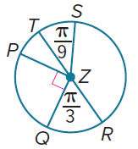
Use ⨀Z to find the length of each arc to the nearest hundredth.
38. $\hat{QR}$, if PZ = 12 feet 39. $\hat{ST}$, if SZ = 8 inches

40. $\hat{PQ}$, if TZ = 14 centimeters 41. $\hat{PT}$, if TR = 20 inches

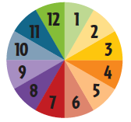
Mixed Exercises
42. CLOCKS Shiatsu is a type of Japanese physical therapy. One of the beliefs is that various body functions are most active at various times during the day. To illustrate this, they use a Chinese clock that is based on a circle divided into 12 equal sections by radii. What are the degree and radian measures of any one of the 12 equal central angles?


43. RIBBONS Cora is wrapping a ribbon around a cylinder-shaped gift box. The box has a diameter of 15 inches, and the ribbon is 60 inches long. Cora is able to wrap the ribbon all the way around the box once and then continue so that the second end of the ribbon passes the first end. What is the measure of the central angle formed by the arc between the ends of the ribbon? Round your answer to the nearest tenth of a degree.

44. PIES Shekeia has divided a circular apple pie into 4 slices by cutting the pie along 4 radii. If the measures of the central angles of the 4 slices are represented by 3x°, (6x – 10)°, (4x + 10)°, and 5x°, what are the measures of the central angles?

45. BIKE WHEELS Louis has to buy a new wheel for his bike. The bike wheel has a diameter of 20 inches.
a. If Louis rolls the wheel one complete rotation along the ground, how far will the wheel travel? Round your answer to the nearest hundredth of an inch.

b. If the bike wheel is rolled along the ground so that it rotates 45°, how far will the wheel travel? Round your answer to the nearest hundredth of an inch.

c. If the bike wheel is rolled along the ground for 10 inches, through what angle does the wheel rotate? Round your answer to the nearest tenth of a degree.

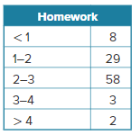
46. USE TOOLS The table on the right shows the number of hours students at Leland High School say they spend on homework each night.
a. If you were to construct a circle graph of the data, how many degrees would be allotted to each category?
b. Describe the types of arcs associated with each category.

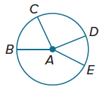
47. PROOF Write a two-column proof of Theorem 10.2.

Given: ∠BAC ≅ ∠DAE

Prove: $\hat{BC}≅\hat{DE}$

REASONING Find each measure. Round each linear measure to the nearest hundredth and each arc measure to the nearest degree.
48. circumference of ⨀S 49. m$\hat{CD}$ 50. radius of ⨀S
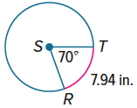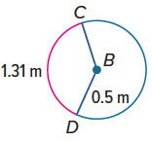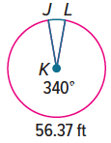

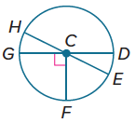
In ⨀C, m∠HCG = 2x° and m∠HCD = (6x + 28)°. $\overline{HE}$ and $\overline{GD}$ are
diameters of the circle. Find each measure.
51. m$\hat{EF}$ 52. m$\hat{HD}$ 53. m$\hat{HGF}$

54. STRUCTURE An arc has a related central angle of 54°. Complete the table by finding the length of the arc in terms of π for each given radius.
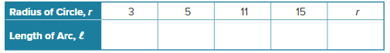

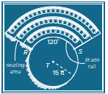
55. REGULARITY An architect is designing the seating area for a theater. The seating area is formed by a region that lies between two circles. The architect is planning to place a brass rail in front of the first row of seats.
a. The architect wants to know the length of the rail. Express the length in terms of π and to the nearest tenth of a foot.

b. The architect is considering changing the radius of ⊙T or changing the measure of $\hat{RS}$. Describe a general method she can use to find the length of $\hat{RS}$.

ANALYZE For Exercises 56-58, determine whether each statement is sometimes, always, or never true. Justify your argument.
56. The measure of a minor arc is less than 180$°$.

57. If a central angle is obtuse, its corresponding arc is a major arc.

58. The sum of the measures of adjacent arcs of a circle depends on the measure of the radius.

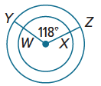
59. FIND THE ERROR Brody says that $\hat{WX}$ and $\hat{YZ}$ are congruent because their central angles have the same measure. Selena says they are not congruent. Who is correct? Explain your reasoning.

60. PERSEVERE The time shown on an analog clock is 8:10. What is the measure of the angle formed by the hands of the clock?

61. CREATE Draw a circle and locate three points on the circle. Estimate the measures of the three nonoverlapping arcs that are formed. Then use a protractor to find the measure of each arc. Label your circle with the arc measures.

62. WRITE Describe the three different types of arcs in a circle and a method for finding the measure of each one.

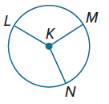
63. PERSEVERE The measures of $\hat{LM}, \hat{MN},$ and $\hat{NL}$ are in the ratio of 5:3:4. Find the measure of each arc.

