Arcs and Chords ⸱ Practice

Examples 1 and 2
REGULARITY Find the value of x.
1. 2. 3.
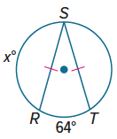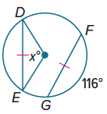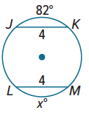

4. 5. 6.
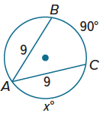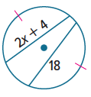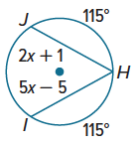

7. 8. ⨀M ≅ ⨀P 9. ⨀V ≅ ⨀W
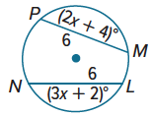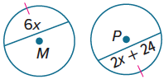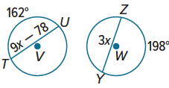

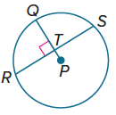
Examples 3 and 4
In ⨀P, $PQ=13$and RS = 24. Find each measure.
10. RT 11. PT 12. TQ

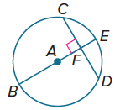
In ⨀A, EB = 12, CD = 8, and m$\hat{CD}$ = 90$°$. Find each measure.
Round to the nearest hundredth, if necessary.
13. m$\hat{DE}$ 14. FD 15. AF

16. USE A MODEL For security purposes a jewelry company prints a hidden watermark on the logo of its official documents. The watermark is a chord located 0.7 cm from the center of a circular ring that has a 2.5 cm radius. To the nearest tenth, what is the length of the chord?

Example 5
17. In ⨀R, TS = 21 and UV = 3x. 18. In ⨀Q, $\overline{CD}$ ≅ $\overline{CB}$, GQ = x + 5 and
What is the value of x? EQ = 3x – 6. What is the value of x?
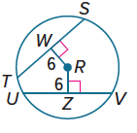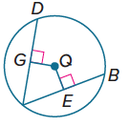


Mixed Exercises
19. USE TOOLS A piece of a broken plate is found during an archaeological dig. Use the sketch of the pottery piece shown to demonstrate how constructions with chords and perpendicular bisectors can be used to draw the plate’s original size.
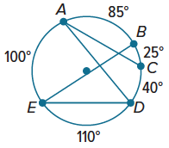
20. REASONING A circular garden has paths around its edge that are identified by the given arc measures. It also has four straight paths, identified by segments $\overline{AC}$, $\overline{AD}$, $\overline{BE}$, and $\overline{DE}$, that cut through the garden’s interior. Which two straight paths have the same length?

PROOF For Exercises 21 and 22, write a two-column proof of the indicated part of Theorem 10.6.
21. In a circle, if two chords are equidistant from the center, then they are congruent.
22. In a circle, if two chords are congruent, then they are equidistant from the center.

23. WRITE Neil draws a diameter of a circle and then marks its midpoint as the center. His teacher asks Neil how he knows that he drew the diameter of the circle and not a shorter chord. How can Neil determine whether he drew an actual diameter?

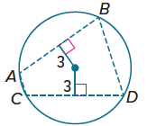
24. PERSEVERE Toshelle is following directions for a quilt pattern. The directions are intended to make a rectangle. They say “In a 10-inch diameter circle, measure 3 inches from the center of the circle and mark a chord $\overline{AB}$ perpendicular to the radius of the circle. Then cut along the chord.” Toshelle is to repeat this for another chord, $\overline{CD}$. Finally, she is to cut along chord $\overline{DB}$ and $\overline{AC}$. The result should be four curved pieces and one quadrilateral. If Toshelle follows the directions, why might the resulting quadrilateral not be a rectangle? Explain how to adjust the directions.

25. CREATE Construct a circle and draw a chord. Measure the chord and the distance that the chord is from the center. Find the length of the radius.

26. ANALYZE In a circle, $\overline{AB}$ is a diameter and $\overline{HG}$ is a chord that intersects $\overline{AB}$ at point X. Is it sometimes, always, or never true that HX = GX? Justify your argument.

