Inscribed Angles ⸱ Practice

Example 1
Find each measure.
1. m$\hat{AC}$ 2. m∠N 3. m$\hat{QSR}$
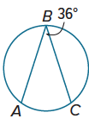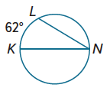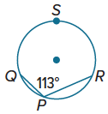

4. m$\hat{XY }$ 5. m∠E 6. m∠R
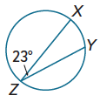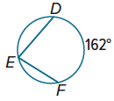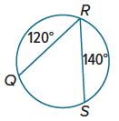

Example 2
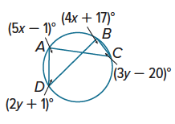
Find each measure.
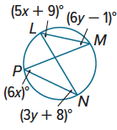
7. m∠N 9. m∠C

8. m∠L 10. m∠A

Example 3
PROOF Write the specified type of proof.
11. paragraph proof 12. two-column proof
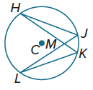
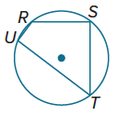
Given: m∠T = $\frac{1}{2}$ m∠S Given: ⊙C
Prove: m$\hat{TUR }$ = 2m$\hat{URS }$ Prove: $△$KML ∼ $△$JMH

Example 4
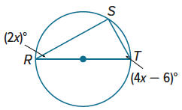
Find each value.
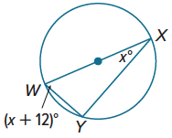
13. x 15. x

14. m∠W 16. m∠T

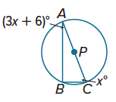
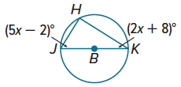
17. m∠J 19. m∠A

18. m∠K 20. m∠C

Example 5
Find each measure.
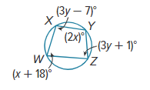
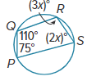
21. m∠R 23. m∠W

22. m∠S 24. m∠X

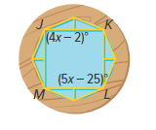
25. USE ESTIMATION Darius bought a circular picture frame with a geometric design. The frame has a quadrilateral inscribed in a circle.
a. Estimate the value of x.
b. Find the exact value of x and m∠J.
c. Is your answer reasonable? Justify your argument.

Mixed Exercises
Find each measure.
26. m$\hat{CE}$ 27. m$\hat{JM}$ 28. m∠QPR
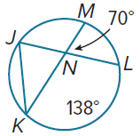
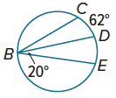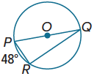

29. m$\hat{UW}$ 30. m∠AFE 31. m∠KJH
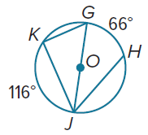
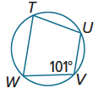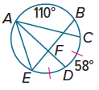

PROOF Write the specified type of proof to prove each theorem.
32. two-column proof Theorem 10.8 33. paragraph proof Theorem 10.10
Given: $\hat{JL}≅\hat{RP}$; $∠JKL$ and $∠RQP$ are Given: Quadrilateral DEFG is inscribed in $⨀C$.
Inscribed.
Prove: $∠JKL≅∠RQP$ Prove: $∠D$ and $∠F$ are supplementary.
$∠E$ and $∠G$ are supplementary.
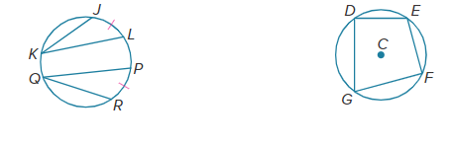

34. PROOF Write a paragraph proof to prove each part of Theorem 10.9.
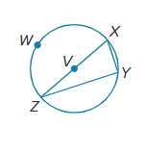
a. Given: $\hat{XWZ}$ is a semicircle.
Prove: $∠XYZ$ is a right angle.

b. Given: $∠XYZ$ is a right angle.
Prove: $\hat{XWZ}$ is a semicircle.

35. PROOF Write a paragraph proof to prove that if PQRS is an inscribed quadrilateral and ∠Q ≅ ∠S, then $\overline{PR}$ is a diameter of the circle.

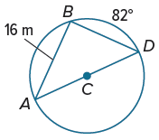
36. REASONING A landscaping crew is installing a circular garden with three paths that form a triangle. The figure shows the plan for the garden and the paths. The leader of the crew wants to determine the radius they should use when they install the circular garden.
a. Find the measures of the angles in $△$ABD.

b. Use trigonometry to find the radius of the circular garden. Round to the nearest tenth meter, if necessary.

c. Given that the path will go along the outside of the garden, as well as along the three interior paths, find the total length of the path that will need to be installed.


37. ARENA A concert arena is lit by five lights equally spaced around the perimeter. What is m∠1?

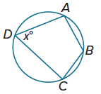
38. JEWELRY Alyssa makes earrings by bending wire into various shapes. She often bends the wire to form a circle with an inscribed quadrilateral as shown. She would like to know how she can find m$\hat{ADC}$ if she knows m∠ADC. Write a formula for finding m$\hat{ADC}$ given that m∠ADC = x°.

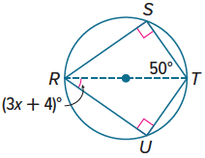
39. TAPESTRY Helga is creating a design for a tapestry she is making for her art class. The design shown uses a kite inscribed in a circle. Find m∠SRU and find the value of x.

ANALYZE Determine whether the quadrilateral can always, sometimes, or never be inscribed in a circle. Justify your argument.
40. square 41. rectangle 42. parallelogram 43. rhombus 44. kite

45. PERSEVERE A square is inscribed in a circle. What is the ratio of the area of the circle to the area of the square?

46. WRITE A 45°-45°-90° right triangle is inscribed in a circle. If the radius of the circle is given, explain how to find the lengths of the legs of the triangle.

47. CREATE Draw an inscribed polygon. Then find the measure of each intercepted arc.

48. WRITE Compare and contrast inscribed angles and central angles of a circle. If they intercept the same arc, how are they related?

ANALYZE Determine whether each statement is always, sometimes, or never true. Justify your argument.
49. If $\hat{PQR}$ is a major arc of a circle, then ∠PQR is obtuse.

50. If $\overline{AB}$ is a diameter of circle O, and X is any point on circle O other than A or B, then $△$AXB is a
right triangle.

51. When an equilateral triangle is inscribed in a circle it partitions the circle into three minor arcs that each measure 120°.

