Tangents ⸱ Practice

Example 1
Identify the number of common tangents that exist between each pair of circles. If no common tangent exists, state no common tangent.
1. 2.


3. 4.

Example 2
Determine whether each segment is tangent to the given circle. Justify your answer.
5. $\overline{HI}$ 6. $\overline{AB}$
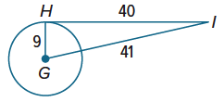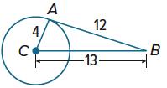

7. $\overline{MP}$ 8. $\overline{QR}$
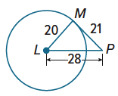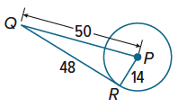
Example 3
Find the value of x. Assume that segments that appear to be tangent are tangent. Round your answer to the nearest hundredth, if needed.
9. 10. 11.
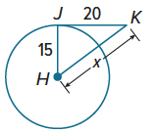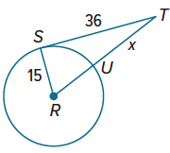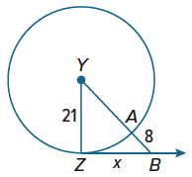
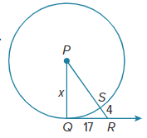
12. 13. 14.
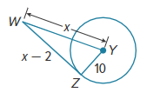
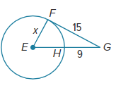

Example 4
Find the value of x. Assume that segments that appear to be tangent are tangent.
15. 16.
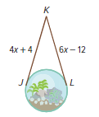
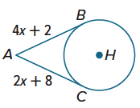
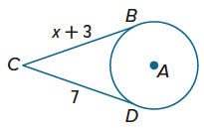
17. DECORATIONS Federico wants to hang a spherical terrarium using rope. $\overline{JK}$ and $\overline{LK}$ are tangent to the terrarium. If the lengths of the tangents are given in inches, how much rope is needed to hang the terrarium?
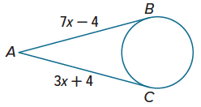
18. CARNIVAL GAMES Phoebe is playing a carnival game that involves tossing softballs into a wooden basket. She positions herself at point A so $\overline{AB}$ and $\overline{AC}$ are tangent to the basket. If the lengths of the tangents are given in feet, find AB.

Example 5
19. If m∠BDC = 12x° and m∠A = (4x + 4)°, 20. If m∠QPS= (15x + 8)° and m∠R = (10x ‒ 3)°,
find m∠A. find m∠R.
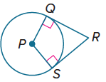
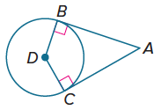

Example 6
Each polygon is circumscribed about a circle. Find the perimeter of each polygon.
21. 22. 23.
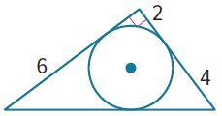
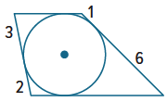
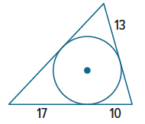

Each polygon is circumscribed about a circle. Find the value of x. Then find the perimeter of each polygon.
24. 25. 26.
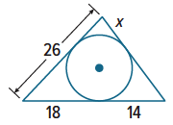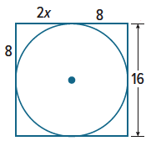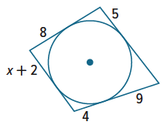

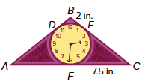
Mixed Exercises
27. REASONING The design shown in the figure is that of a circular clock face inscribed in a triangular base. AF and FC are equal.
a. Find AB.
b. Find the perimeter of the clock.

PROOF Write a two-column proof to prove each theorem.
28. Theorem 10.12
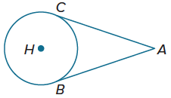
Given: $\overline{AC}$ is tangent to ⊙H at C.
$\overline{AB}$ is tangent to ⊙H at B.
Prove: $\overline{AC}≅\overline{AB}$

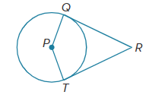
29. Theorem 10.13
Given: $\overline{RQ}$ is tangent to ⊙P at Q.
$\overline{RT}$ is tangent to ⊙P at T.
Prove: $m∠P+m∠R=180°$

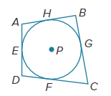
30. PROOF Write a two-column proof.
Given: Quadrilateral ABCD is circumscribed about $⨀P$.
Prove: $AB+CD=AD+BC$

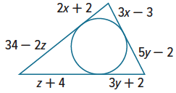
31. JEWELRY Joan is designing a pendant with a circular gem inscribed in a triangle.
a. Find the values of x, y, and z.

b. Find the perimeter of the triangle.

PRECISION Find the value of x to the nearest hundredth. Assume that segments that appear to be tangent are tangent.
32. 33.
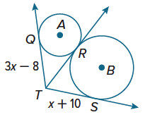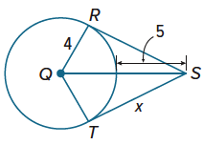

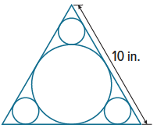
34. DESIGN Ignacio wants to make a design of circles inside an equilateral triangle as shown.
a. What is the radius of the large circle to the nearest hundredth of an inch?

b. What are the radii of the smaller circles to the nearest hundredth of an inch?

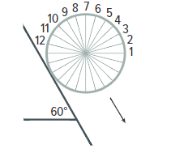
35. PERSEVERE A wheel is rolling down an incline as shown in the figure at the right. Twelve evenly spaced radii form spokes of the wheel. When spoke 2 is vertical, which spoke will be perpendicular to the incline?

36. USE TOOLS Construct a line tangent to a circle through a point on the circle.
Use a compass to draw ⊙A. Choose a point P on the circle and draw $\overset{⃡}{AP}$. Then construct a segment through point P perpendicular to $\overset{⃡}{AP}$. Label the tangent line t. Justify each step.

37. USE A MODEL NASA has procedures for limiting orbital debris to mitigate the risk to human life and space missions. Orbital debris refers to materials from space missions that still orbit Earth. Suppose an ammonia tank is accidentally discarded from a spacecraft at an altitude of 435 miles. What is the distance from the tank to the farthest point on Earth’s surface from which the tank is visible? Assume that the radius of Earth is 4000 miles. Round your answer to the nearest mile. Draw a diagram to represent this situation
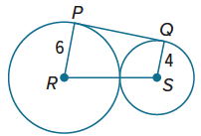
38. PERSEVERE $\overline{PQ}$ is tangent to circles R and S. Find PQ. Explain your reasoning.

39. WHICH ONE DOESN’T BELONG Which of the polygons shown below is not circumscribed? Justify your conclusion.
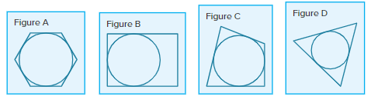

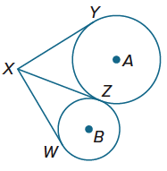
40. CREATE Draw a circumscribed triangle and an inscribed triangle.

41. ANALYZE In the figure, $\overline{XY}$ and $\overline{XZ}$ are tangent to ⊙A. $\overline{XZ}$ and $\overline{XW}$ are tangent to ⊙B. Explain how segments $\overline{XY}$, $\overline{XZ}$, and $\overline{XW}$ can all be congruent if the circles have different radii.

42. WRITE Is it possible to draw a tangent from a point that is located anywhere outside, on, or inside a circle? Explain.

