Tangents, Secants, and Angle Measures ⸱ Practice

Example 1
Find each measure.
1. $m∠2$ 2. m∠1 3. m$\hat{GH}$
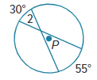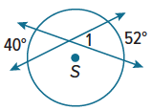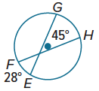

4. m∠5 5. m∠1 6. m∠2
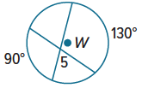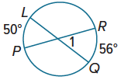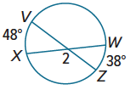

Example 2
Find each measure. Assume that segments that appear to be tangent are tangent.
7. $m∠1$ 8. m∠3 9. m$\hat{RT }$
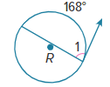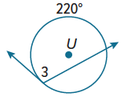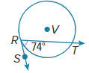

10. m∠6 11. m∠3 12. m∠4
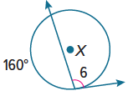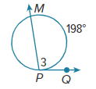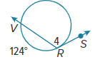

Example 3
Find each measure. Assume that segments that appear to be tangent are tangent.
13. m∠R 14. m∠U 15. m$\hat{DPA}$
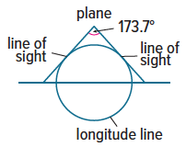
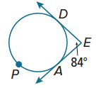
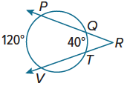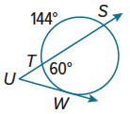

16. FLIGHT When a plane is flying at an altitude of 5 miles, the lines of sight to the horizon looking north and south make about a 173.7° angle. What portion of the longitude line is visible from 5 miles high?

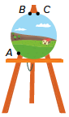
Mixed Exercises
17. REASONING Salvador places a circular canvas on his A-frame easel and carefully centers it. The apex of the easel forms a 30° angle and $m\hat{BC}=22°$. What is $m\hat{AB}$?

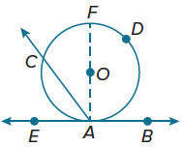
18. PROOF Write a paragraph proof for each part of Theorem 10.15.
a. Given: $\overset{⃡}{AB}$ is a tangent of ⊙O.
$\vec{AC}$ is a secant of ⊙O.
$∠CAE$ is acute.
Prove: m∠CAE = $\frac{1}{2}m\hat{CA}$
b. Prove that if $∠CAB$ is obtuse, m$∠CAB$ = $\frac{1}{2}m\hat{CDA}$.

REASONING Find the value of x.
19. 20. 21.
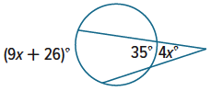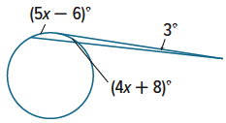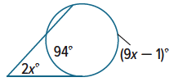

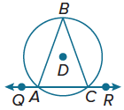
22. ANALYZE Isosceles △ABC is inscribed in ⊙D. What can you conclude about $m\hat{AB}$ and $m\hat{BC}$? Explain.

23. WRITE Explain how to find the measure of an angle formed by a secant and a tangent that intersect outside a circle.

24. CREATE Draw a circle and two tangents that intersect outside the circle. Use a protractor to measure the angle that is formed. Find the measures of the minor and major arcs formed. Explain your reasoning.

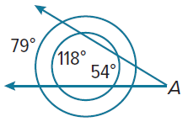
25. PERSEVERE The circles shown are concentric. What is the measure of $∠$A?

26. WRITE A circle is inscribed within △PQR. If m$∠P$ = 50° and m$∠Q$ = 60°, describe how to find the measures of the three minor arcs formed by the points of tangency.

