Areas of Quadrilaterals ⸱ Practice

Examples 1, 2, 4–6
Find the area of each parallelogram, trapezoid, rhombus, or kite. Round to the nearest tenth,
if necessary.
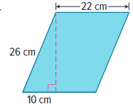
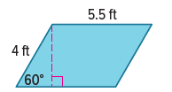
1. 2. 3.

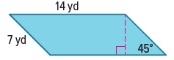
4. 5. 6.
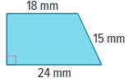

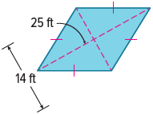
7. 8. 9. 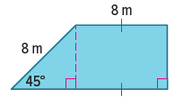 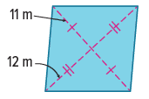

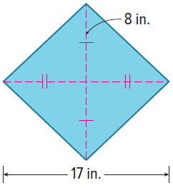
10. 11. 12.
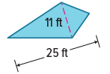

23.

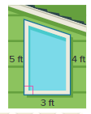
Example 3
13. CONSTRUCTION A contractor is replacing a trapezoidal window on the front of a house.
a. Find the area of the window.
b. If the glass for the window costs $7 per square foot, about how much should the contractor expect to pay to replace the window?
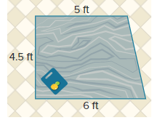
14. HOME IMPROVEMENT Iker is building an island for his kitchen in the shape of a trapezoid as shown.
a. What is the area of the top surface of the island?
b. The island will be made of granite which costs $65 per square foot. Approximately how much will the granite cost?

Example 7
15. The area of a rhombus is 168 square centimeters. If one diagonal is three times as long as the other, what are the lengths of the diagonals to the nearest tenth of a centimeter?

16. A trapezoid has base lengths of 12 and 14 feet with an area of 322 square feet. What is the height of the trapezoid?

17. A trapezoid has a height of 8 meters, a base length of 12 meters, and an area of 64 square meters. What is the length of the other base?

18. The height of a parallelogram is 10 feet more than the length of the base. If the area of the parallelogram is 1200 square feet, find the length of the base and the height.

19. A trapezoid has base lengths of 4 and 19 feet, and an area of 115 square feet. What is the height of the trapezoid?

20. One diagonal of a kite is twice as long as the other diagonal. If the area of the kite is 240 square inches, what are the lengths of the diagonals?

21. One diagonal of a kite is four times as long as the other diagonal. If the area of the kite is
72 square meters, what are the lengths of the diagonals?

Mixed Exercises
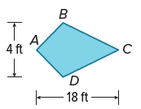
22. REASONING Meghana is making a kite out of nylon. The material is sold for $5.99 per square yard. She needs enough material to cover her kite on both sides.
a. What is the area of Meghana’s kite?
b. How many yards of material will Meghana need to cover both sides of her kite?
c. How much will the material cost before taxes?

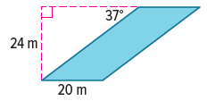
23. DESIGN An architect is planning to build an office with a glass façade in the shape of a parallelogram using the given measurements. How much glass will be needed to cover this structure?

24. The diagonal of a square is 6$\sqrt{2}$ inches. What is the area of the square?

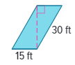
25. SHADOWS A rectangular billboard casts a shadow on the ground in the shape of a parallelogram. What is the area of the ground covered by the shadow? Round your answer to the nearest tenth.

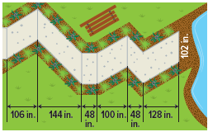
26. PATHS The concrete path shown is made by joining several parallelograms. What is the total area of the path?

Find the area of each quadrilateral with the given vertices.
27. A(–8, 6), B(–5, 8), C(–2, 6), and D(–5, 0)

28. W(3, 0), X(0, 3), Y(–3, 0), and Z(0, –3)

29. REGULARITY Given the area of a geometric figure, describe the method you use to solve for a missing dimension.

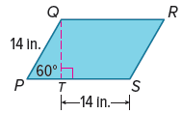
30. PRECISION Refer to parallelogram PQRS.
a. Explain how a 30°-60°-90° triangle can be used to find the area of parallelogram PQRS.

b. Find the area of parallelogram PQRS to the nearest tenth.


31. STRUCTURE For Bruno’s birthday, he got a cake shaped like a kite. He cuts the cake along the diagonals to form 4 pieces. The diagonals are 6 inches and 10 inches long. Which piece(s) is the largest? What is the area of the top of the cake?

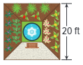
32. GARDENS A square landscape plan is composed of three indoor gardens and one walkway that are all congruent. The gardens are centered around a square lounging area. If each side of the lounging area is 15 feet long, what is the area of one of the gardens?

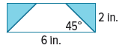
33. STRUCTURE A trapezoid is cut from a rectangle that is 6 inches long and 2 inches wide. The length of one base of the trapezoid is 6 inches. What is the area of the trapezoid?

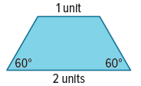
34. REASONING Tile making often requires an artist to find clever ways of dividing a shape into several smaller, congruent shapes. Consider the isosceles trapezoid shown at the right. The trapezoid can be divided into
3 congruent triangles. What is the area of each triangle?

35. ANALYZE Will the perimeter of a nonrectangular parallelogram sometimes, always, or never be greater than the perimeter of a rectangle with the same area and the same height? Justify your argument.

36. FIND THE ERROR Armando and Niran want to draw a trapezoid that has a height of 4 units and an area of 18 square units. Armando says that only one trapezoid will meet the criteria. Niran disagrees and thinks that she can draw several different trapezoids with a height of 4 units and an area of 18 square units. Who is correct? Explain your reasoning.

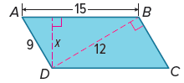
37. PERSEVERE Find x in parallelogram ABCD.

38. CREATE Draw a kite and a rhombus with an area of 6 square inches. Label and justify your drawings.

39. ANALYZE If the areas of two rhombi are equal, are the perimeters sometimes, always, or never equal? Justify your argument.

40. WRITE How can you use trigonometry to find the area of a figure?

