Areas of Regular Polygons ⸱ Practice

Example 1
In each figure, a regular polygon is inscribed in a circle. Identify the center, a radius, an apothem, and a central angle of each polygon. Then find the measure of a central angle.
1. 2.
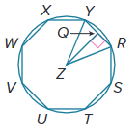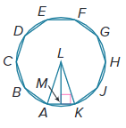
Example 2
Find the area of each regular polygon. Round to the nearest tenth.
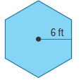
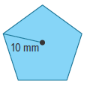
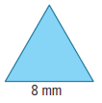
3. 4. 5.

6. COINS The Susan B. Anthony dollar coin has a hendecagon (11-gon) inscribed in a circle in its design. Each edge of the hendecagon is approximately 7.46 millimeters. What is the area of this regular polygon? Round to the nearest hundredth.

7. RECREATION A regular octagonal trampoline has a diameter of 16 feet. What is the area of the surface of the trampoline? Round to the nearest tenth.

Examples 3 and 4
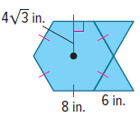
Find the area of each figure. Round to the nearest tenth, if necessary.
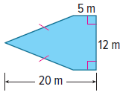
8. 9. 10.
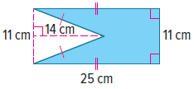

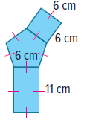
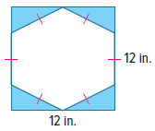
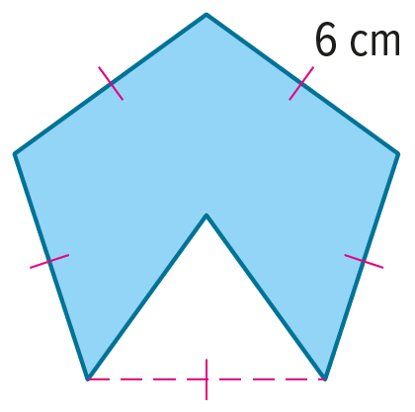
11. 12. 13.

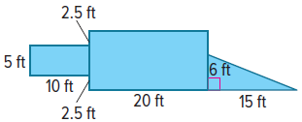
Mixed Exercises
14. LAWN Lalita has to buy grass seed for her lawn. Her lawn is in the shape of the composite figure shown. What is the area of the lawn?

15. PATIO Chenoa is building a patio to surround his fire pit. The patio is in the shape of the composite figure shown. If each side of the fire pit is 2 feet long, how many square feet of patio pavers will Chenoa need to buy to complete the patio? Round to the nearest tenth.

16. Find the area of a regular hexagon with a perimeter of 72 inches. Round to the nearest square inch.

17. USE TOOLS Draw a regular pentagon inscribed in a circle with center of X, a radius of $\overline{XV}$, an apothem of $\overline{XY}$, and a central angle of $∠$VXT that measures 72$°$.

18. Find the perimeter and area of a regular hexagon with a side length of 12 centimeters. Round to the nearest tenth, if necessary.
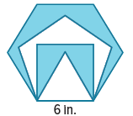

19. Find the total area of the shaded regions. Round to the nearest tenth, if necessary.

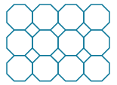
20. HOME IMPROVEMENT Pilar is putting a backsplash in her kitchen made up of octagon and square tiles. The pattern she has chosen is sold in sheets of 4 × 3 octagons as shown. The side length of both the squares and the octagons is 3 centimeters.

a. Draw one octagon and one square. Label the side length and area of each and the apothem of the octagon. Find the area of one tile sheet to the nearest whole number.

b. Small square tiles will be placed to fill the nooks around the edges of the tile
sheet. How many complete squares will be needed? What is the additional
area of these tiles?

c. If Pilar’s backsplash measures 42 centimeters by 84 centimeters, approximately how many sheets of tile will Pilar need to purchase? How many extra square tiles will need to be purchased?

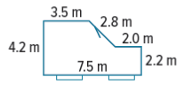
21. REASONING Miguel is planning to renovate his living room. Refer to the given floor plan.
a. How much varnish will he need to stain the hardwood floor? Assume 1 liter of finish covers 4.5 square meters and round to the nearest tenth.

b. The height of the room is 2.6 meters. Approximate how much paint is needed for the walls. Assume that 1 liter of paint covers 7.5 square meters and round to the nearest tenth.

c. Why might Miguel adjust your estimates when he purchases materials?

22. STATE YOUR ASSUMPTION Chilam is going to build a shelf for his 15 homerun baseballs. He wants the shelf to be in the shape of a regular triangle. Find the area of the shelf he must create. State any assumptions you make. Round your answer to the nearest tenth.

23. USE A SOURCE Research the shape and dimensions of the Pentagon building in Arlington, Virginia.
a. Draw and label a diagram of the Pentagon including the courtyard.

b. Use your diagram in part a to find the area in square feet of the Pentagon. Round your answer to the nearest tenth.

24. REGULARITY Explain how using the formula for the area of a regular polygon is related to finding the area of a triangle.

25. SIGNS A stop sign has side lengths of approximately 12.5 inches. What is the area of a regular octagonal stop sign? Round your answer to the nearest tenth.


26. DIAMONDS Mr. Figueroa has bought his wife an anniversary ring with a regular heptagon diamond as shown. If each side of the diamond is 6 millimeters long, what is the area of the face of the diamond?

27. ARCHITECTURE Fort Jefferson in the Florida Keys is the largest brick masonry building in the Americas. The Fort was built in the shape of a hexagon with side lengths of 477 feet. What
is the area of the hexagon formed by the exterior walls of the fort? Round your answer to the nearest tenth.

28. FRAME Darren is hanging a picture frame that is shaped like a regular pentagon with outside side lengths of 9 inches. What is the area this picture frame will take up on Darren’s wall? Round your answer to the nearest tenth.

29. FLOWER Delfina photographed a triangular flower for a photo contest. The flower was approximately regular and had side lengths measuring about 4 centimeters. What is the area of the flower? Round your answer to the nearest tenth.

30. STAINED GLASS Kenia makes regular octagonal-shaped stained glass windows. If the apothem of the window is 14 inches, what is the area of the window? Round your answer to the nearest tenth.

31. GAMING A 12-sided gaming die is made up of 12 regular pentagons, each with a side length of 1.5 centimeters. What is the area of one face of the gaming die? Round your answer to the nearest hundredth.

32. HONEYCOMB A honeycomb is a structure bees make of hexagonal wax cells to contain honey, larvae, and pollen. The height of one hexagon in a honeycomb is approximately 5 millimeters. What is the area of one hexagon? Round your answer to the nearest tenth.

33. FIND THE ERROR Chenglei and Flavio want to find the area of the hexagon shown. Who is correct? Explain your reasoning.
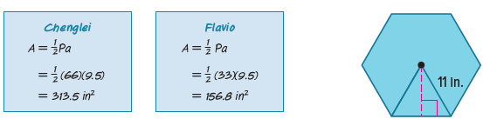
34. ANALYZE Is the measure of an apothem of a regular polygon sometimes, always, or never $\frac{\sqrt{3}}{2}s$ where s is a side length of the polygon? Justify your argument.

35. CREATE Draw a pair of composite figures that have the same area. Make one composite figure out of a rectangle and a trapezoid, and make the other composite figure out of a triangle and a rectangle. Show the area of each basic figure.

36. PERSEVERE Consider the sequence of area diagrams shown. What algebraic theorem do the diagrams prove? Explain your reasoning.
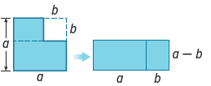

37. WRITE How can you find the area of any figure?

38. WHICH ONE DOESN’T BELONG? Alden drew the following diagrams to find the area of 4 regular polygons. Which drawing is incorrect. Justify your conclusion.
