Areas of Circles and Sectors ⸱ Practice
Example 1
Find the area of each circle. Round to the nearest tenth.
1. 2. 3.

4. DINING Maricela is making a tablecloth for a circular table that has a diameter of 8 feet.
a. Find the area of the tabletop. Round your answer to the nearest tenth.

b. If a square yard of fabric costs $13.99, what is the minimum Maricela will need
to spend to make the tablecloth?

5. GAMES Kiyoshi is making circular tiles to display houses for his role-playing game. Each tile has a radius of 2 inches and is being made out of balsa wood that costs $1.99 per square foot.
a. Find the area of a single tile. Round your answer to the nearest tenth.

b. How much will it cost Kiyoshi to make 30 tiles?

6. PORTHOLES A circular window on a ship is designed with a radius of 8 inches. What is the area of glass needed for the window? Round your answer to the nearest hundredth.

Example 2
Find the indicated measure. Round to the nearest tenth.
7. Find the diameter of a circle with an area of 94 square millimeters.

8. The area of a circle is 132.7 square centimeters. Find the diameter of the circle.

9. The area of a circle is 112 square inches. Find the radius of the circle.

10. Find the diameter of a circle with an area of 1134.1 square millimeters.

11. The area of a circle is 706.9 square inches. Find the radius of the circle.

12. Find the radius of a circle with an area of 2827.4 square feet.

Example 3
Find the area of each shaded sector. Round to the nearest tenth.
13. 14. 15.

16. SPINNERS Jeremy wants to make a spinner for a new board game he invented. The spinner is a circle divided into 8 congruent pieces. What is the area of each piece to the nearest tenth?

Example 4
Find the area of the circle that contains each sector. Round to the nearest tenth, if necessary.
17. One sector has an area of 210 square centimeters and an arc measure of 30°.

18. One sector has an area of 65 square feet and an arc measure of 270°.

19. One sector has an area of 325 square millimeters and an arc measure of 72°.

20. One sector has an area of 167 square inches and an arc measure of 110°.

21. One sector has an area of 98 square meters and an arc measure of 40°.

22. One sector has an area of 412 square inches and an arc measure of 82°.

Mixed Exercises
23. LOBBY The lobby of a bank features a large marble circular table for displaying brochures.
a. The diameter of the circle is 15 feet. What is the area of the circular table? Round your answer to the nearest tenth.

b. If the bank manager adds a floral arrangement with a diameter of 2 feet, how much space remains for brochure displays?

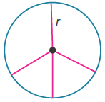
24. STRUCTURE A stained-glass artist is making a circle separated into 3 equal sectors with the bottom sector divided equally in two. Suppose the circle has radius r. What is the area of each of the larger equal sectors?

25. SOUP CAN Jaclynn needs to cover the top and bottom of a can of soup with construction paper to include in her art project. Each circle has a diameter of 7.5 centimeters. What is the total area of the can that Jaclynn must cover?

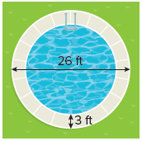
26. POOL A circular pool is surrounded by a circular sidewalk. The circular sidewalk is 3 feet wide. The diameter of the sidewalk and the pool is 26 feet.

a. What is the diameter of the pool?

b. What is the area of the sidewalk and pool?

c. What is the area of the pool?

27. REASONING Explain how to find the area of the shaded region. Then find the area of the shaded region. Round to the nearest tenth, if necessary.

28. REGULARITY A sector of a circle has an area A and a central angle that
measures x°. Explain how you can find the area of the whole circle.

29. PIE One sector of an apple pie has an area of 8 square inches and an arc measure of 45°. Find the area of the pie.

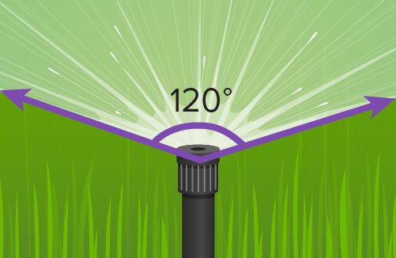
30. USE ESTIMATION A lawn sprinkler sprays water in an arc as shown in the picture. The area of the sector covered by the spray is approximately 235.6 square feet.

a. Estimate the area of the yard that can be covered by the sprinkler if the
sprinkler is set to water a complete circle.

b. Find the exact area covered by the sprinkler.

c. Is your answer reasonable? Justify your argument.

31. PRECISION Luciano wants to use sectors of different circles as part of a mural he is painting. The specifications for each sector are shown.
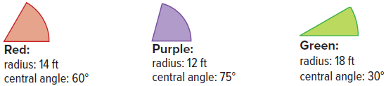
a. Find the area of each sector to the nearest tenth.

b. Was the sector with the largest area the one with the longest radius? Was it the one with the largest central angle? What can you conclude from this?

c. Luciano plans to paint 235 stars on each of the purple sectors and 153 stars on each of the green sectors. To the nearest tenth, how many stars are there per square foot for sectors of each color?

d. Luciano also plans to paint stars on the red sectors. He wants there to be twice as many stars per square foot in the red sectors as there are in the green sectors. How many stars should he paint on each red sector? Round to the nearest whole star.

32. FIND THE ERROR Ketria and Colton want to find the area of a shaded region in the circle shown. Who is correct? Explain your reasoning.

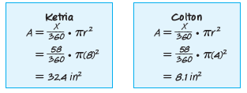
33. PERSEVERE Find the area of the shaded region. Round to the nearest tenth.

34. ANALYZE A segment of a circle is the region bounded by an arc and a chord. Is the area of a sector of a circle sometimes, always, or never greater than the area of its corresponding segment? Justify your argument.

35. WRITE Describe two methods you could use to find the area of the shaded region of the circle. Which method do you think is more efficient? Explain your reasoning.

36. PERSEVERE Derive the formula for the area of a sector of a circle using the formula for
arc length.

37. CREATE Draw a circle with a shaded sector. Label the length of the radius and the measure of the arc intercepted by the sector. Then find the area of the shaded sector.

