Surface Area ⸱ Practice

Examples 1, 2, 4, and 5
Find the lateral area and surface area of each solid. Round to the nearest tenth, if necessary.
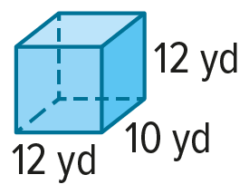
1. 2. 3.

4. 5. 6.

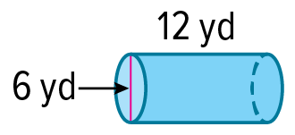
7. 8. 9.

10. 11. 12.

Examples 3 and 6
13. PAINTING Greg is painting the four walls of his bedroom and the ceiling.
a. If the height of the walls is x and the edge length of the square ceiling is 2x, approximate the surface area Greg will be painting in terms of x.
b. Approximate the surface area that will be painted to the nearest tenth if x = 8 feet.

14. MANUFACTURING A food distribution manufacturer is developing a new cylindrical package with a cardboard bottom and sides and a plastic lid. They are evaluating the cost of manufacturing based on the amount of cardboard used.
a. If the radius of the package is x and the height is x + 4, approximate the surface area of the package that will be cardboard in terms of x and $π$.
b. Approximate the surface area of the package that will be cardboard to the nearest tenth if
x = 6 centimeters.

15. CAMPING A company that manufactures camping gear is designing a new tent shaped like a square pyramid with sidewalls made of a waterproof material.
a. If the base of the tent is x units long and the slant height of the walls is 1.5x units, approximate the surface area of the sidewalls in terms of x.
b. Approximate the amount of material needed to manufacture the sidewalls if x = 9 feet.

16. TOPIARY Davea is planning to prune her landscaping bushes into topiaries shaped like cones.
a. The radius of the bush is $\frac{1}{2}$x units and the slant height is 4x units. Approximate the lateral area of one topiary in terms of x and $π$.
b. A frost is expected, and Davea is making plastic slipcovers to protect her new topiaries. Approximate the surface area of one slipcover to the nearest tenth if the slipcover does not cover the base and x = 0.75 meter.

Example 7
Find the surface area of each sphere to the nearest tenth.
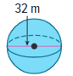
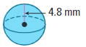
17. 18. 19.

20. MOONS OF SATURN The planet Saturn has several moons, and they can be modeled accurately by spheres. Saturn’s largest moon, Titan, has a radius of about 2575 kilometers. What is the approximate surface area of Titan? Round your answer to the nearest tenth.

Example 8
21. AMUSEMENT PARK Spaceship Earth at Disney’s Epcot Center is a sphere. If the circumference of Spaceship Earth is $C=7πx^{2}$, find the surface area in terms of $x$ and $π$.

22. BILLIARDS If the circumference of an eight-ball is $C=4πx$, find the surface area in terms of $x$ and $π$.

Example 9
Find the surface area of each figure to the nearest tenth.
23. 24.

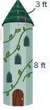

25. THEATER Carlos is building a prop for the school play, and he needs to calculate the amount of lumber needed to make it. The prop is shaped like a tower and the radius of the base of the tower is 2.5 feet. If the tower is hollow and has no base, what is the approximate surface area of the tower? Round your answer to the nearest tenth.

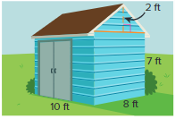
Mixed Exercises
26. STATE YOUR ASSUMPTION Maddie is painting the shed in her backyard. Approximate the surface area of the shed that will be painted. Explain any assumptions that you make.

27. STRUCTURE A cylinder has a lateral area of 120π square meters, and a height of 7 meters. Find the radius of the cylinder. Round to the nearest tenth.

For Exercises 28-32, find the lateral area and surface area of each solid. Round to the nearest tenth, if necessary.
28. a triangular prism with height of 6 inches, right triangle base with legs of 9 inches and 12 inches

29. a square pyramid with an altitude of 12 inches and a slant height of 18 inches

30. a hexagonal pyramid with a base edge of 6 millimeters and a slant height of 9 millimeters

31. a cone with a diameter of 3.4 centimeters and a slant height of 6.5 centimeters

32. a cone with an altitude of 5 feet and a slant height of 9$\frac{1}{2}$ feet

33. The great circle of a sphere lies on a plane that passes through the center of the circle. The diameter of a sphere’s great circle is the diameter of the sphere.
a. Find the surface area of a sphere with a great circle that has a circumference of 2$π$ centimeters. Round to the nearest tenth, if necessary.

b. Find the surface area of a sphere with a great circle that has an area of about 32 square feet. Round to the nearest tenth, if necessary.

34. GREENHOUSE Reina’s greenhouse is shaped like a square pyramid with four congruent equilateral triangles for its sides. All of the edges are 6 feet long. What is the total surface area of the greenhouse including the floor? Round your answer to the nearest hundredth.

35. PAPER MODELS Prevan is making a paper model of a castle. Part of the model involves cutting out the net shown and folding it into a pyramid. The pyramid has a square base. What is the surface area of the resulting pyramid?

36. CAKES A cake is a rectangular prism with a height of 4 inches and a base that is 12 inches by 15 inches. Wallace wants to apply frosting to the sides and the top of the cake. What is the surface area of the part of the cake that will have frosting?

37. CONSTRUCTION A metal pipe is shaped like a cylinder with a height of 50 inches and a radius of
6 inches. What is the surface area of the pipe? Round your answer to the nearest tenth.

38. INSTRUMENTS A mute for a brass instrument is formed by taking a solid cone with a radius of 10 centimeters and an altitude of 20 centimeters and cutting off the top. The cut is made along a plane that is perpendicular to the altitude of the cone and intersects the altitude 6 centimeters from the vertex. Round your answers to the nearest hundredth.
a. What is the surface area of the original cone?

b. What is the surface area of the cone that is removed?

c. What is the surface area of the mute?
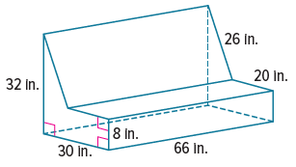
39. USE A MODEL The model shows the dimensions of a sofa.
a. Draw a diagram to show how to calculate the total surface area of the sofa that would be covered by a fitted cover. Explain your technique.

b. How much fabric is needed for a fitted sofa cover?

40. REASONING Jaylen builds a sphere inside of a cube. The sphere fits snugly inside the cube so that the sphere touches the cube at one point on each face. The length of each edge of the cube is 2 inches.
a. What is the surface area of the cube?

b. What is the surface area of the sphere? Round your answers to the
nearest hundredth.

c. What is the ratio of the surface area of the cube to the surface area of
the sphere? Round your answer to the nearest hundredth.

41. CONSTRUCT ARGUMENTS A cone and a square pyramid have the same surface area. If the areas of their bases are also equal, do they have the same slant height as well? Justify your argument.

42. ANALYZE Classify the following statement as sometimes, always, or never true. Justify
your argument.
The surface area of a cone of radius r and height h is less than the surface area of a cylinder of radius r and height h.
43. WRITE Compare and contrast finding the surface area of a prism and finding the surface area of a cylinder.
44. CREATE Give an example of two cylinders that have the same lateral area and different surface areas. Find the lateral area and surface areas of each cylinder.
45. PERSEVERE A right prism has a height of h units and a base that is an equilateral triangle with a side length of $l$ units. Find the general formula for the total surface area of the prism. Explain your reasoning.
46. WRITE A square prism and a triangular prism are the same height. The base of the triangular prism is an equilateral triangle, with an altitude equal in length to the side of the square. Compare the lateral areas of the prisms.

