Cross Sections and Solids of Revolution ⸱ Practice
Example 1
Describe each plane of symmetry for each solid.
1. 2. 3.

Example 2
Identify the shape of each cross section.
4. 5.
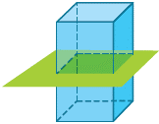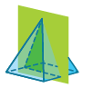

6. 7.
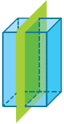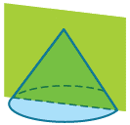

Example 3
Identify the solid formed by rotating the two-dimensional shape about each line.
8. 9.

10. 11.
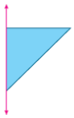

Example 4
Determine whether each item has axis symmetry. Write yes or no.
12. traffic cone with a base 13. one pound weight 14. flower petal and stem
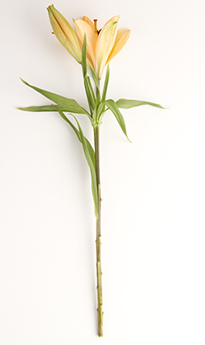


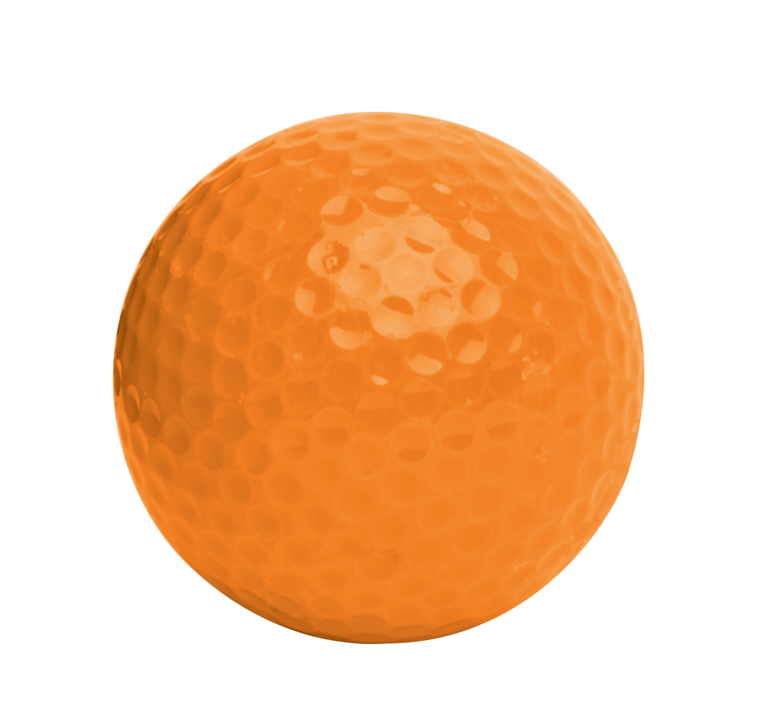

15. golf ball 16. tree 17. lamp


Mixed Exercises
For Exercises 18 and 19, refer to the solid at the right.
18. Name the shape of the cross section cut parallel
to the base.

19. Name the shape of the cross section cut perpendicular to the base.

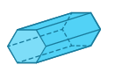
20. Sketch the cross section from a vertical slice of the solid shown at the right.

21. Reshan rotated a semicircle about a vertical axis to create a sphere. Describe another way Reshan could have rotated a semicircle about an axis to generate a sphere.

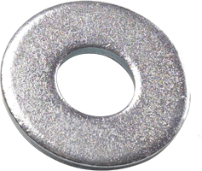
22. WASHER Consider the washer shown. Describe the two-dimensional shape and axis that could be used to generate the washer by rotating the two-dimensional shape around the axis.

23. TRIANGLES Sallie is going to rotate the right triangle around the axis shown. Describe a real-world object that could be generated.

24. REASONING The rectangle shown will be rotated about the x-axis.

a. Describe the three-dimensional shape that is generated.

b. What is the length of the radius and height of the
figure generated?

25. USE TOOLS Determine whether each cross section can be made from a cube. If so, sketch the cube and its cross section.

a. triangle b. square c. rectangle

d. pentagon e. hexagon f. octagon

26. USE A SOURCE Research the shape and dimensions of the Washington Monument.

a. Describe each plane of symmetry of the Washington Monument.

b. Describe the cross section of the Washington Monument from a vertical slice perpendicular to the base through the vertex.

c. Determine if the Washington Monument has axis symmetry. Write yes or no.

For Exercises 27 and 28, identify and sketch the cross section of an object made by each cut described.
27. square pyramid cut perpendicular to 28. rectangular prism cut diagonally from a top
base but not through the vertex edge to a bottom edge on the opposite side
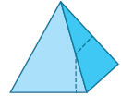

29. You want to cut each geometric object so that the cross section is a circle. Give the name for each object. Then describe the cut that results in a circle.
a. b. c.

30. USE TOOLS Sketch and describe the object that is created by rotating each shape around the indicated axis of rotation.
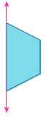
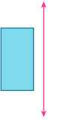
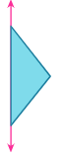
a. b. c.

31. CONSTRUCT ARGUMENTS A regular polyhedron has axis symmetry of order 3, but does not have plane symmetry. What is the figure? Justify your argument.

32. PERSEVERE The figure at the right is a cross section of a geometric solid. Describe a solid and how the cross section was made.

33. WRITE A hexagonal pyramid is sliced through the vertex and the base so that the prism is separated into two congruent parts. Describe the cross section. Is there more than one way to separate the figure into two congruent parts? Will the shape of the cross section change? Explain.

34. CREATE Sketch a real-world object that has plane symmetry, but not axis symmetry.

35. ANALYZE Determine whether the statement below is true or false. Justify your argument.
The only two shapes formed by the cross sections of a square pyramid are a triangle and a square.

