Volumes of Prisms and Pyramids ⸱ Practice

Examples 1, 2, and 4
Find the volume of each prism or pyramid. Round your answer to the nearest tenth, if necessary.
1. 2. 3.

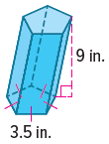
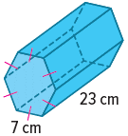
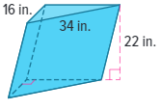
4. 5. 6.

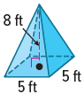
7. 8. 9.
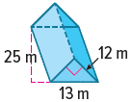

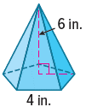
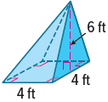
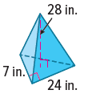
10. 11. 12.

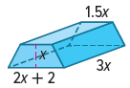
Example 3
13. CHOCOLATE Leah wants to calculate the volume of chocolate in her candy bar.
a. Find the volume of the candy bar in terms of x.

b. Find the volume of the candy bar if x = 2 inches.

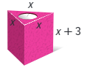
14. CANDLE Benton wants to calculate the volume of wax needed to make a candle.
a. Find the volume of the candle in terms of x.

b. Find the volume of the candle if x = 3 centimeters.

Example 5
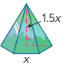
15. SAND ART Noelle wants to calculate the volume of sand needed to make
the art decoration within the regular hexagonal pyramid.
a. Find the volume of the sand art in terms of x.

b. Find the volume of the sand art if x = 5 inches. Round to the nearest tenth.
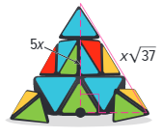
16. PUZZLE Roger bought a puzzle shaped like a pyramid. The base of the puzzle is a square and the height of the puzzle is 5x units. In the figure, the shorter leg of the triangle shown connects the center of the base to a vertex of the base.
a. Find the volume of the pyramid in terms of x.

b. Find the volume of the pyramid if x = 10 centimeters.

Example 6
Find the volume of each composite solid. Round to the nearest tenth, if necessary.
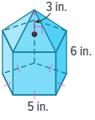
17. 18. 19.

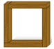
Example 7
20. FRAMES Margaret makes a square frame out of four pieces of wood. Each piece of wood is a rectangular prism with a length of 40 centimeters, a height of 4 centimeters, and a depth of 6 centimeters. What is the total volume of the wood used in the frame?

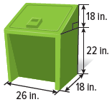
21. PARKS Grimby Park is installing new animal-proof trashcans. Approximate the volume of the trashcan.

Mixed Exercises
22. A rectangular prism has a length of 16 feet, a width of 9 feet, and a height of 8 feet. Find the volume of the prism.

23. A pyramid has a height of 18 centimeters and a base with an area of 26 square centimeters. Find the volume.

24. BENCH Inside a lobby, there is a bench shaped like a simple block with square base that measures 6 feet on each side. The height of the bench is 1$\frac{3}{5}$ feet. What is the volume of the bench?

25. TUNNELS Construction workers are digging a tunnel through a mountain. The space inside the tunnel is going to be shaped like a rectangular prism. The mouth of the tunnel will be a rectangle 20 feet high and 50 feet wide, and the length of the tunnel will be 900 feet. What volume of rock must be removed to make the tunnel?

26. GREENHOUSES A greenhouse has the shape of a square pyramid. The base has a side length of 30 yards. The height of the greenhouse is 18 yards. What is the volume of the greenhouse?

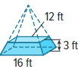
27. STAGES A solid wooden stage is made out of oak, which has a weight of about 45 pounds per cubic foot. The stage has the form of a square pyramid with the top sliced off along a plane parallel to the base. The side length of the top square is 12 feet, and the side length of the bottom square is 16 feet. The height of the stage is 3 feet.

a. What is the volume of the entire square pyramid from which the stage is made?

b. What is the volume of the top of the pyramid that is removed to create the stage?

c. What is the volume of the stage?

d. What will be the weight of the stage?

28. PRECISION Refer to the prisms.

- What is the volume of the triangular prism?

- What is the volume of the rectangular prism?

c. Discuss how the formulas that you used to find the volume of each prism are similar.

29. USE A MODEL Benjamin finds that baking soda has a mass of 2.2 grams per cubic centimeter, and corn flakes have a mass of 0.12 gram per cubic centimeter. A box of baking soda is 8 centimeters long by 4 centimeters wide by 12 centimeters high. The dimensions for a box of corn flakes are 30 centimeters long by 6 centimeters wide by 35 centimeters high. Benjamin wants to find the mass of the contents of each box if each box is filled to within 2 centimeters of the top.

a. How can Benjamin determine the mass of the contents of each box?

b. Find the mass of the contents of each box.

30. STRUCTURE A model pyramid has a volume of 270 cubic feet and a base area of 90 square feet. What is the height if the pyramid is a right pyramid? What is the height if the pyramid is an oblique pyramid? Explain your reasoning.

31. REASONING Tristan makes and sells sugar-free candies. He packages them in square pyramid-shaped boxes with a height of 3 inches and a base that has a side length of 2 inches. He sells each box for $2.00.
a. What is the volume of sugar-free candies in each box? What is the price per cubic inch?
b. Tristan wants to make a bigger package by doubling the lengths of the sides of the square base. How can he figure out how much to charge if he wants to keep the price per cubic inch the same?
c. Tristan wants to design a box in the shape of a square pyramid that
holds between 7 and 8 cubic inches of sugar-free candies. He wants the height to be within 1$\frac{1}{4}$ inches of the length of each side of the square. What is one possible set of dimensions that he can use?

32. STRUCTURE Anisa is building a box in the shape of a right triangular prism for her magic act. She is making a secret compartment inside the box. The compartment will be a pyramid with base $△$ABE and vertex at point C. After the secret compartment has been made, how is the volume of the space remaining inside the box related to the volume of the secret compartment? Explain your reasoning.

33. FIND THE ERROR Francisco and Valerie each calculated the volume of an equilateral triangular prism with a height of 5 units and a base that has an apothem of 4 units. Who is correct? Explain your reasoning.
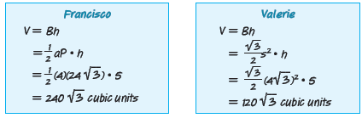

34. CREATE Give an example of a pyramid and a prism that have the same base and the same volume. Explain your reasoning.

35. ANALYZE Make a conjecture about how many pentagonal pyramids will fit inside a pentagonal prism of the same height. Justify your answer.

36. PERSEVERE Write an equation to find the dimensions of a composite solid composed of a cube with a square pyramid on top of equal height. If the volume is equal to 36 cubic inches, what are the dimensions of the solid?

