Volumes of Cylinders, Cones, and Spheres ⸱ Practice
Example 1
1. DISPOSAL The Meyer family uses a kitchen trash can shaped like a cylinder. It has a height of 18 inches and a base diameter of 12 inches. What is the approximate volume of the trash can? Round your answer to the nearest tenth of a cubic inch.

2. COFFEE A roasting company sells their coffee in canisters shaped like a cylinder. The radius of the cylinder is 1.5 inches and the height is 7.5 inches. What is the approximate volume of a coffee canister? Round your answer to the nearest cubic inch.

Example 2
3. Find the volume of a cylinder with a radius of 2x millimeters and a height of x – 2 millimeters.
a. Find the volume of the cylinder in terms of x and π.

b. Find the volume of the cylinder if x = 10. Round your answer to the nearest tenth.

4. Find the volume of a cylinder with a diameter that is 6 centimeters shorter than the height x.
a. Find the volume of the cylinder in terms of x and π.

b. Find the volume of the cylinder if the height is 14 centimeters. Round your answer to the nearest tenth.

5. Find the volume of a cylinder with a radius of x feet and a height of 3x + 4 feet.
a. Find the volume of the cylinder in terms of x and π.
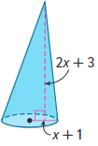
b. Find the volume of the cylinder if x = 3. Round your answer to the nearest tenth.

Examples 3 and 4
6. Examine the cone.
a. Find the volume of the cone in terms of x and π.

b. Find the volume of the cone if x = 4 feet. Round your answer to the nearest tenth.

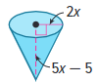
7. Examine the cone.
a. Find the volume of the cone in terms of x and π.

b. Find the volume of the cone if x = 6 meters. Round your answer to the nearest tenth.

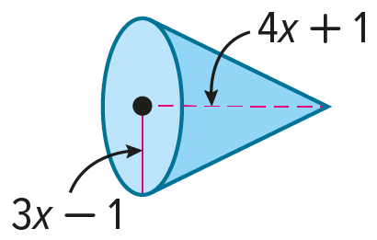
8. Examine the cone.
a. Find the volume of the cone in terms of x and π.

b. Find the volume of the cone if x = 3 inches. Round your answer to the nearest tenth.

9. DINING The part of a dish designed for ice cream is shaped like a cone. The base of the cone has a radius of 2 inches and the height is 1.2 inches. What is the volume of the cone? Round your answer to the nearest hundredth.

10. AUTOMOBILE Don uses a funnel to pour oil into his car engine. The funnel has a radius of
6 centimeters and a slant height of 10 centimeters. How much oil, to the nearest cubic centimeter, will the funnel hold?

Examples 5 and 6
11. ORANGES Moesha cuts a spherical orange in half along a great circle. The radius of the orange is
2 inches. Find the approximate volume of the orange to the nearest tenth of a cubic inch.

12. DESIGN A spherical fountain has a radius of 1.5 feet. Find the volume of the fountain to the nearest tenth of a cubic foot.

13. Examine the sphere.
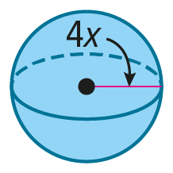
a. Find the volume of the sphere in terms of x and π.

b. Find the volume of the sphere if x = 1 centimeter. Round your answer to the nearest tenth.

14. Examine the sphere.
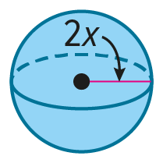
a. Find the volume of the sphere in terms of x and π.

b. Find the volume of the sphere if x = 4.3 inches. Round your answer to the nearest tenth.

15. Examine the sphere.
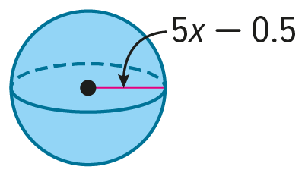
a. Find the volume of the sphere in terms x and π.

b. Find the volume of the sphere if x = 0.25 yards. Round your answer to the nearest tenth.

16. Examine the sphere.
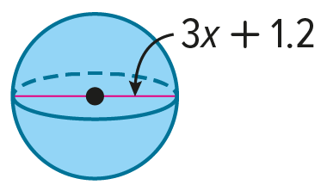
a. Find the volume of the sphere in terms of x and π.

b. Find the volume of the sphere if x = 5 centimeters. Round your answer to the nearest tenth.

Examples 7 and 8
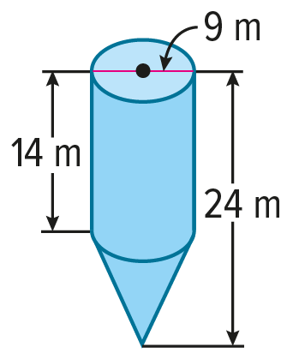
Find the volume of each composite solid. Round to the nearest tenth, if necessary.
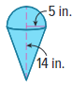
17. 18.



19. CELEBRATION Emilia is having a three-tiered cake made for her quinceañera party. Each tier of the cake will have a height of 4 inches. The diameters of the top, middle, and bottom tiers will measure 6 inches, 10 inches, and 14 inches, respectively. Find the total volume of the cake to the nearest cubic inch.
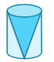
20. SCULPTING A sculptor wants to remove stone from a cylindrical block that has a height of 3 feet to create a cone. The diameter of the base of the cone and cylinder is 2 feet. What is the volume of the stone that the sculptor must remove? Round your answer to the nearest hundredth.

Mixed Exercises
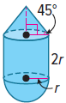
For Exercises 21 and 22, refer to the composite solid shown at the right.
21. STRUCTURE Write a formula for the volume of this solid in terms of the radius r.

22. PRECISION Explain how you wrote a formula for the volume of this solid.

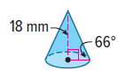

23. Find the volume of the cone. Round to the nearest tenth.

24. REASONING A hemisphere has a base with an area that is 25π square centimeters. Find the volume of the hemisphere. Round to the nearest tenth.

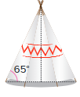

25. TEEPEE Cathy made a teepee for a class project. Her teepee had a diameter of 6 feet. The angle that the side of the teepee made with the ground was 65°. What was the volume of the teepee? Round your answer to the nearest hundredth.

26. SCHOOL SUPPLIES A pencil grip is shaped like a triangular prism with a cylinder removed from the middle. The base of the prism is a right isosceles triangle with leg lengths of 2 centimeters. The diameter of the base of the removed cylinder is 1 centimeter. The heights of the prism
and the cylinder are the same and equal to 4 centimeters. What is the exact volume of the pencil grip?

27. CONSTRUCT ARGUMENTS A wooden sphere is carved from a solid cube of wood so that the least amount of wood is carved away.
a. If the block of wood had a volume of 729 cubic inches, what is the volume of the sphere? Explain.
b. Devon says that he can multiply the volume of any cube by $\frac{π}{6}$ to find the volume of the sphere that shares the same diameter as the cube’s side. Is he correct? Justify your argument.

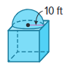
28. REASONING Reginald is creating a scale model of a building using a scale of 4 feet = 3 inches. The building is in the shape of a cube topped with a hemisphere so that the circular base of the hemisphere is inscribed in the square base of the cube. At its highest point, the building has a height of 30 feet. Find the volume of his scale model to the nearest cubic inch. Explain.

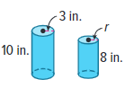
29. REGULARITY A container company manufactures cylindrical containers with a radius of 3 inches and a height of 10 inches. The company decided to produce a different cylindrical container that has a height of 8 inches and the same volume as the original container. What steps would you use to find the radius of the new container? What is the radius of the new container to the nearest tenth?

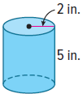
30. PERSEVERE The cylindrical can shown is used to fill a container with liquid. It takes three full cans to fill the container. Describe possible dimensions of the container if it is each of the following shapes.
a. rectangular prism

b. square prism

c. triangular prism with a right triangle as the base

31. CREATE Sketch a composite solid made of a cylinder and cone that has an approximate volume of 7698.5 cubic centimeters.

32. WRITE How are the volume formulas for prisms and cylinders similar? How are they different?

33. ANALYZE Determine whether the following statement is sometimes, always, or never true. Justify your argument.

The volume of a cone with radius r and height h equals the volume of a prism with height h.

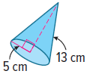
34. FIND THE ERROR Alexandra and Cornelio are calculating the volume of the cone at the right. Who is correct? Explain your reasoning.
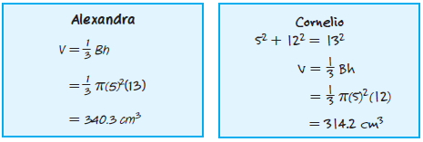

35. ANALYZE Determine whether the following statement is true or false. If true, explain your reasoning. If false, provide a counterexample.

If a sphere has radius r, there exists a cone with radius r having the same volume.

