Applying Similarity to Solid Figures ⸱ Practice
Example 1
For each pair of similar figures, find the missing area. Round your answer to the nearest tenth, if necessary.
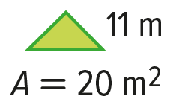
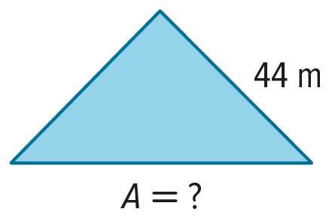
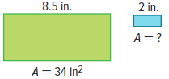
1. 2.

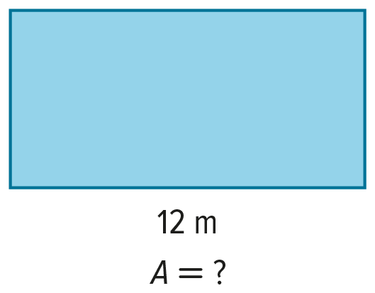
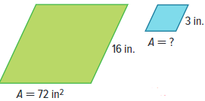
3. 4.
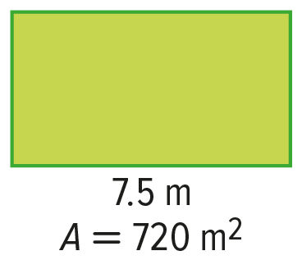

Example 2
For each pair of similar figures, use the given areas to find the scale factor from the figure on the left to the figure on the right. Then find the value of x to the nearest tenth.
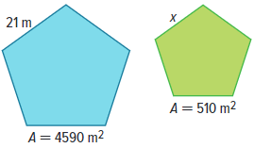
5. 6.
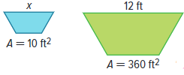

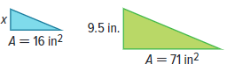
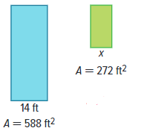
7. 8.

Example 3
9. ASSIGNMENTS Matt has two similar posters for his science project. Each poster is a rectangle. The length of the larger poster is 11 inches. The length of the smaller poster is 6 inches. What is the area of the smaller poster if the larger poster is 93.5 square inches?

10. ACCESSORIES Carla has a shirt with decorative pins in the shape of equilateral triangles. The pins come in two sizes. The larger pin has a side length that is three times longer than the smaller pin. If the area of the smaller pin is 6.9 square centimeters, what is the approximate area of the larger pin?

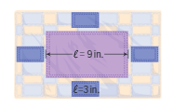
11. QUILT A quilt design has one large rectangle surrounded by four congruent rectangles that are similar to the large rectangle. If the large rectangle has an area of 45 square inches, what is the area of each small rectangle?

Example 4
Each pair of solids is similar. Find the volume of each solid. Round to the nearest tenth, if necessary.
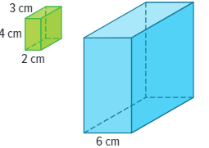
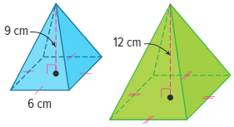
12. 13.

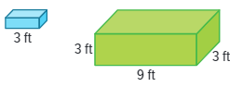
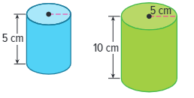
14. 15.

Example 5
16. Two similar cylinders have radii of 3 inches and 12 inches. If the height of the larger cylinder is 24 inches, what is the surface area of the smaller cylinder? Round your answer to the nearest tenth.

17. Two similar rectangular prisms have surface areas of 112 square centimeters and 1008 square centimeters. If the length and width of the base of the smaller prism are 4 centimeters and 2 centimeters, respectively, what is the perimeter of one base of the larger prism?

Mixed Exercises
18. Two similar prisms have heights of 12 feet and 20 feet. What is the ratio of the volume of the small prism to the volume of the large prism?

19. Two cubes have surface areas of 81 square inches and 144 square inches. What is the ratio of the volume of the small cube to the volume of the large cube?

20. REGULARITY A polygon has an area of 225 square meters. If the area is tripled, how does each side length change?

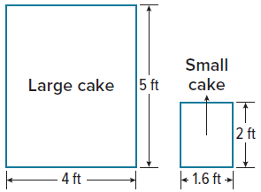
21. REASONING Smith’s Bakery is baking several large cakes for a community festival. The cakes consist of two geometrically similar shapes as shown. If 50 pieces of cake can be cut from the small cake, how many pieces of the same size can be cut from the large cake? Round to the nearest piece of cake.

PROOF Write a paragraph proof to prove each theorem.
22. Theorem 11.1 23. Theorem 11.2
Given: $△DEF∼△PQR$ Given: rectangular prisms with scale
factor a : b
Prove: $\frac{area of △DEF}{area of △PQR}={\left(\frac{d}{p}\right)}^{2}$ Prove: The surface areas have a ratio of
$a^{2} :b^{2}$, and the volumes have a
ratio of $a^{3} :b^{3}$.
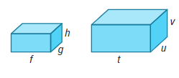
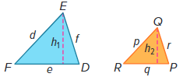

24. ATMOSPHERE About 99% of Earth’s atmosphere is contained in a 31-kilometer thick layer that surrounds the planet. The Earth itself is approximately a sphere with radius 6378 kilometers. What is the ratio of the volume of the atmosphere to the volume of Earth? Round your answer to the nearest thousandth.

25. SCULPTURE An artist creates metal sculptures in the shape of regular octagons. The length of each side of the larger sculpture is 7 inches, and the area of the base of the smaller sculpture is 19.28 square inches.
a. What is the length of each side of the smaller sculpture?

b. The artist is going to pack the sculptures in a circular box to take them to an art show. Will the larger sculpture fit in a circular box with a 15-inch diameter? Explain your reasoning.

26. SPORTS Major League Baseball, or MLB, rules state that baseballs must have a circumference of
9 inches. The National Softball Association, or NSA, rules state that softballs must have a circumference not exceeding 12 inches.
a. Find the ratio of the circumference of an MLB baseball to the circumference of a 12-inch NSA softball.

b. Find the ratio of the volume of the MLB baseball to the volume of the NSA softball. Round your answer to the nearest tenth.

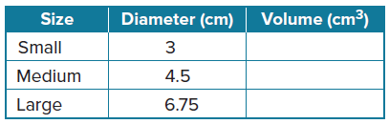
27. STRUCTURE At a pet store, toy tennis balls for pets are sold in 3 different sizes. Complete the table by calculating the volume for each size ball. Record the volume of each tennis ball in terms of π. What pattern do you notice as the diameter increases?

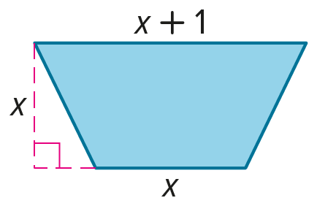
28. Describe the dimensions of a similar trapezoid that has an area four times the area of the one shown. Explain how you found your answer.

29. FIND THE ERROR Violeta and Gavin are trying to come up with a formula that can be used to find the area of a circle with a radius r after it has been enlarged by a scale factor k. Is either of them correct? Explain your reasoning.
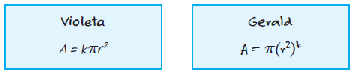

30. PERSEVERE If you want the area of a polygon to be x% of its original area, by what scale factor should you multiply each side length?

31. CREATE Draw a pair of similar figures with areas that have a ratio of 4 : 1. Explain.

32. WRITE Explain how to find the area of an enlarged polygon if you know the area of the original polygon and the scale factor of the enlargement.

33. PERSEVERE The ratio of the volume of Cylinder A to the volume of Cylinder B is 5 : 1. Cylinder A is similar to Cylinder C with a scale factor of 2 : 1, and Cylinder B is similar to Cylinder D with a scale factor of 3 : 1. What is the ratio of the volume of Cylinder C to the volume of Cylinder D? Explain your reasoning.

