Density ⸱ Practice

Example 1
POPULATION Use the data in the table to find the population density of each city.
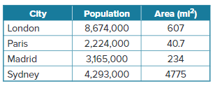
1. London, England

2. Paris, France

3. Madrid, Spain

4. Sydney, Australia

Example 2
5. WILDLIFE A town is installing bat boxes to reduce the number of mosquitos in the area. Each bat box will house 150 bats. The town officials approximate that 300 bats per square mile can control the mosquito population. If the area of the town is 12 square miles, how many bat boxes are needed?

6. OCCUPANCY Jamero is planning to open a new restaurant. Safety regulations recommend that a restaurant allows for 15 square feet of floor space per person. If Jamero wants his restaurant to be able to accommodate 50 people, what is the smallest area of floor space he will need?

Example 3
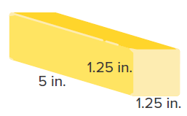
7. FESTIVALS Every year the Ohio State Fair features sculptures made of butter. While the sculptures vary from year to year, every year a new rendition of a cow and calf are created. In 2017, the sculptures of the cow and calf weighed 2000 pounds.
a. If a stick of butter weighs 4 ounces, what is its approximate density?
b. What was the total volume of the cow and calf sculptures that were made in 2017? (Hint: 1 pound = 16 ounces)
c. Approximately how many sticks of butter were used to create the sculptures?

8. ENERGY A British Thermal Unit (BTU) is equal to the amount of energy used to raise the temperature of one pound of water 1°F. A house is shaped like a rectangular prism with a length, width, and height of 80 feet, 25 feet, and 8 feet, respectively. Approximately 60,000 BTUs are required to heat the house properly.
a. What is the density of the house in BTUs?
b. A nearby house requires approximately 52,000 BTUs for heating. If the house is 31 feet long and 25 feet wide, what is the height of the house? Round your answer to the nearest foot.

Mixed Exercises
9. REGULATIONS A rectangular national sight-seeing park with a length of 2 miles and a width of
3 miles has a maximum capacity of 250 people. Find the population density of people to the nearest hundredth.

10. REASONING A city is divided by a river. The portion of the city east of the river covers 25% of the city and has a population density of 28 persons/km². The portion on the west side of the river has a population density of 17 persons/km². Find the population density of the city as a whole.

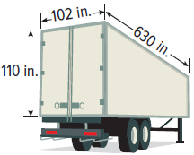
11. CONSTRUCT ARGUMENTS The cargo of a semi-trailer can weigh no more than 34,000 pounds. The interior dimensions of a semi-trailer are shown. Suppose a freight company wants to haul a shipment that will completely fill the entire interior of the trailer, and the freight has a known density of 0.006 pounds/in³. Will this proposed load meet the weight restrictions? Justify your argument.

12. PAPER WEIGHTS The cylindrical paper weight with dimensions shown has a mass of 606.7 grams.
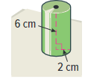
a. Find the density of the paperweight.

b. Use the table to determine which, if any, of the materials listed may have been used to make the paperweight.
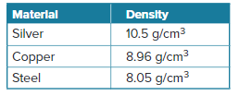

13. WHICH ONE DOESN’T BELONG? Jonathan is building his own terrarium for 18 plants, and he wants 120 cubic inches of space per plant. Which of the following proposed structures will not allow Jonathan to meet his requirement? Justify your conclusion.
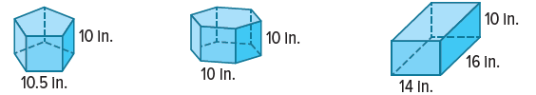

14. WRITE Explain why a cubic foot of gas and a cubic foot of gold do not have the same density.

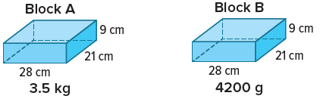
15. ANALYZE Determine whether the following statement is true or false. Justify your argument. Block A has a greater density than Block B.

16. PERSEVERE An engineer is designing a marble fountain for the lobby of a museum. Before the engineer can finalize the design, she must choose a type of marble to use for the fountain. The marble samples that are available for viewing are rectangular prisms. The width, length, and height of each sample is 4 inches, 6 inches, and 1 inch, respectively. The mass of each sample is 1066.32 grams.
a. What is the density of each marble sample?
b. The main feature of the fountain will be a marble sphere that has a radius of 2 feet. What will be the mass of the sphere? Round your answer to the nearest kilogram.

