Sample Spaces ⸱ Practice

Example 1
1. Define the sample space, S, of a fair coin being tossed once.

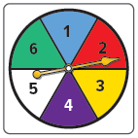

2. A numbered spinner with six equal parts is spun once.
a. What is the sample space of the experiment?

b. What is the sample space for the event of landing on a prime number?

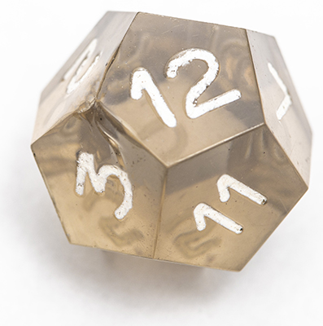

3. DODECAGON A regular, 12-sided dodecagon is rolled once.
a. What is the sample space of the experiment?

b. What is the sample space for the event of rolling an even number?

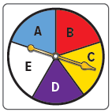
4. SPINNERS A lettered spinner with five equal parts is spun once.
a. What is the sample space of the experiment?

b. What is the sample space for landing on a vowel?

Example 2
5. UNIFORMS For away games, the baseball team can wear blue or white shirts with blue or white pants. Represent the sample space for each experiment by completing the table and tree diagram, and by making an organized list.

6. CHILDCARE Khalid’s baby sister can drink either apple juice or milk from a bottle or a toddler cup. Represent the sample space for each experiment by making an organized list, a table, and a tree diagram.


Example 3
Classify each sample space as finite or infinite. If it is finite, write the sample space. If it is infinite, classify whether it is discrete or continuous.
7. A color tile is drawn from a cup that contains 1 yellow, 2 blue, 3 green, and 4 red color tiles.
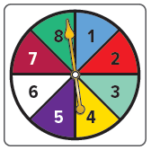
8. A numbered spinner with eight equal parts is spun until it lands on 2.

9. An angler casts a fishing line into a body of water and its distance is recorded
in centimeters.

10. A letter is randomly chosen from the alphabet.

Example 4
Find the number of possible outcomes for each situation.
11. A video game lets you decorate a bedroom 12. A cafeteria meal at Angela’s work includes
using one choice from each category. one choice from each category.
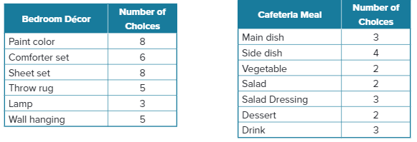

13. SHOPPING On a website showcasing outdoor patio plans, there are 4 types of stone, 3 types of edging, 5 dining sets, and 6 grills. Kamar plans to order one item from each category. How many different patio sets can Kamar order?

14. AUDITIONS The drama club held tryouts for 6 roles in a one-act play. Five people auditioned for lead female, 3 for lead male, 8 for the best friend, 4 for the mother, 2 for the father, and 3 for the humorous aunt. How many different casts can be created from those who auditioned?

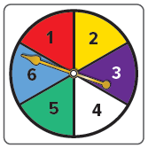
Mixed Exercises
15. BOARD GAMES The spinner shown is used in a board game. If the spinner is spun 4 times, how many different possible outcomes are there?

16. BASKETBALL In a city basketball league there must be a minimum of 14 players on a team’s roster. One 14-player team has three centers, four power forwards, two small forwards, three shooting guards, and the rest of the players are point guards. How many different 5-player teams are possible if one player is selected from each position?

17. VACATION RENTAL Angelica is comparing vacation prices in Boulder, Colorado, and Sarasota, Florida. In Boulder, she can choose a 1- or 2-week stay in a 1- or 2-bedroom suite. In Sarasota, she can choose a 1-, 2-, or 3-week stay in a 2- or 3-bedroom suite, on the beach or not.
a. How many outcomes are available in Boulder?

b. How many outcomes are available in Sarasota?

c. How many total outcomes are available?
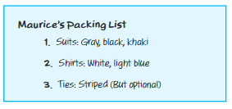
18. TRAVEL Maurice packs suits, shirts, and ties that can be mixed and matched. Use his packing list to draw a tree diagram to represent the sample space for possible suit combinations using one article from each category.

Find the number of possible outcomes for each situation.
19. SCHOOL Tala wears a school uniform that consists of a skirt or pants, a white shirt, a blue jacket or sweater, white socks, and black shoes. She has 3 pairs of pants, 3 skirts, 6 white shirts, 2 jackets, 2 sweaters, 6 pairs of white socks, and 3 pairs of black shoes.
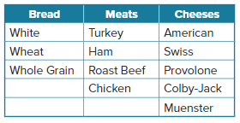
20. FOOD A sandwich shop provides its customers with a number of choices for bread, meats, and cheeses. Provided one item from each category is selected, how many different sandwiches can be made?

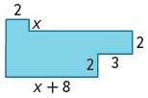
21. List six different expressions that could be used to evaluate the area of the composite figure.

22. LICENSE PLATES One state requires license plates to consist of three letters followed by three numbers. The letter "O" and the number "0" may not be used, but any other combination of letters or numbers is allowed. How many different license plates can be created?

23. COLLEGE Jack has been offered a number of internships that could occur in 3 different months, in 4 different departments, and for 3 different companies. Jack is only available to complete his internship in July. How many different outcomes are there for his internship?

24. BIKING Talula got a new bicycle lock that has a four-number combination. Each number in the combination is from 0 to 9.

a. How many combinations are possible if there are no restrictions on the number of times Talula can use each number?

b. How many combinations are possible if Talula can use each number only once? Explain.

25. BOARD GAMES Hugo and Monette are playing a board game in which the player rolls two fair dice per turn.

a. In one turn, how many outcomes result in a sum of 8?

b. How many outcomes in one turn result in an odd sum?

26. WRITING Explain when it is necessary to show all the possible outcomes of an experiment by using a tree diagram and when using the Fundamental Counting Principle is sufficient.

27. REASONING A multistage experiment has n possible outcomes at each stage. If the
experiment is performed with k stages, write an equation for the total number of possible outcomes P. Explain.

28. PERSEVERE A box contains n different objects. If you remove three objects from the box, one at a time, without putting the previous object back, how many possible outcomes exist? Explain your reasoning.

29. CREATE Sometimes a tree diagram for an experiment is not symmetrical. Describe a
two-stage experiment where the tree diagram is asymmetrical. Include a sketch of the tree diagram. Explain.

30. WRITE Explain why it is not possible to represent the sample space for a multi-stage experiment by using a table.

31. ANALYZE Determine if the following statement is sometimes, always, or never true. Justify your argument.
When an outcome falls outside the sample space, it is a failure.

