Probability and Counting ⸱ Practice

Example 1
1. A fair die is rolled once. Let A be the event of rolling an even number, and let B be the event of rolling a number greater than 4. Find A ∩ B.

2. A fair die is rolled once. Let A be the event of rolling an even number, and let B be the event of rolling an odd number. Find A ∩ B.

Use the spinner.
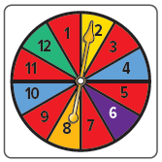
3. Let A be the event of the spinner landing on 4 or 10, and let B be the event of the spinner landing on a section with a number divisible by 4. What are the possible outcomes of each event?
a. A = {___}

b. B = {___}

c. A ∩ B = {___}

4. Let P be the event of the spinner landing on a section with a prime number, and let Q be the event of the spinner landing on a section with a number that is a multiple of 3. What are the possible outcomes of each event?
a. P = {___}

b. Q = {___}

c. P ∩ Q = {___}

Example 2
5. A card is selected from a standard deck of cards. What is the probability that the card is a diamond and is a seven?

6. A card is selected from a standard deck of cards. What is the probability that the card has a number on it that is divisible by 2 and is black?

Example 3
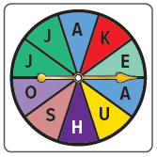
Use the spinner.
7. Let A be the event that the spinner lands on a vowel. Let B be the event that it lands on the letter J. What are the possible outcomes of each event?
a. A = {___}

b. B = {___}

c. A ∪ B = {___}

8. Let X be the event that the spinner lands on a consonant. Let Y be the event that it lands on the letter K. What are the possible outcomes of each event?
a. X = {___}

b. Y = {___}

c. X ∪ Y = {___}

9. A random number generator is used to generate one integer between 1 and 20. Let C be the event of generating a multiple of 5, and let D be the event of generating a number less than 12. What are the possible outcomes of each event?
a. C = {___}

b. D = {___}

c. C ∪ D = {___}

10. A random number generator is used to generate one integer between 1 and 100. Let A be the event of generating a multiple of 10, and let B be the event of generating a factor of 30. What are the possible outcomes of each event?
a. A = {___}

b. B = {___}

c. A ∪ B = {___}

Example 4
Determine the probability of each event. Round to the nearest hundredth, if necessary.

11. What is the probability of drawing a card from a standard deck and not getting a spade?

12. What is the probability of flipping a coin and not landing on tails?

13. Carmela purchased 10 raffle tickets. If 250 were sold, what is the probability that one of Carmela’s tickets will not be drawn?

14. What is the probability of spinning a spinner numbered 1 to 6 and not landing on 5?

Mixed Exercises
15. STATISTICS A survey found that about 90% of the junior class is right-handed. If 1 junior is chosen at random out of 100 juniors, what is the probability that he or she is left-handed?

16. RAFFLE Raul bought 24 raffle tickets out of 1545 tickets sold. What is the probability that Raul will not win the grand prize of the raffle?

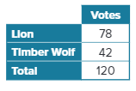
17. MASCOT At Riverview High School, 120 students were asked whether they prefer a lion or a timber wolf as the new school mascot. What is the probability that a randomly-selected student will have voted for a lion as the new school mascot?

18. COLLEGE In Evan’s senior class of 240 students, 85% are planning to attend college after graduation. What is the probability that a senior chosen at random is not planning to attend college after graduation?

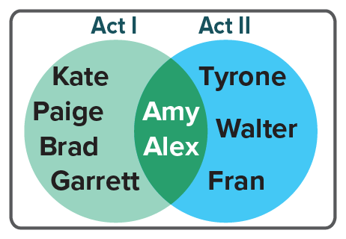
19. DRAMA CLUB The Venn diagram shows the cast members who are in Acts I and II of a school play. One of the students will be chosen at random to attend a statewide performing arts conference. Let A be the event that a cast member is in Act I of the play and let B be the event that a cast member is in Act II of the play.

a. Find A ∩ B.

b. What is the probability that the student who is chosen to attend the conference is a cast member in only one of the two Acts of the play.

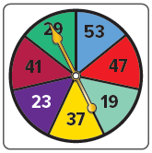
20. GAMES LaRae is playing a game that uses a spinner. What is the probability that the spinner will land on a prime number on her next spin?

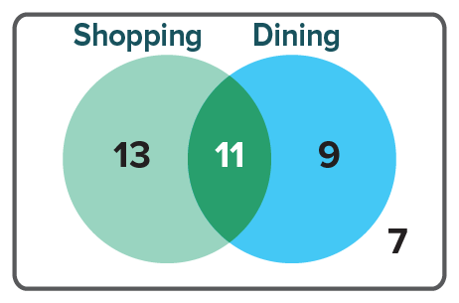
21. SHOPPING Raya asks 40 people outside the mall whether or not they visited for shopping or dining. She records the results in a Venn diagram. One person will be chosen at random to be interviewed on the local evening news. Find the probability that the person chosen will be someone who visited the mall for shopping and dining.

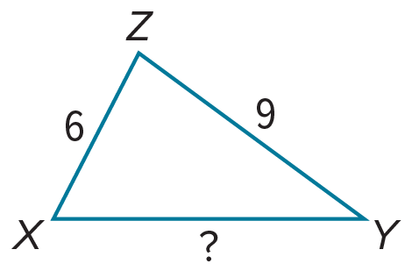
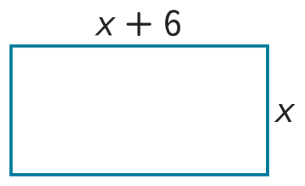
22. PERSEVERE Let A be the possible integer side measures of the rectangle with perimeter P = 52. Let B represent the possible integer measures of $\overline{XY}$ in $△$XYZ.
a. Find A ∩ B.

b. Find A ∪ B.

23. CREATE Let A be the months of the year with 31 days and let B be the months of the year that begin with the letter J. Create a Venn diagram to display this data.

24. WRITE Suppose you need to explain the concept of intersections and unions
to someone with no knowledge of the topic. Write a brief description of
your explanation.

25. ANALYZE Determine if the following statement is sometimes, always, or never true. Justify your argument.
The union of two sets has more elements than the intersection of two sets.

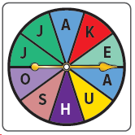
26. FIND THE ERROR Let A be the event that the spinner lands on a vowel. Let B be the event that it lands on the letter J. Truc says A ∪ B is {A, E, O, U, J}, and Alan says A ∪ B is ∅. Who is correct? Explain.

