Geometric Probability ⸱ Practice

Example 1
Point M is chosen at random on $\overline{ZP}$ . Find the probability of each event.
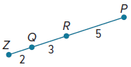
1. P(M is on $\overline{ZQ}$) 2. P(M is on $\overline{QR}$)

3. P(M is on $\overline{RP}$) 4. P(M is on $\overline{QP}$)

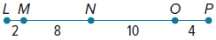
Point X is chosen at random on $\overline{LP}$. Find the probability of each event.
5. P(X is on $\overline{LN}$) 6. P(X is on $\overline{MO}$)

Example 2
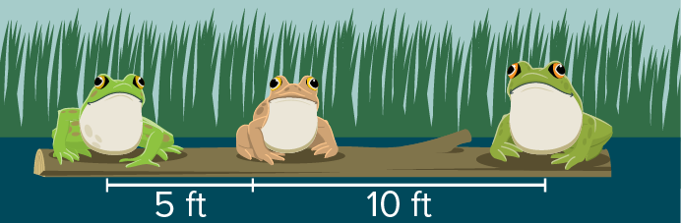
7. WILDLIFE Three frogs are sitting on a 15-foot log. The first two frogs are spaced 5 feet apart and the third frog is 10 feet away from the second one. What is the probability that when a fourth frog hops onto the log, it lands between the first two?

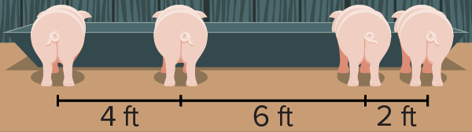
8. LIVESTOCK Four pigs are lined up at a feeding trough. What is the probability that when a fifth pig comes to eat, it lines up between the second and third pig?

9. DRIVING In a 5-minute traffic cycle, a traffic light is green for 2 minutes 27 seconds, yellow for 6 seconds, and red for 2 minutes 27 seconds. What is the probability that when you get to the light it is green?

10. CARS Once a particular electric car is plugged into a charger, it takes two hours for the battery to have a full charge. If you check the battery level randomly during a charge, what is the probability that the battery will be between $\frac{1}{4}$ and $\frac{1}{2}$ charged?

11. MOVIES A certain store plays a two-hour movie on repeat during store hours. In the movie, there is a song that lasts for 6 minutes and 31 seconds. What is the probability that when a customer randomly enters the store, the song will be playing in the movie?

12. RADIO A radio station is running a contest in which listeners call in when they hear a certain song. The song is 2 minutes 40 seconds long. The radio station claims that they will play the song sometime between noon and 4 P.M. If you randomly turn on that radio station between noon and 4 P.M., what is the probability that the song will be playing?

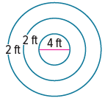
Example 3
13. GAMES One carnival game tasks players with launching a fish charm onto a circular landing pad. The largest prize is awarded if the charm lands in the center circle with a 4-foot diameter. What is the probability the charm lands in the center circle?

14. RECREATION A parachutist is aiming to land in a circular target with a 10-yard radius. The target is in a rectangular field that is 120 yards long and 30 yards wide. Given that the parachutist will land in the field, what is the probability he will land in the target?

Example 4
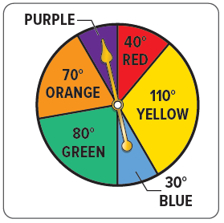
Use the spinner to find each probability. If the spinner lands on a line it is spun again.

15. P(pointer landing on red)

16. P(pointer landing on blue)

17. P(pointer landing on green)

18. P(pointer landing on either green or blue)

19. P(pointer landing on neither red nor yellow)

Example 5
20. STATE YOUR ASSUMPION Deangelo is planning a bus ride to the airport. He can choose between the Crimson bus, which arrives at the bus stop every 8 minutes, or the Gold bus, which arrives at the bus stop every 15 minutes. He would prefer to take the Gold bus because the bus makes fewer stops. In order to get to the airport by a certain time, Deangelo cannot wait more than 5 minutes without risking being late for his flight.

a. What assumption do you have to make to solve this problem?

b. To the nearest percent, what is the probability that Deangelo will have to wait 5 minutes or less to see both buses?

c. To the nearest percent, what is the probability that Deangelo will have to wait 5 minutes or less to see only one of the buses?

Mixed Exercises
Describe an event with a 33% probability for each model.
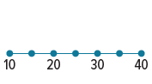
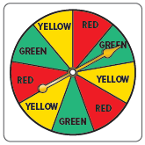
21. 22. 23.
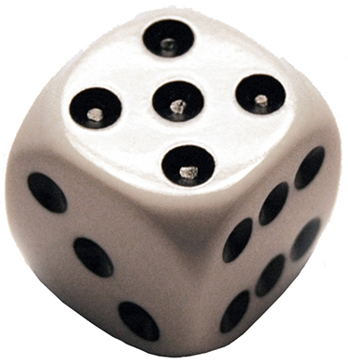

Find the probability that a point chosen at random lies in the shaded region.


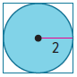
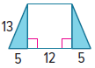
24. 25. 26.

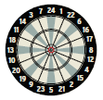
27. DARTS Each sector of a dart board has the same central angle. If a thrown dart has equal probability of hitting any point in play on the dart board, what is the probability that the dart will land in a shaded sector?

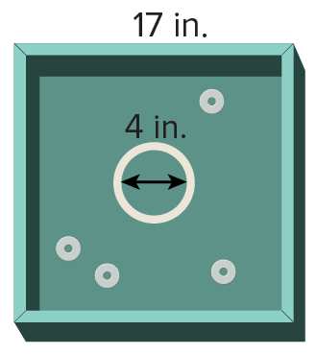
28. GAMES Washers is a popular outdoor game where players attempt to
throw washers into the 17-inch by 17-inch square pit. Generally, when a
player throws a washer into the square box, he or she scores 1 point; however, if the washer lands within the circular region in the center of the board with a 4-inch diameter, then the player scores 5 points.

a. What is the probability a washer is tossed into the circular region? Round to the nearest percent. Use π ≈ 3.14.

b. What assumption do you have to make to solve this problem?

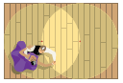
29. ENTERTAINMENT A rectangular dance stage is lit by two lights that light up
circular regions of the stage. The circles have radii of the same length and each
circle passes through the center of the other. The stage perfectly circumscribes
the two circles. A spectator throws a bouquet of flowers onto the stage. Assume
the bouquet has an equal chance of landing anywhere on the stage. (Hint: Use inscribed equilateral triangles.)

a. What is the probability that the flowers land on a part of the stage that is illuminated?

b. What is the probability that the flowers land on the part of the stage where the
spotlights overlap?


30. CONSTRUCT ARGUMENTS Prove that the probability that a randomly chosen point in the circle will lie in the shaded region is equal to $\frac{x}{360}$.

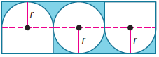
31. PERSEVERE Find the probability that a point chosen at random would lie in the shaded area of the figure. Round to the nearest tenth of a percent.

32. ANALYZE An isosceles triangle has a perimeter of 32 centimeters. If the lengths of the sides of the triangle are integers, what is the probability that the area of the triangle is exactly 48 square centimeters? Justify your reasoning.

33. WRITE Can athletic events be considered random events? Explain.

34. CREATE Represent a probability of 20% using three different geometric figures.

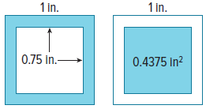
35. WRITE Explain why the probability of a randomly chosen point falling in the shaded region of either of the squares shown is
the same.

