Probability with Permutations and Combinations ⸱ Practice

Example 1
1. CHEERLEADING The cheerleading squad is made up of 12 girls. A captain and a co-captain are selected at random. What is the probability that Chantel and Clover are chosen as leaders?

2. BOOKS You have a textbook for each of the following subjects: Spanish, English, Chemistry, Geometry, History, and Psychology. If you choose 4 of these at random to arrange on a shelf, what is the probability that the Geometry textbook will be first from the left and the Chemistry textbook will be second from the left?

3. RAFFLE Alfonso and Cordell each bought one raffle ticket at the state fair. If 50 tickets were randomly sold, what is the probability that Alfonso got ticket 14 and Cordell got ticket 23?

4. CONCERT Nia and Ciro are going to a concert with their high school’s key club. If they choose a seat in the row below at random, what is the probability that Ciro will be in seat C11 and Nia will be in C12?

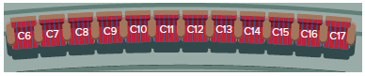

Examples 2 and 3
5. PHONE NUMBERS What is the probability that a 7-digit telephone number generated using the digits 2, 3, 2, 5, 2, 7, and 3 is the number 222-3357?

6. IDENTIFICATION A store randomly assigns their employees work identification numbers to track productivity. Each number consists of 5 digits ranging from 1-9. If the digits cannot repeat, find the probability that a randomly generated number is 25938.

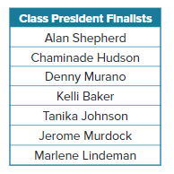
7. STUDENT COUNCIL The table shows the finalists for class president. The order in which they will give their speeches will be chosen randomly.

a. What is the probability that Denny, Kelli, and Chaminade are the first
3 speakers, in any order?

b. What is the probability that Denny is first, Kelli is second, and Chaminade is third?

Example 4
8. TROPHIES Taryn has 15 soccer trophies but she only has room to display 9 of them on a shelf. If she chooses them at random, what is the probability that each of the trophies from the school invitational from the 1st through 9th grades will be chosen?

9. FROZEN YOGURT Kali has a choice of 20 flavors for her triple scoop cone. If she chooses the flavors at random, what is the probability that the 3 flavors she chooses will be vanilla, chocolate, and strawberry?

10. BUSINESS Kaja has a dog walking business that serves 9 dogs. If she chooses 4 of the dogs at random to take an extra trip to the dog park, what is the probability that Cherish, Taffy, Haunter, and Maverick are chosen?

11. FOOD TRUCKS A restaurant critic has 10 new food trucks to try. If she tries half of them this week, what is the probability that she will choose Nacho Best Tacos, Creme Bruleezin, Fre Sha Vaca Do’s, You Can’t Get Naan, and Grillarious?

12. DONATIONS Emily has 20 collectible dolls from different countries that she will donate. If she selects 10 of them at random, what is the probability that she chooses the dolls from Ecuador, Paraguay, Chile, France, Spain, Sweden, Switzerland, Germany, Greece, and Italy?

13. AMUSEMENT PARK An amusement park has 12 major attractions: four roller coasters, two carousels, two drop towers, two gravity rides, and two dark rides. The park’s app will randomly select attractions for you to visit in order. What is the probability that the four roller coasters are the first four suggested attractions?

Mixed Exercises
14. BUSINESS TRAVEL A department manager is selecting team members at random to attend one of four conferences in Los Angeles, Atlanta, Chicago, and New York. If there are 20 team members, what is the probability that Jariah, Sherry, Emilio, and Lavon are chosen for the conferences?

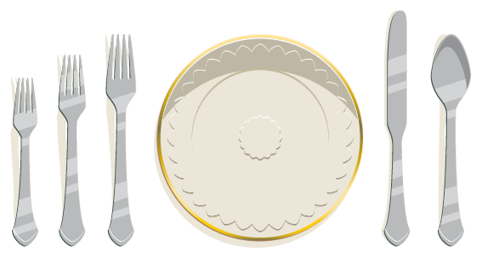
15. DINING You are handed 5 pieces of silverware for
the formal place setting shown. If you guess their placement at
random, what is the probability that the knife and spoon are placed correctly?

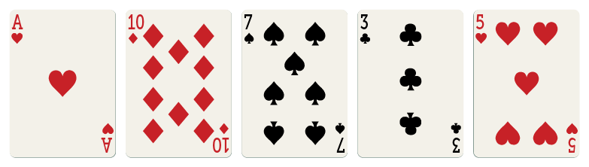
16. CARDS What is the probability in a line of these
five cards that the ace would be first from the left and
the 10 would be second from the left?

17. Points A, B, C, D, and E are coplanar, but no 3 are collinear.
a. What is the total number of lines that can be determined by these points?

b. What is the probability that $\overset{⃡}{AB}$ would be chosen at random from all of the possible
lines formed?


18. CRAFTING Jaclyn bought some decorative letters for a scrapbook project. If she randomly selected a permutation of the letters shown, what is the probability that they would form the word “photography”?

19. BUSINESS Andres sent emails to 20 of his contacts advertising his new lawn services. If 6 contacts responded to the email, what is the probability that the Michaelsons, the Rodriquezes, the Farooqis, the Salahis, the Kryceks, and the Waltons responded?

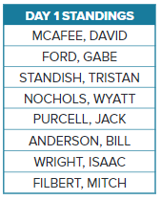
20. GAME SHOW The people on the list at the right will be considered to participate in a game show. What is the probability that Wyatt, Gabe, and Isaac will be chosen as the first three contestants?

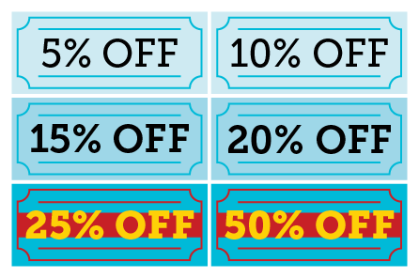
21. SALES The owner of a hair salon advertises that on the first day of each month, the first 6 customers will receive one of the coupons shown at the right for a discount off their total bill. Each coupon is given at random to a different customer.

a. What is the probability that the first customer on May 1 gets the 10% discount and the second customer gets the 25% discount? Explain your answer using favorable and possible outcomes.

b. How many different groups of two coupons can the first two customers on August 1 receive regardless of order?
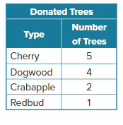
22. DONATIONS As part of a school beautification project, 12 alumni each donated a tree to be planted on the school grounds. The types of trees are shown in the table. There will be a sign next to each tree with the donor’s name.

a. If the trees are planted in a row at random, what is the probability that they will be in alphabetical order by donor name? Explain.

b. If 4 trees are randomly selected and planted near the school entrance, what is the probability that they will all be dogwood trees? Explain.

23. PARKING STICKERS Parking stickers contain randomly generated numbers with 5 digits ranging from 1 to 9. No digits are repeated. What is the probability that a randomly generated number
is 54321?

24. CONSTRUCT ARGUMENTS Prove that _{n}C_{n ‒ r} = _{n}C_{r}.

25. PERSEVERE Fifteen boys and fifteen girls entered a drawing for four free movie tickets. What is the probability that all four tickets were won by girls?

26. ANALYZE Is the following statement sometimes, always, or never true? Justify your reasoning.
_{n}P_{r} = _{n}C_{r}

27. WRITE Compare and contrast permutations and combinations.

28. CREATE Describe a situation in which the probability is given by $\frac{1}{}$.

29. PERSEVERE A student claimed that permutations and combinations were related by r! ∙ _{n}C_{r} = _{n}P_{r}. Use algebra to show that this is true. Then explain why _{n}C_{r} and _{n}P_{r} differ by the factor r!

30. FIND THE ERROR Charlie claims that the number of ways n objects can be arranged if order matters is equal to the number of permutations of n objects taken n ‒ 1 at a time. Do you agree with Charlie? Explain your reasoning.

