Probability and the Addition Rule ⸱ Practice

Example 1
Determine whether the events are mutually exclusive or not mutually exclusive. Explain
your reasoning.
1. A die is rolled while a game is being played. The result of the next roll is a 6 or an even number.

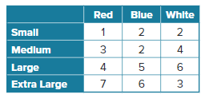
2. SALES A street vendor is selling T-shirts outside of a concert arena. The colors and sizes of the available T-shirts are shown in the table. The vendor selects a T-shirt that is blue or large.

Examples 2 and 3
3. AWARDS The student of the month gets to choose one award from 9 gift certificates to area restaurants, 8 T-shirts, 6 water bottles, or 5 gift cards to the mall. What is the probability that the student of the month chooses a T-shirt or a water bottle?

4. SALES PROMOTIONS At a grand opening event, a store allows customers to choose an envelope from a bag. Ten of the envelopes contain store coupons, 8 envelopes contain gift cards, and 2 envelopes contain $100. What is the probability that a customer selects an envelope with a gift card or an envelope with $100?

5. TRAFFIC If the chance of making a green light at a certain intersection is 35%, what is the probability of arriving when the light is yellow or red?

6. STUDENTS In a group of graduate students, 4 out of the 5 females are international
students, and 2 out of the 3 men are international students. What is the probability of
selecting a graduate student from this group that is a male or an international student?

Mixed Exercises
CARDS Suppose you pull a card from a standard 52-card deck. Find the probability of each event.

7. The card is a 4. 8. The card is red.

9. The card is a face card. 10. The card is not a face card.

11. P(queen or heart) 12. P(jack or spade)

13. P(five or prime number) 14. P(ace or black)

15. A drawing will take place where one ticket is to be drawn from a set of 80 tickets numbered 1 to 80. If a ticket is drawn at random, what is the probability that the number drawn is a multiple of 4 or a factor of 12?

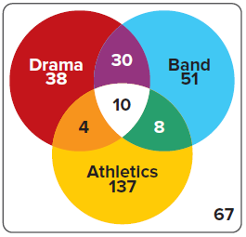
16. SCHOOL The Venn diagram shows the extracurricular activities enjoyed by the senior class at Valley View High School.

a. How many students are in the senior class?

b. How many students participate in athletics?

c. If a student is randomly chosen, what is the probability that the student participates in athletics or drama?

d. If a student is randomly chosen, what is the probability that the student participates in only drama and band?

17. BOWLING Cindy’s bowling records indicate that for any frame, the probability that she will bowl a strike is 30%, a spare 45%, and neither 25%. What is the probability that she will bowl either a spare or a strike for any given frame?

18. SPORTS CARDS Dario owns 145 baseball cards, 102 football cards, and 48 basketball cards. What is the probability that he randomly selects a baseball or a football card?

19. SCHOLARSHIPS A review committee read 3000 application essays for one $5000 college scholarship. Of the applications reviewed, 2865 essays were the required length, 2577 of the applicants had the minimum required grade-point average, and 2486 had the required length and minimum grade-point average. What is the probability that an application essay selected at random will have the required length or the required gradepoint average?

20. PETS Ruby’s cat had 8 kittens. The litter included 2 orange females, 3 mixed-color females,
1 orange male, and 2 mixed-color males. Ruby wants to keep one kitten. What is the probability that she randomly chooses a kitten that is female or orange?

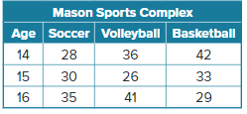
21. SPORTS The table shows the age and number of participants in each sport at a sporting complex. What is the probability that a player is 14 or plays basketball?

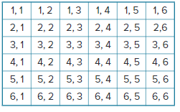
22. USE A MODEL Vicente and Kelly are designing a board game. They decide that the game will use a pair of dice and the players will have to find the sum of the numbers rolled. VIcente and Kelly created the table shown to help determine probabilities. Each player will roll the pair of dice twice during that player’s turn.

a. What is the probability of rolling a pair or two numbers that have a sum of seven?

b. What is the probability of rolling two numbers whose sum is an even number or not rolling a 2? Round to the nearest thousandth.

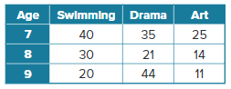
23. PARKS The table shows Parks and Recreation Department classes and the number of participants ages 7-9. What is the probability that a participant chosen at random is in drama or is an 8-year-old?

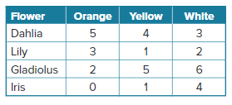
24. FLOWER GARDEN Erin is planning her summer garden. The table shows the number of bulbs she has according to type and color of flower. If Erin randomly selects one of the bulbs, what is the probability that she selects a bulb for a yellow flower or a dahlia?

25. PERSEVERE You roll 3 dice. What is the probability that the outcome of at least two of the dice will be less than or equal to 4? Explain your reasoning.

26. FIND THE ERROR Teo and Mason want to determine the probability that a red marble will be chosen out of a bag of 4 red, 7 blue, 5 green, and 2 purple marbles. Is either of them correct? Explain your reasoning.
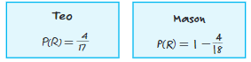

ANALYZE Determine whether the following are mutually exclusive. Explain.
27. choosing a quadrilateral that is a square and a quadrilateral that is a rectangle

28. choosing a triangle that is equilateral and a triangle that is equiangular

29. choosing a complex number and choosing a natural number

30. WRITE Explain why the sum of the probabilities of two mutually exclusive events is not always 1.

