Two-Way Frequency Tables ⸱ Practice

Example 1
1. VEHICLES One hundred people are surveyed about the type of vehicle they drive. The survey finds that 15 males and 40 females drive SUVs, while 35 males and 10 females drive trucks.

- Organize the responses in a two-way frequency table.

- Construct a relative frequency table.

2. SOCIAL MEDIA One hundred students are asked whether or not they have social media accounts. The survey finds that 25 males and 35 females have social media accounts, while 25 males and 15 females do not have social media accounts.

- Organize the responses in a two-way frequency table.

- Construct a relative frequency table.

Example 2
3. COLLEGE A ride-sharing company surveys 2000 of its customers who are college students. The survey asks the following two questions about the previous academic year:
- Are you attending college in or out of state?
- Did you visit home more than four times this school year?

The survey finds that of the 1260 students who attend an in-state college, 928 visited home more than four times and 332 visited home four or less times. Of the 740 students who attend an out-of-state college, 118 visited home more than four times and 622 visited home four or less times.

a. Organize the responses in a two-way frequency table.

b. Construct a relative frequency table. Enter each fraction as a percent rounded to the nearest tenth, if necessary.

- Suppose you let event A represent whether the students attend an in-state or an out-of-state college, and event B represent whether the students visit home more than four times or visit home four or fewer times. Use the table to determine whether the number of visits home is independent or dependent on whether the student is attending college at an in-state or out-of-state institution. Justify your response.

Example 3
4. TICKETS A movie theater is keeping track of the last 800 tickets it sold to two different movies. Of the 578 adult tickets sold, 136 of them were for the animated film and 442 were for the documentary film. Of the 222 student tickets sold, 181 of them were for the animated film and 41 were for the documentary film.

a. Complete the two-way frequency table shown.
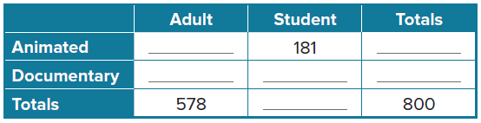

b. Construct a relative frequency table of your completed two-way frequency table. Round each percent to the nearest tenth, as necessary.

c. Find the probability that a ticket sold is an adult ticket given that it is a documentary ticket. Show your work by writing the formula that you used to perform the calculation.

Mixed Exercises
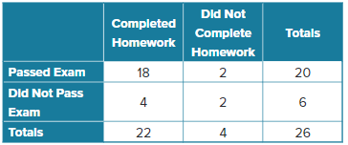
5. SCHOOL The two-way frequency table compares data about students in a class who completed or did not complete homework and those who passed or did not pass an exam. How many students completed their homework and passed the exam? Identify whether marginal or joint frequencies are used.

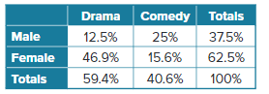
6. MOVIES Raquel surveys 160 people to determine if they prefer drama or comedy movies. The relative frequency table shows the data collected from the survey. Determine whether gender is independent of movie type preference. Explain your reasoning.

7. TECHNOLOGY For a business report on technology use, Darnell asks a random sample of
72 shoppers whether they own a smart phone and whether they own a tablet computer. His survey shows that out of 51 shoppers who own smart phones, 9 of them also own a tablet, while out of 21 shoppers who do not own smart phones, 15 of them do not own tablets either. Find conditional probability that a shopper has a tablet, given that he or she has a smart phone. Justify your reasoning.

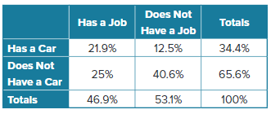
8. CONSTRUCT ARGUMENTS Paz asks a random sample of seniors at her high school whether they own a car and whether they have a job. The results of the survey are shown in the two-way relative frequency table. Paz says that the conditional probability that a student has a job given that he or she has a car is 46.7%. Do you agree? Justify your argument.

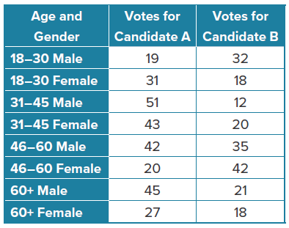
9. PERSEVERE Suppose an exit poll held outside a voting area on the day of an election produced these results.

a. Which events are mutually exclusive?

b. Find the probability that a male between the ages of 46 and 60 would vote for Candidate A.

c. Find the probability that a female would vote for Candidate A.

d. Find the probability that someone who voted for Candidate B was a female and age 18-30.

e. According to the data, on which demographic(s) does Candidate A need to
focus campaign efforts?

f. According to the data, on which demographic(s) does Candidate B need to
focus campaign efforts?

10. ANALYZE A market research firm asks a random sample of 240 adults and students at a movie theater whether they would rather see a new summer blockbuster in 2-D or 3-D. The survey shows that 64 adults and 108 students prefer 3-D, while 42 adults and 26 students prefer 2-D.

a. Organize the responses into a two-way frequency table.

b. Convert the table from part a into a two-way relative frequency table. Round to the nearest tenth of a percent. Out of every 10 people surveyed, about how many would prefer to see the movie in 3-D? Explain.

c. Find the probability that a person surveyed prefers seeing the movie in 3-D, given that he or she is an adult. Write the formula that you used to perform the calculation.

d. An analyst at the firm claims that the probability that a person surveyed is a child given that he or she does not prefer to see the movie in 3-D is 10.8%. Do you agree? Justify your answer.

e. Is a preference for 2-D or 3-D movies independent of age? Explain your reasoning.

