Functions and Continuity ⸱ Practice

Example 1
Identify the domain, range, and codomain in each graph. Then use the codomain and range to determine whether the function is onto.
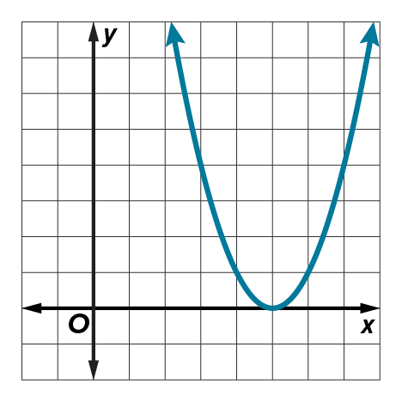
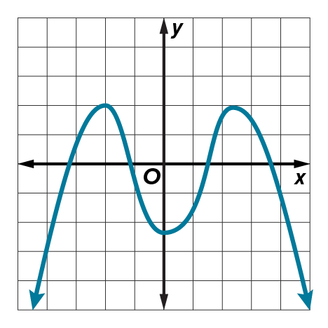
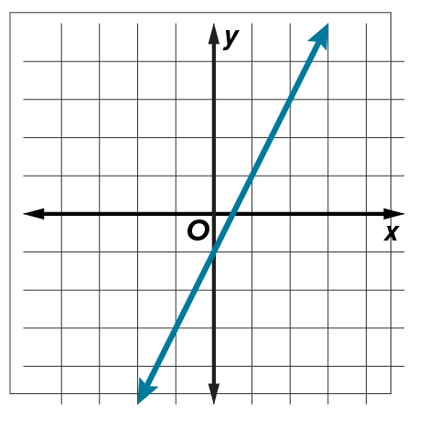
1. 2. 3.

Example 2
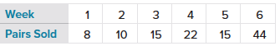
4. SALES Cool Athletics introduced the new Power Sneaker in one of their stores. The table shows the sales for the first 6 weeks. Define the domain and range of the function and state whether it is one-to-one, onto, both or neither.

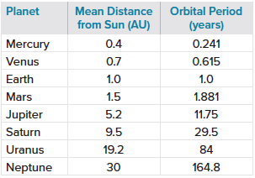
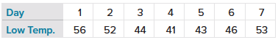
5. TEMPERATURES The table shows the low temperatures in degrees Fahrenheit for the past week in Sioux Falls, Idaho. Define the domain and range of the function and state whether it is one-to-one, onto, both, or neither.

6. PLANETS The table shows the orbital period of the eight major planets in our Solar System given their mean distance from the Sun. Define the domain and range of the function and state whether it is one-to-one, onto, both or neither.

Example 3
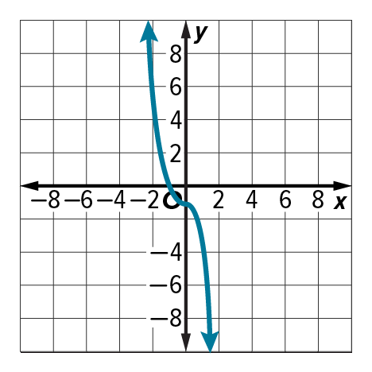
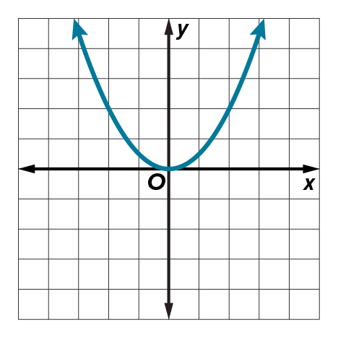
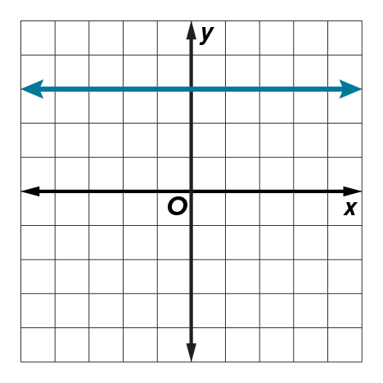
Determine whether each function is one-to-one, onto, both, or neither.
7. 8. 9.

Example 4
Examine the graphs. Determine whether each function is discrete, continuous, or neither discrete nor continuous. Then state the domain and range of each function.
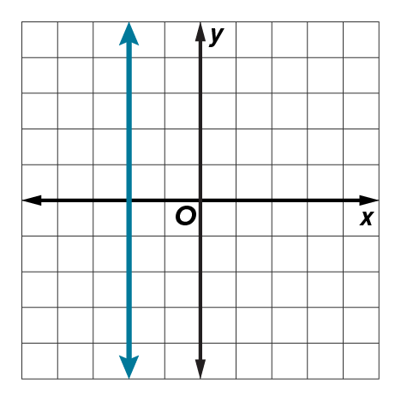
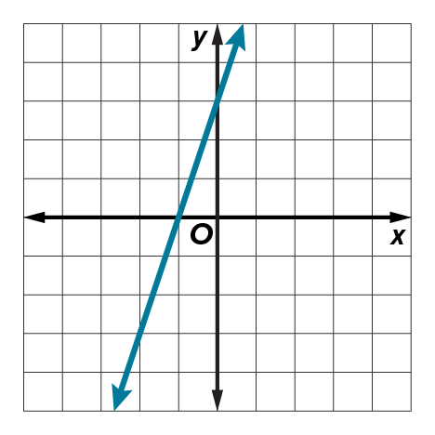
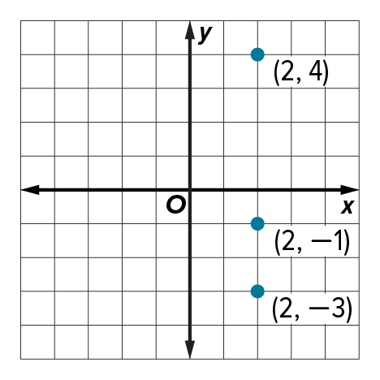
10. 11. 12.

Example 5
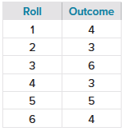
13. PROBABILITY The table shows the outcome of rolling a number cube. Determine whether the function that models the outcome of each roll is discrete, continuous, or neither discrete nor continuous. Then state the domain and range of the function.

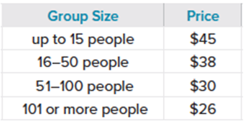
14. AMUSEMENT PARK The table shows the price of tickets to an amusement park based on the number of people in the group. Determine whether the function that models the price of tickets is discrete, continuous, or neither discrete nor continuous. Then state the domain and range of the function.

15. GROCERIES A local grocery store sells grapes for $1.99 per pound. Determine whether the function that models the cost of grapes is discrete, continuous, or neither discrete nor continuous. Then state the domain and range of the function.

Examples 6 and 7
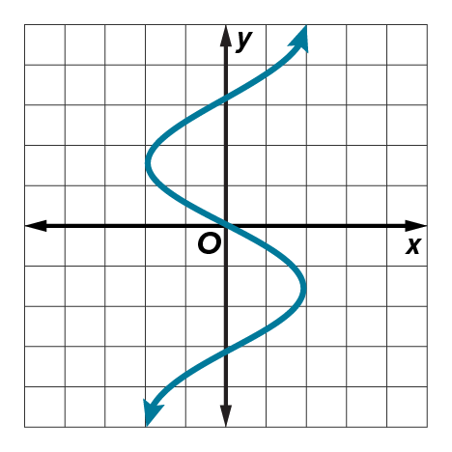
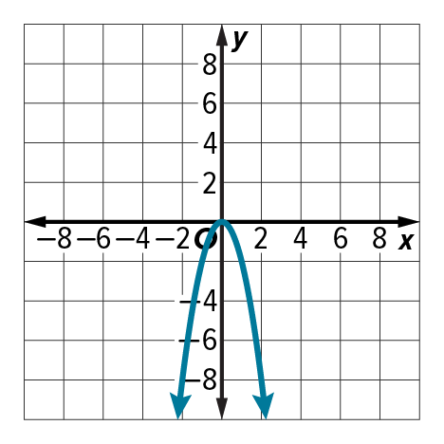
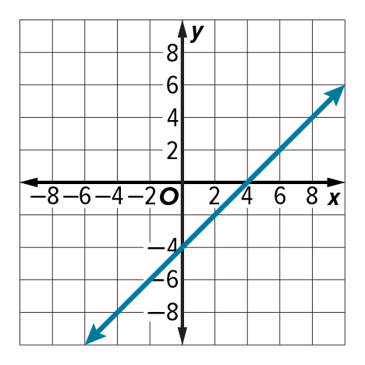
Write the domain and range of the graph in set-builder and interval notation.
16. 17. 18.

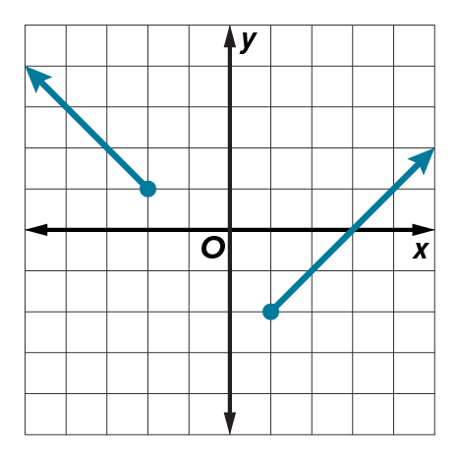
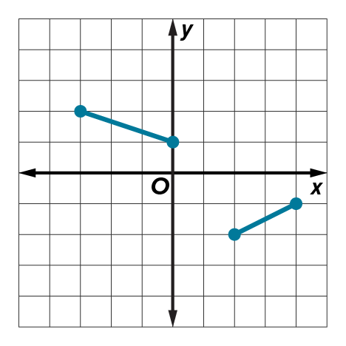
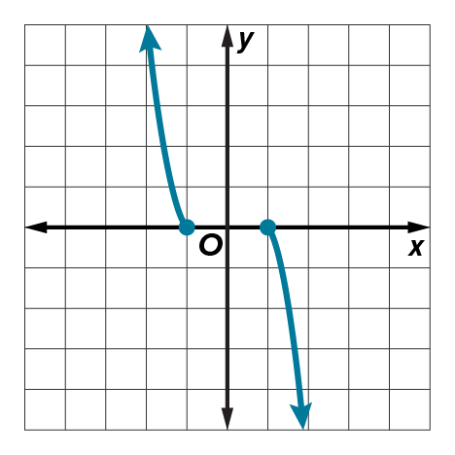
Write the domain and range of the graph in set-builder and interval notation.
19. 20. 21.

Mixed Exercises
STRUCTURE Write the domain and range of each function in set-builder and interval notation. Determine whether each function is one-to-one, onto, both, or neither. Then state whether it is discrete, continuous, or neither discrete nor continuous.
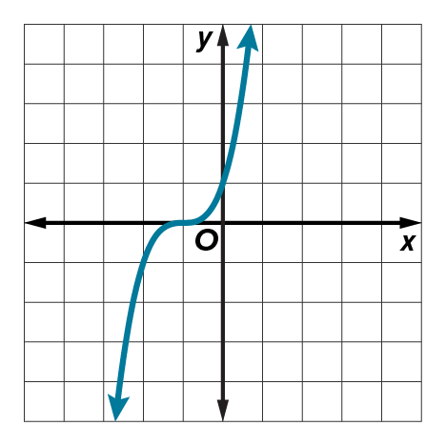
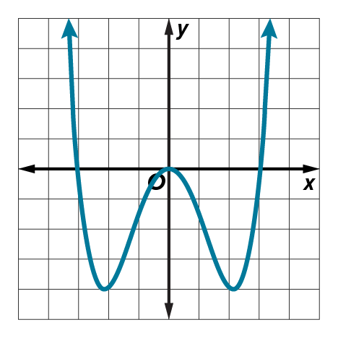
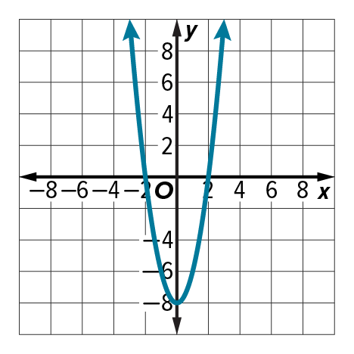
22. 23. 24.

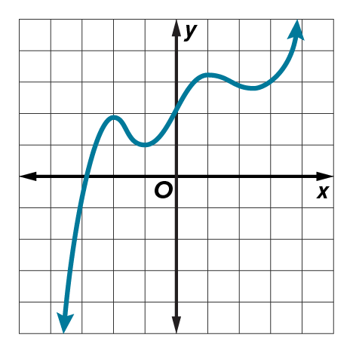
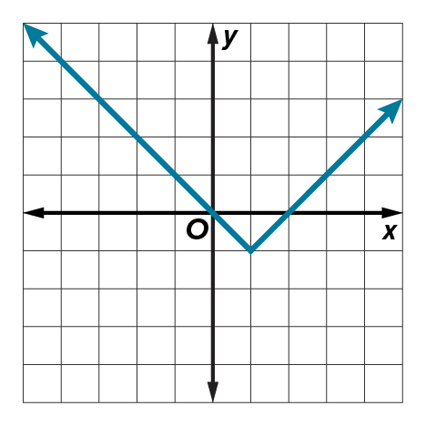
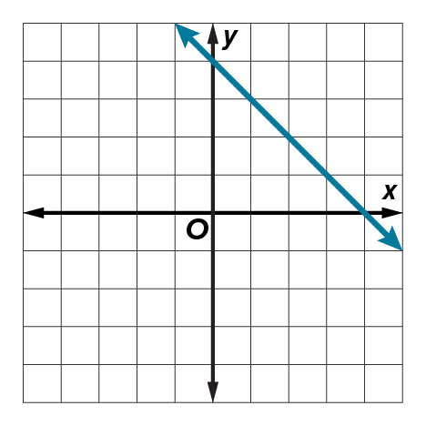
25. 26. 27.

28. USE A SOURCE Research the total number of games won by a professional baseball team each season for five consecutive years. Determine the domain, range, and continuity of the function that models the number of wins.

29. SPRINGS When a weight up to 15 pounds is attached to a 4-inch spring, the length L, in inches, that the spring stretches is represented by the function L(w) = $\frac{1}{2}w+4$, where w is the weight, in pounds, of the object. State the domain and range of the function. Then determine whether it is one-to-one, onto, both, or neither and whether it is discrete, continuous, or neither discrete nor continuous.

30. CASHEWS An airport snack stands sells whole cashews for $12.79 per pound. Determine whether the function that models the cost of cashews is discrete, continuous, or neither discrete nor continuous. Then state the domain and range of the function in set-builder and interval notation.

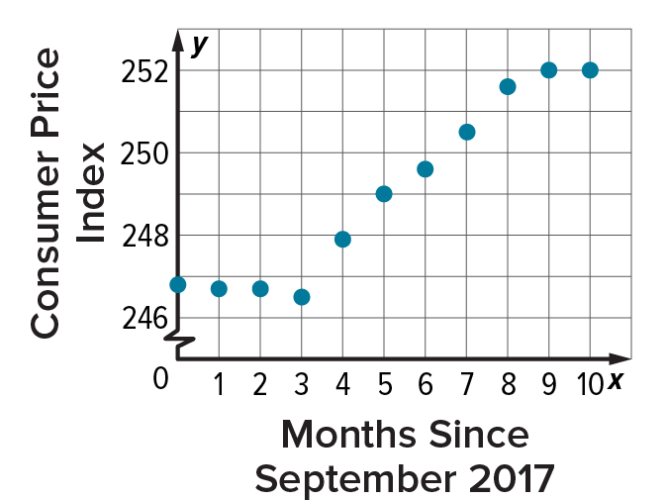
31. PRICES The Consumer Price Index (CPI) gives the relative price for a fixed set of goods and services. The CPI from September, 2000 to July, 2001 is shown in the graph. Determine whether the function that models the CPI is one-to-one, onto, both, or neither. Then state whether it is discrete, continuous, or neither discrete nor continuous.

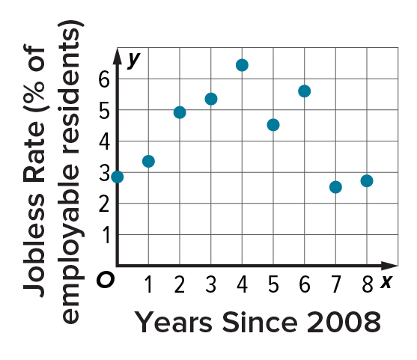
32. LABOR A town’s annual jobless rate is shown in the graph. Determine whether the function that models the jobless rate is one-to-one, onto, both, or neither. Then state whether it is discrete, continuous, or neither discrete nor continuous.

33. COMPUTERS If a computer can do one calculation in 0.0000000015 second, then the function T(n) = 0.0000000015n gives the time required for the computer to do n calculations. State the domain and range of the function. Then determine whether it is one-to-one, onto, both, or neither and whether it is discrete, continuous, or neither discrete nor continuous.

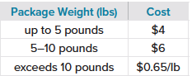
34. SHIPPING The table shows the cost to ship a package based on the weight of the package. Determine whether the function that models the shipping cost is discrete, continuous, or neither discrete nor continuous. Then state the domain and range of the function in set-builder notation.

35. CREATE Sketch the graph of a function that is onto, but not one-to-one, if the codomain is restricted to values greater than or equal to –3.

36. ANALYZE Determine whether the following statement is true or false. Explain your reasoning.
If a function is onto, then it must be one-to-one as well.

37. PERSEVERE Consider f(x) = $\frac{1}{x}$. State the domain and the range of the function. Determine whether the function is one-to-one, onto, both, or neither. Determine whether the function is discrete, continuous, or neither discrete nor continuous.

38. PERSEVERE Use the domain { −4, −2, 0, 2, 4}, the codomain { −4, −2, 0, 2, 4}, and the range
{0, 2, 4} to create a function that is neither one-to-one nor onto.

39. WRITE Compare and contrast the vertical and horizontal line tests.

