Linearity, Intercepts, and Symmetry ⸱ Practice

Example 1
Determine whether each function is a linear function. Justify your answer.
1. y = 3x 2. y = –2 + 5x

3. 2x + y = 10 4. y = 4$x^{2}$

Example 2
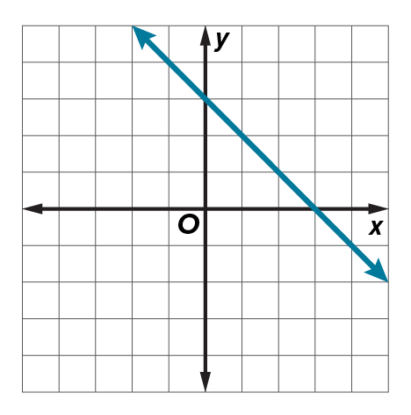
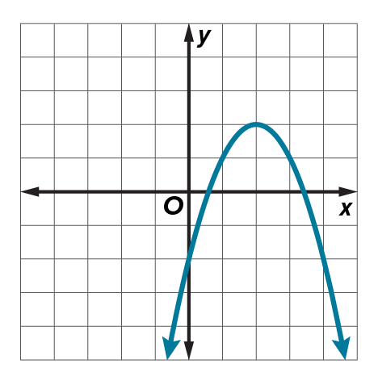
Determine whether each graph represents a linear or nonlinear function.
5. 6.

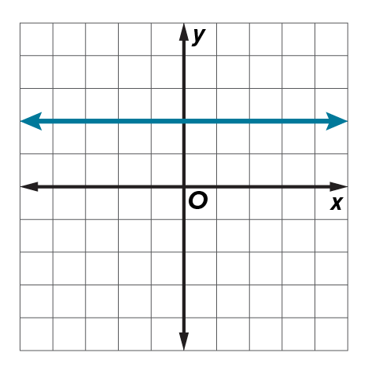
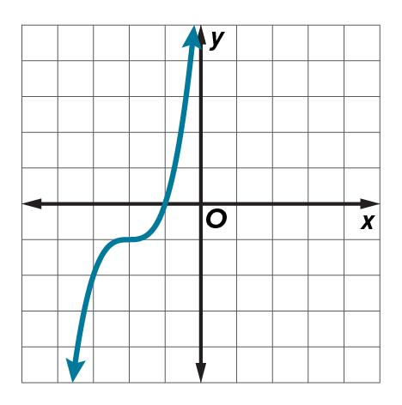
7. 8.

Example 3
9. MEASUREMENT The table shows a function modeling the number of inches and feet. Can the relationship be modeled by a linear or nonlinear function? Explain.

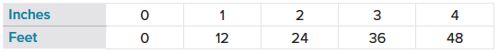

10. ASTRONOMY The table shows the velocity of Cassini 2 space probe as it passes Saturn. Is the velocity modeled by a linear or nonlinear function? Explain.

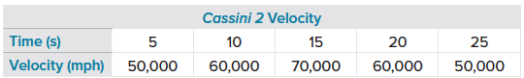

Examples 4 and 5
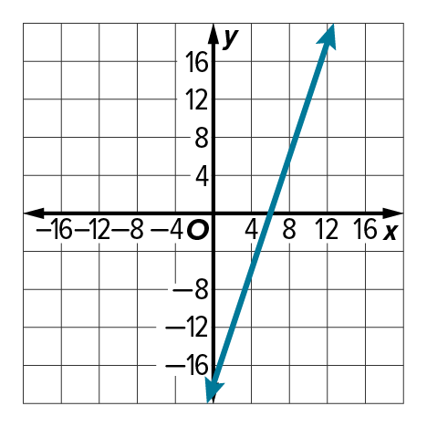
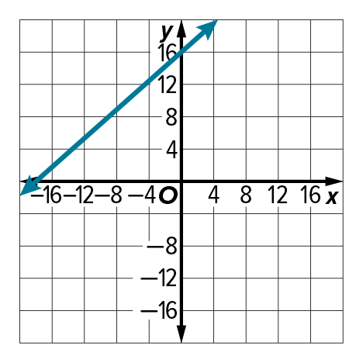
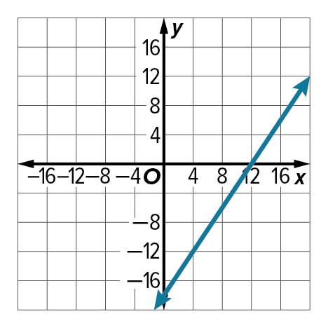
Use the graph to estimate the x- and y-intercepts.
11. 12. 13.

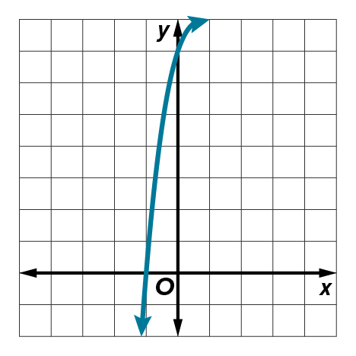
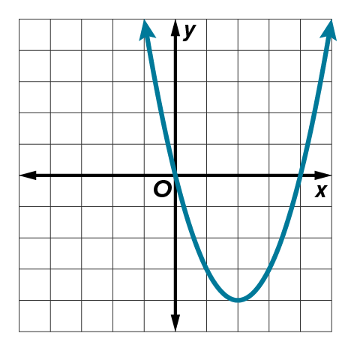
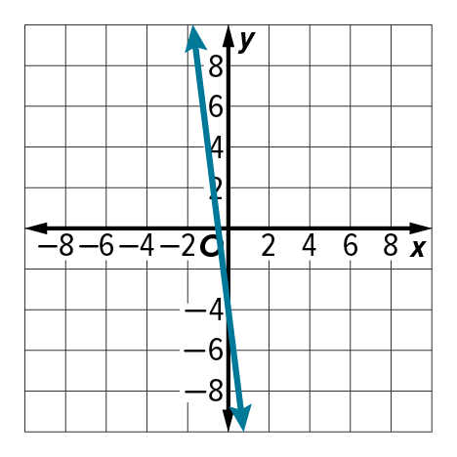
14. 15. 16.

Example 6
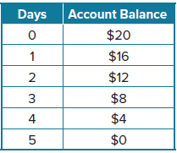
17. MONEY At the beginning of the week, Aksa’s parents deposited $20 into Aksa’s lunch account. The amount of money Aksa had left after each day is shown in the table, where x is the number of days and y is the remaining balance.
a. What are the x- and y-intercepts?
b. What do the x- and y-intercepts represent?

18. GOLF In golf, the first shot on every hole can be hit off a tee. The table shows the height y of the golf ball x seconds after it has been hit off the tee.

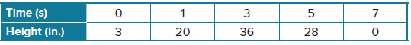

a. What are the x- and y-intercepts?
b. What do the x- and y-intercepts represent in the context of the situation?

Example 7
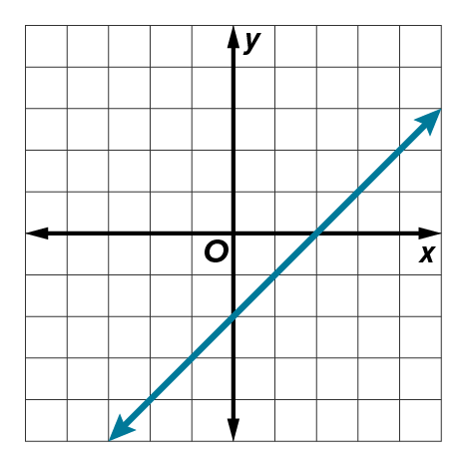
Identify the type of symmetry for the graph of each function.
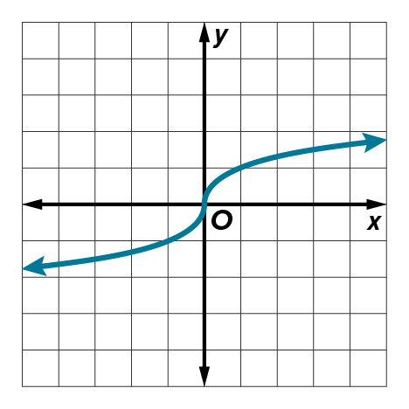
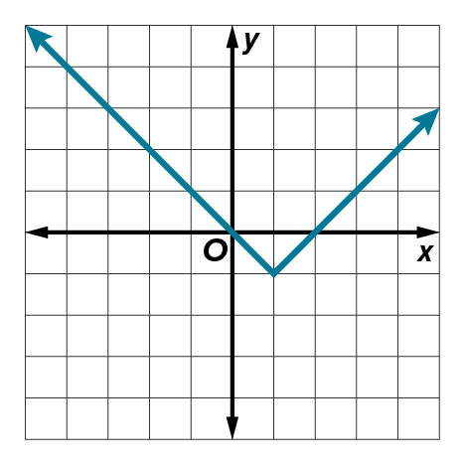
19. 20. 21.

Example 8
Determine whether each function is even, odd, or neither. Confirm algebraically. If the function is odd or even, describe the symmetry.
22. f(x) = 2x³ – 8x 23. f(x) = x³ + x² 24. f(x) = x² + 2
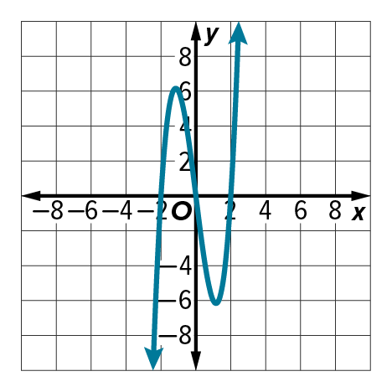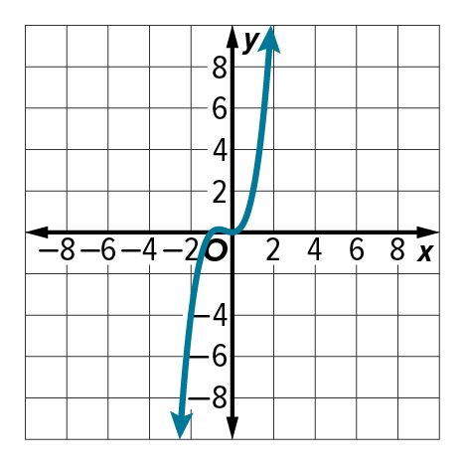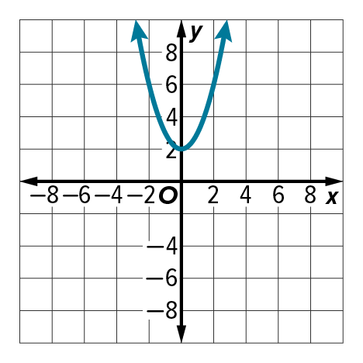

Mixed Exercises
Determine whether each equation represents a linear function. Justify your answer. Algebraically determine whether each equation is even, odd, or neither.
25. – $\frac{3}{x}$ + y = 15 26. x = y + 8 27. y = 8

28. y = $\sqrt{x }+3$ 29. y = 3x² ‒ 1 30. y = 2x³ + x + 1

Determine whether each graph represents a linear or nonlinear function. Use the graph to estimate the x- and y-intercepts. Identify the type of symmetry in each graph.
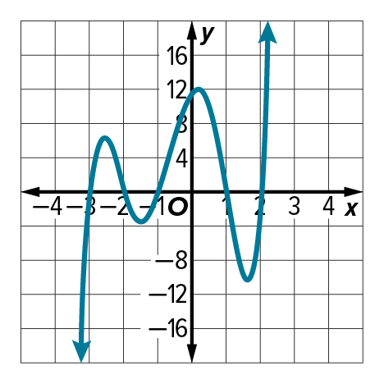
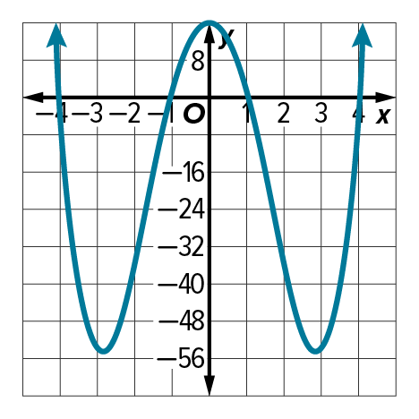
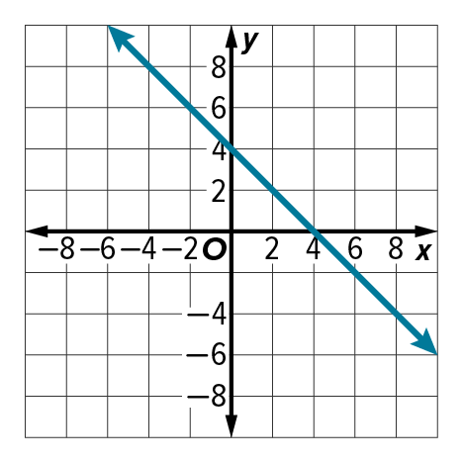
31. 32. 33.

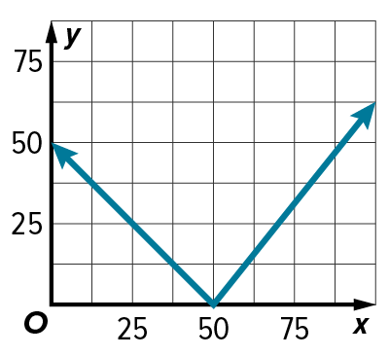
34. GAMES Pedro is creating an online racquetball game. In one play, the
motion of the ball across the screen is partially modeled by the graph
shown. State whether the graph has line symmetry or point symmetry,
and identify any lines or points of symmetry.

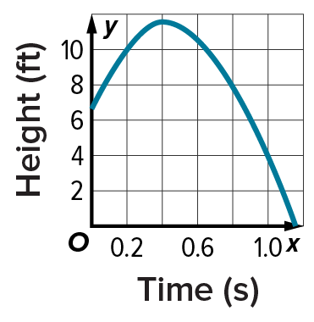
35. BASKETBALL Tiana tossed a basketball. The graph shows the height of the basketball as a function of time. If the graph of the function is extended to include the domain of all real numbers, would it have line or point symmetry? If so, identify the line or point of symmetry.

36. PROFIT Stefon charges people $25 to test the air quality in their homes. The device he uses to test air quality cost him $500. The function
y = 25x – 500 describes Stefon’s net profit, y, as a function of the number of clients he gets, x.
a. State whether the function is a linear function. Write yes or no. Explain.
b. What do the x- and y-intercepts of the function represent in terms of the situation?

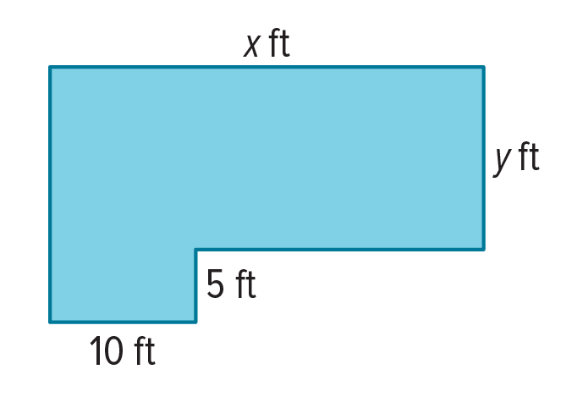
37. PLAYGROUNDS A playground is shaped as shown. The total perimeter is 500 feet.
a. Write an equation that relates x and y.

b. Is the equation that relates x and y linear? Explain.

c. Graph the equation. State whether the graph has line symmetry or point symmetry.

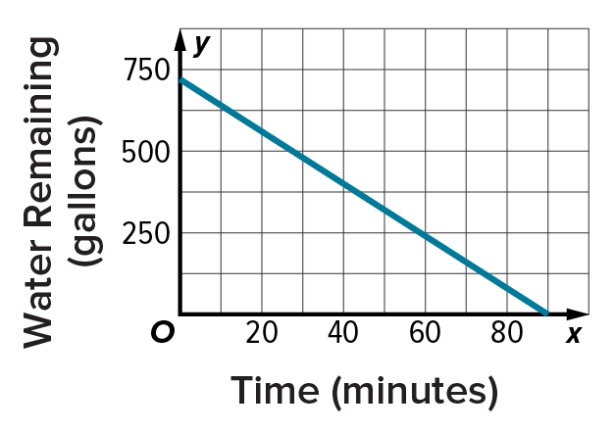
38. POOLS The graph represents a 720-gallon pool being drained.
a. What are the x- and y-intercepts? What do the x- and y-intercepts represent?
b. Does the graph display line symmetry? Explain why or why not in terms of the situation.

39. VOLUME The function, f(r) = $\frac{4}{3}πr^{3}$ describes the relationship between the volume f(r) and radius r of a sphere. Determine whether the function is odd, even, or neither. Explain your reasoning.

40. USE A SOURCE Research online to find an equation that models a car’s braking distance in relation to its speed. Then identify and interpret the y-intercept of the equation.

41. FIND THE ERROR Javier claimed that all cubic functions are odd. Is he correct? If not, provide a counterexample.

42. ANALYZE The table shows a function modeling the number of gifts y Cornell can wrap if he spends x hours wrapping. Can the table be modeled by a linear or nonlinear function? Explain.

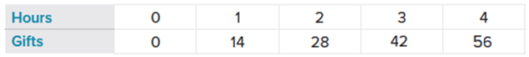

43. PERSEVERE Determine whether an equation of the form x = a, where a is a constant, is sometimes, always, or never a linear function. Explain your reasoning.

44. WHICH ONE DOESN’T BELONG? Of the four functions shown, identify the one that does not belong. Explain your reasoning.

