Extrema and End Behavior ⸱ Practice

Examples 1 and 2
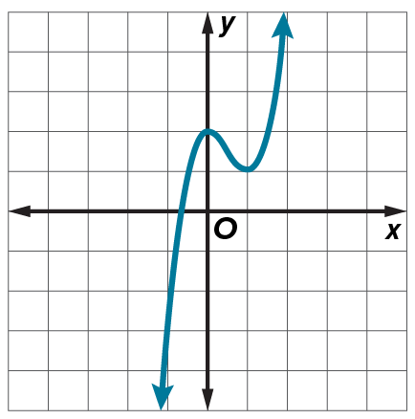
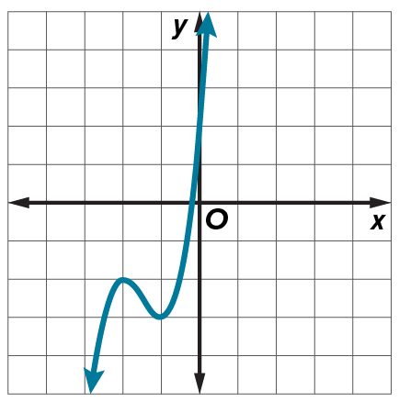
Identify and estimate the x- and y-values of the extrema. Round to the nearest tenth if necessary.
1. 2.

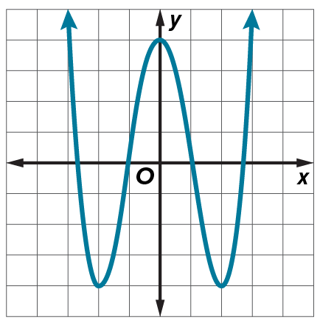
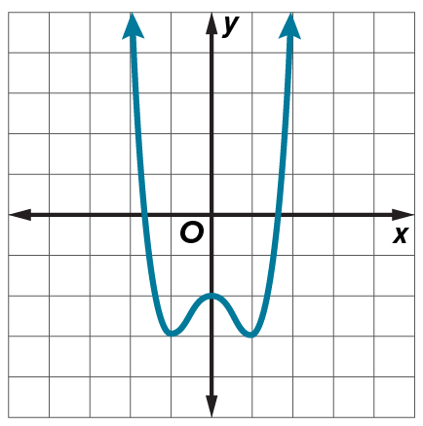
3. 4.

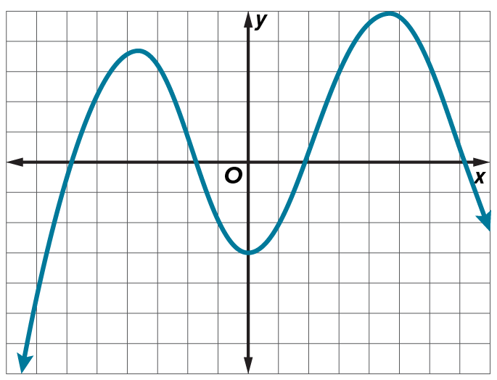
5. LANDSCAPES Jalen uses a graph of a function to model the shape of two hills in the background of a videogame that he is writing. Estimate the x-coordinates at which the relative maxima and relative minima occur. Describe the meaning of the extrema in the context of the situation.

Examples 3–5
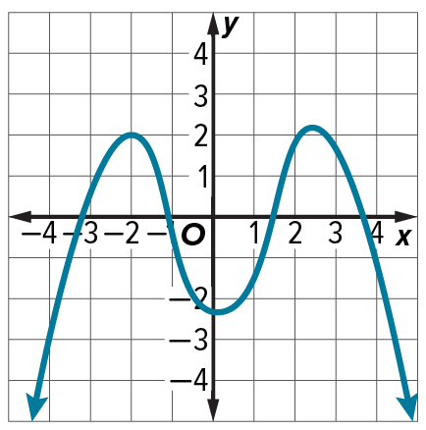
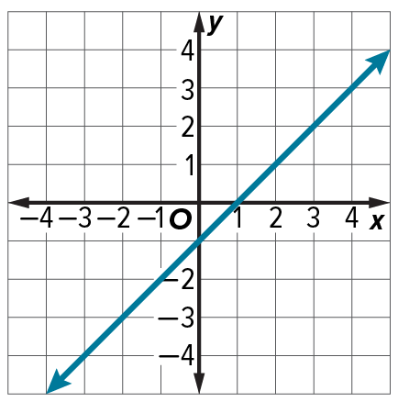
Describe the end behavior of each function.
6. 7.

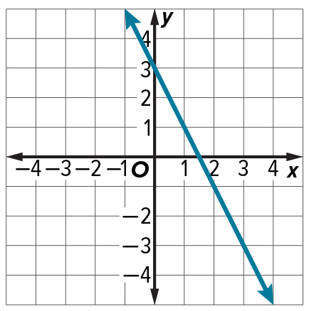
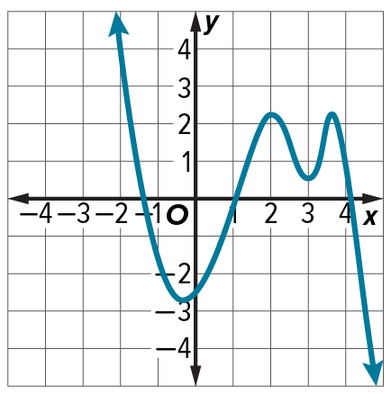
8. 9.

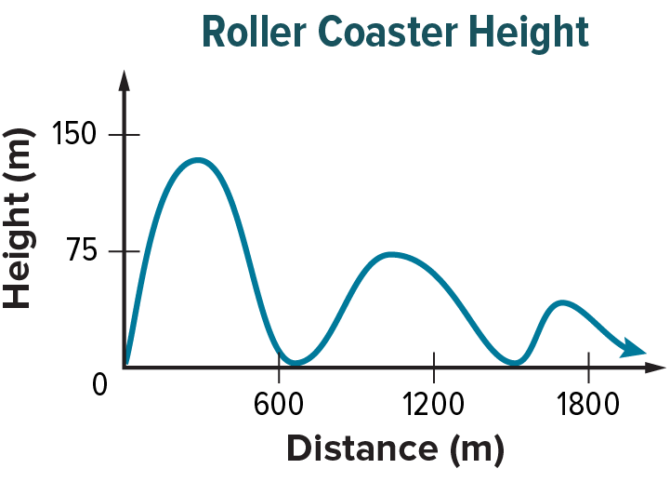
10. ROLLER COASTER The graph shows the height of a roller coaster in terms of its distance away from the starting point. Describe and interpret the end behavior in the context of the situation.

Mixed Exercises
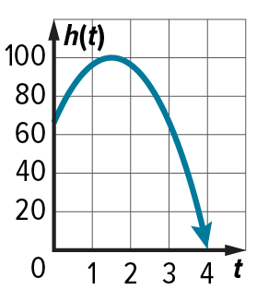
11. MODEL The height of a fish t seconds after it is thrown to a dolphin from a 64-foot-tall platform can be modeled by the equation h(t) = –16t² + 48t + 64, where h(t) is the height of the fish in feet. The graph of the function is shown.
a. Estimate the t-coordinate at which the height of the fish changes from increasing to decreasing. Describe the meaning in terms of the context of the situation.

b. Describe and interpret the end behavior of h(t) in the context of the situation.

Identify and estimate the x- and y-values of the extrema. Round to the nearest tenth if necessary. Then use the graphs to describe the end behavior of each function.
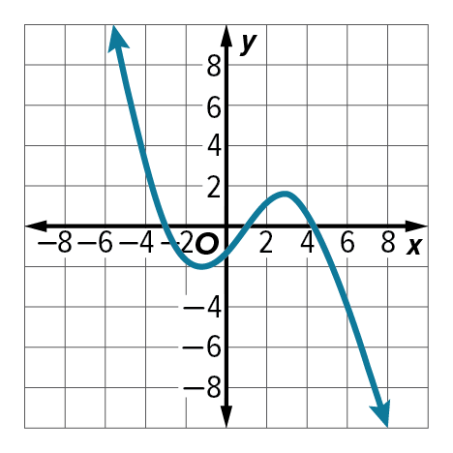
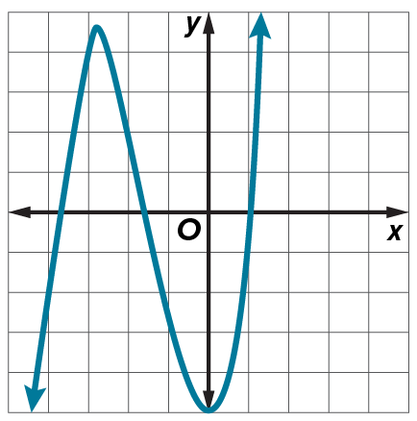
12. 13.

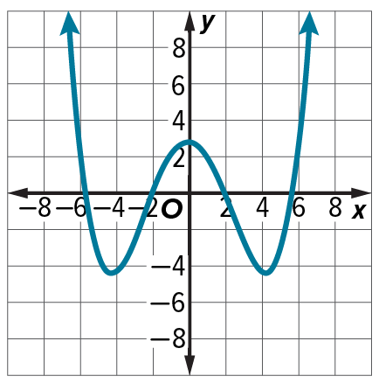
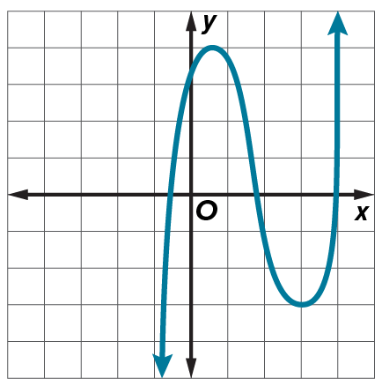
14. 15.

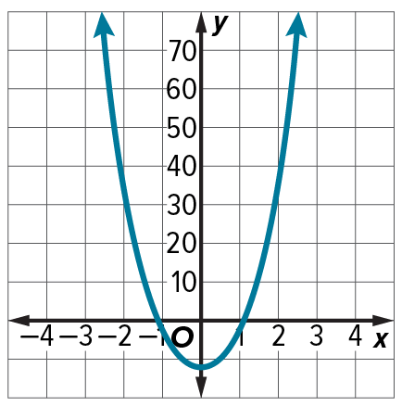
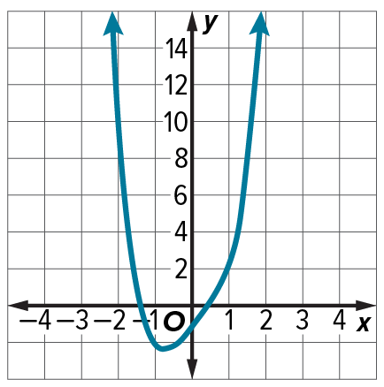
16. 17.

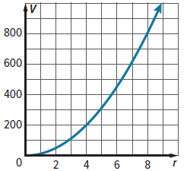
18. BUBBLES The volume of a soap bubble can be estimated by the formula V = 4πr², where r is its radius. The graph shows the function of the bubble's volume. Describe the end behavior of the graph.

19. SCIENCE The table shows the density of water at its saturation pressure
for various temperatures. Interpret the end behavior of the graph of the
function as temperature increases.

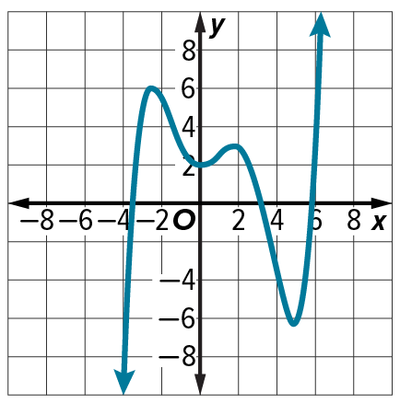
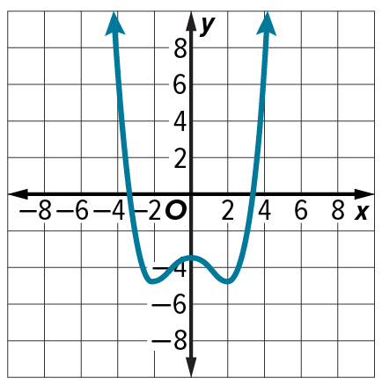
Identify and estimate the x- and y-values of the extrema. Round to the nearest tenth if necessary. Then describe the end behavior of each function.
20. 21.

USE ESTIMATION Use a graphing calculator to estimate the x-coordinates at which any extrema occur for each function. Round to the nearest hundredth.
22. f(x) = x³ + 3x² – 6x – 6 23. f(x) = –2x³ + 8

24. f(x) = –2x⁴ + 5x³ – 4x² + 3x – 7 25. f(x) = x⁵ – 4x³ + 3x² – 8x – 6

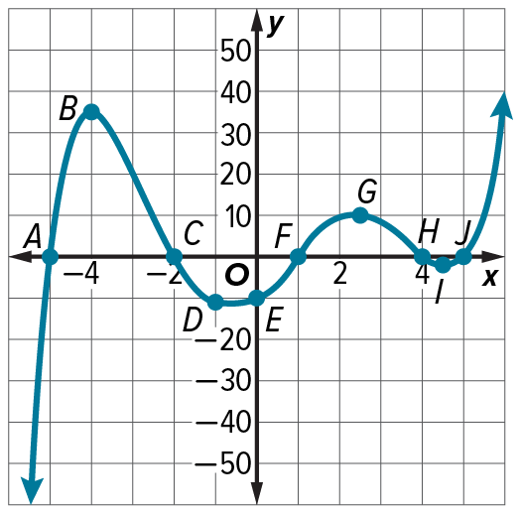
26. CONSTRUCT ARGUMENTS Sheena says that in the graph of f(x) shown at the right, the graph has relative maxima at B and G, and a relative minimum at A. Is she correct? Explain.

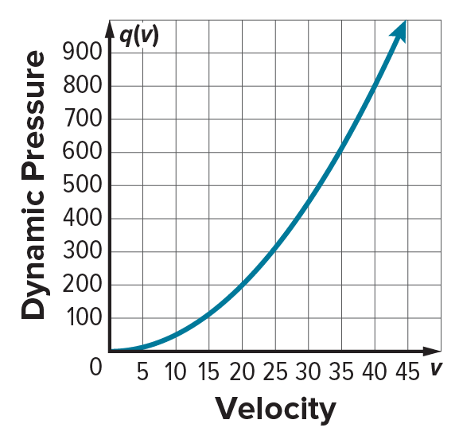
27. CHEMISTRY Dynamic pressure is generated by the velocity of a moving fluid and is given by q(v) = $\frac{1}{2}$pv², where p is the density of the fluid and v is its velocity. Water has a density of 1 g/cm³. What happens to the dynamic pressure of water when the velocity continuously increases?

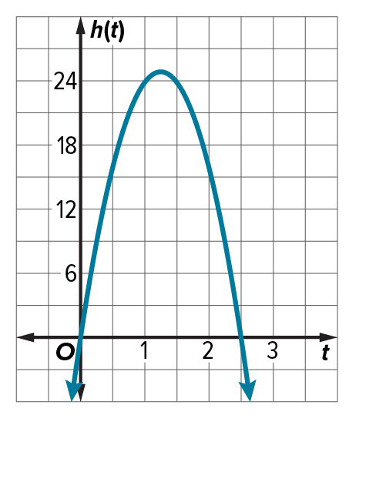
28. ENGINEERING Several engineering students built a catapult for a class project. They tested the catapult by launching a watermelon and modeled the height h of the watermelon in feet over time t in seconds.
a. Considering the context of the problem, what is an appropriate domain for h(t)? Explain your reasoning.
b. Use the graph of h(t) to find the maximum height of the watermelon. When does the watermelon reach the maximum height? Explain your reasoning.
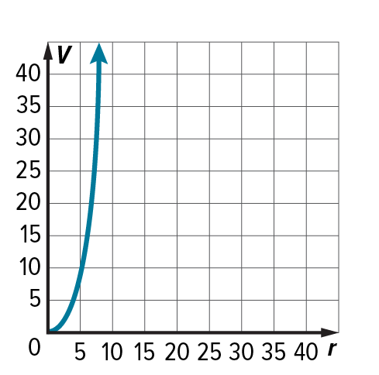
29. DRILLING The volume of a drill bit can be estimated by the formula for a cone,
V = $\frac{1}{3}$ ${πhr}^{2}$, where h is the height of the bit and r is its radius. Substituting $\frac{\sqrt{3}}{3}$r for h, the volume of the drill bit is estimated as $\frac{\sqrt{3}}{9}$ ${πr}^{3}$. The graph shows the function of drill bit volume. Describe the end behavior.

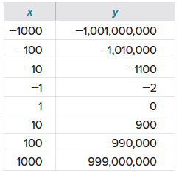
30. The table shows the values of a function. Use the table to describe the end behavior of the function.

31. WRITE Describe what the end behavior of a graph is and how it is determined.
32. CREATE Sketch a graph of a linear function and a nonlinear function with the following end behavior: as x → –∞, f(x) → ∞ and as x → ∞, f(x) → –∞.
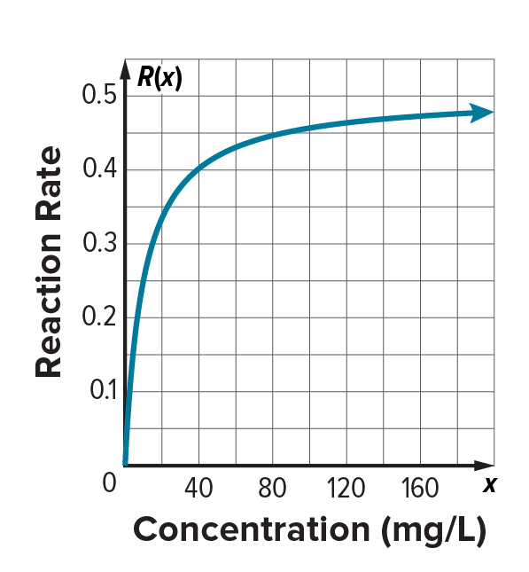

33. ANALYZE A catalyst is used to increase the rate of a chemical reaction. The reaction rate, or the speed at which the reaction is occurring, is given by R(x) = $\frac{0.5x}{x+10}$, where x is the concentration of the catalyst solution in milligrams of solute per liter. What does the end behavior of the graph mean in the context of this experiment?

34. PERSEVERE Sketch a graph with the following characteristics:
- 2 relative maxima
- 2 relative minima
- end behavior: x → ∞, f(x) → ∞ and as x → −∞, f(x) → −∞
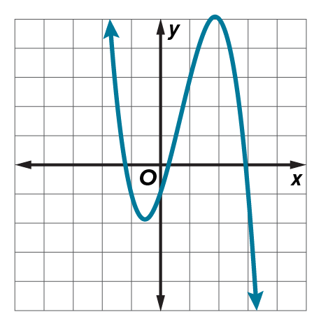
35. FIND THE ERROR Joshua states that the end behavior of the graph is: as x → –∞, f(x) → –∞ and as x → ∞, f(x) → ∞. What error did he make?

