Sketching Graphs and Comparing Functions ⸱ Practice

Examples 1 and 2
Use the key features of each function to sketch its graph.
1. x-intercept: (2, 0) 2. x-intercept: (0, 0)
y-intercept: (0, –6) y-intercept: (0, 0)
Linearity: linear Linearity: linear
Continuity: continuous Continuity: continuous
Positive: for values x > 2 Positive: for values x < 0
Increasing: for all values of x Negative: for values of x > 0
End Behavior: As x → ∞, f(x) → ∞ and Decreasing: for all values of x
as x → −∞, f(x) → −∞. End Behavior: As x → ∞, f(x) → −∞ and
as x → −∞, f(x) → ∞.

3. x-intercept: (5, 0) 4. x-intercept: (5, 0)
y-intercept: (0, 5) y-intercept: (0, 2)
Linearity: linear Linearity: linear
Continuity: continuous Continuity: continuous
Positive: for values x < 5 Positive: for values x < 5
Decreasing: for all values of x Decreasing: for all values of x
End Behavior: As x → ∞, f(x) → −∞ and End Behavior: As x → ∞, f(x) → −∞ and
as x → −∞, f(x) → ∞. as x → −∞, f(x) → ∞.

5. x-intercept: (–1, 0) and (1, 0) 6. x-intercept: (–3, 0) and (2, 0)
y-intercept: (0, 1) y-intercept: (0, –4)
Linearity: nonlinear Linearity: nonlinear
Continuity: continuous Continuity: continuous
Symmetry: symmetric about the line x = 0 Positive: for values x < −3 and x > 2
Positive: for values –1 < x < 1 Negative: for values of –3 < x < 2
Negative: for values of x < –1 and x > 1 Increasing: for all values of x > 0
Increasing: for all values of x < 0 Decreasing: for all values of x < 0
Decreasing: for all values of x > 0 Extrema: minimum at (0, −4)
Extrema: maximum at (0, 1) End Behavior: As x → ∞, f(x) → ∞ and
End Behavior: As x → ∞, f(x) → −∞ and as x → −∞, f(x) → ∞.
as x → −∞, f(x) → −∞.

7. x-intercept: (1, 0) 8. x-intercept: (–2, 0) and (2, 0)
y-intercept: (0, –1) y-intercept: (0, –1)
Linearity: linear Linearity: nonlinear
Continuity: continuous Continuity: continuous
Positive: for values x > 1 Symmetry: symmetric about the line x = 0 Increasing: for all values of x Positive: for values x < −2 and x > 2
End Behavior: As x → −∞, f(x) → −∞ and Negative: for values of –2 < x < 2
as x → ∞, f(x) → ∞. Increasing: for all values of x > 0
Decreasing: for all values of x < 0
Extrema: minimum at (0, −1)
End Behavior: As x → −∞, f(x) → ∞ and
as x → ∞, f(x) → ∞.

Example 3
9. PELICANS A pelican descends to the ground. The pelican starts at a height of 6 feet. The pelican reaches the ground, at a height of 0 feet, after 3 seconds. The function that models the situation is linear. Use the key features to sketch a graph.

10. SCOOTERS Greg rides his motorized scooter for 20 minutes. Greg starts riding at 0 mph. Greg’s maximum speed is 35 mph, which he reaches 5 minutes after he starts riding. Greg’s speed increases steadily for 5 minutes. At the 10-minute mark, Greg decreases his speed for
2.5 minutes, then he stays at 20 mph for 5 minutes. At the 17.5-minute mark, he again decreases his speed for 2.5 minutes until he stops. Use the key features to sketch a graph.

Examples 4 and 5
11. Compare the key features of the functions represented with a graph and a table.
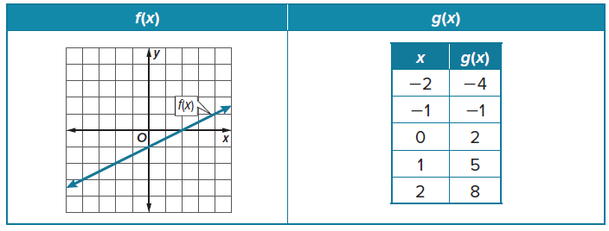

12. Compare the key features of the functions represented with a graph and a verbal description.
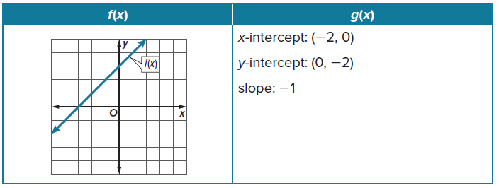

13. Compare the key features of the functions represented with a table and a verbal description.
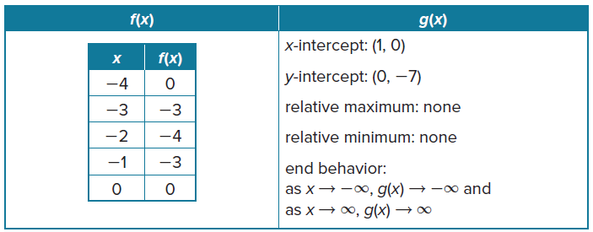

14. Compare the key features of the functions represented with a graph and a verbal description.
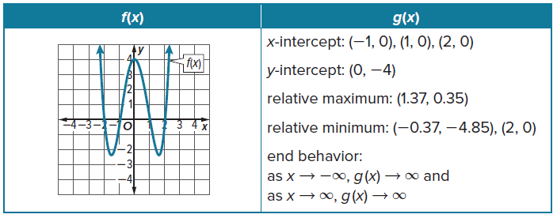

15. Compare the key features of the functions represented with a table and a verbal description.
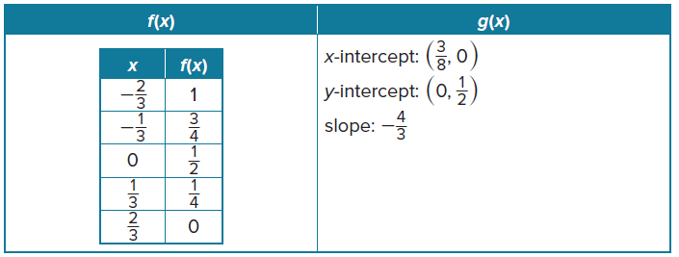

16. Compare the key features of the functions represented with a graph and a table.
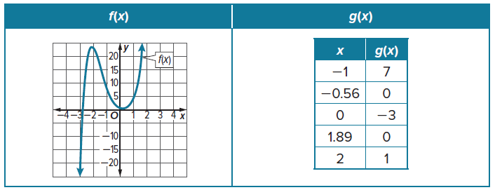

Mixed Exercises
17. USE A MODEL Sketch the graph of a linear function with the following key features. The
x-intercept is 2. The y-intercept is 2. The function is decreasing for all values of x. The function is positive for x < 2. As x → –∞, f(x) → ∞ and as x → ∞, f(x) → –∞.

18. WATER Sia filled a pitcher with water. The pitcher started with 0 ounces of water. After 8 seconds the pitcher contains 64 ounces of water. The function that models the situation is linear.
a. Use the key features to sketch a graph.
b. What is the end behavior of the graph? Explain.

19. USE TOOLS Monica walks for 60 minutes. She starts walking from her house. The maximum distance Monica is from her house is 2 miles, which she reaches 30 minutes after she starts walking. At the 30-minute mark, Monica starts walking back to her house for 30 minutes until she reaches her house. Use the key features to sketch a graph.

20. USE A SOURCE Research the value of a new car after it is purchased. Use the information you collect to describe key features of a graph that represents the value of a new car x years after it is purchased. Then use the key features to sketch a graph.

21. SKI LIFTS A ski lift descends at a steady pace down a mountainside from a height of 1800 feet to ground level. If it makes no stops along the way to load or unload passengers, then the time it takes to complete its descension is 4 minutes.
a. Is the graph that relates the lift’s height as a function of time linear or nonlinear? Explain.
b. Use the key features to sketch a graph.
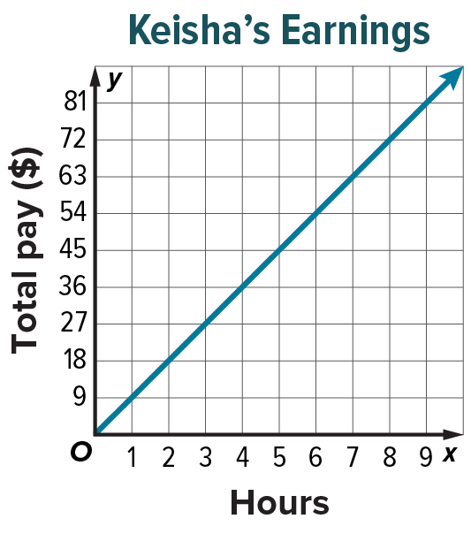
22. CONSTRUCT ARGUMENTS Keisha babysits for her aunt for an hourly rate of $9. The graph shows Keisha’s earnings y as a function of hours spent babysitting x. Explain why the graph only exists for positive x- and y-values.

23. CREATE Choose a function and create a list key features to describe the function. Then sketch the function.

24. WRITE Describe the relationship between the slope of a linear function and when the function is increasing or decreasing.

25. ANALYZE Determine whether the statement is always, sometimes, or never true.
A graph that has more than one x-intercept is represented by a nonlinear function.

26. PERSEVERE Deborah filled an empty tub with water for 30 minutes. The maximum amount of water in the tub is 50 gallons, which is reached 10 minutes after Deborah starts filling the tub. The amount of water in the tub increases steadily for 10 minutes. At the 10-minute mark, the amount of water in the tub starts decreasing for 20 minutes until there is no water left in the tub.
a. Use the key features to sketch a graph.
b. Describe an event that could have occurred at the 10-minute mark if Deborah continues filling the tub at the same rate from the 10-minute mark to the 30-minute mark as the rate from the 0-minute mark to the 10-minute mark.

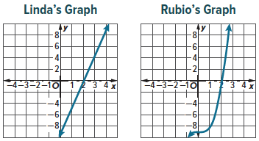
27. FIND THE ERROR Linda and Rubio sketched a graph with the following key features. The x-intercept is 2. The y-intercept is
–9. The function is positive for x > 2. As x → –∞, f(x) → –∞ and as x → ∞, f(x) → ∞. Is either graph correct based on the key features? Explain your reasoning.

