Special Functions ⸱ Practice

Examples 1 and 2
Graph each function. Then, analyze the key features.
1. f(x) = $\left\{\begin{matrix}-1 \\ 2x \\ 6\end{matrix}\begin{aligned}if x≤0 \\ if 0<x≤ 3 \\ if x>3\end{aligned}\right.$ 2. f(x) = $\left\{\begin{matrix}-x \\ 0 \\ x\end{matrix} \begin{matrix} if x<-1 \\ if -1≤x≤ 1 \\ if x>1\end{matrix}\right.$

3. f(x) = $\left\{\begin{aligned}x if x<0 \\ 2 if x≥0\end{aligned}\right.$ 4. h(x) = $\left\{\begin{matrix}3 \\ x+1\end{matrix}\begin{aligned} if x<-1 \\ if x>1\end{aligned}\right.$

5. TILE Mark is purchasing new tile for his bathrooms. The home improvement store charges
$48 for each box of tiles when three or fewer boxes are purchased, $45 for each box when
4 to 8 boxes are purchased, $42 for each box when 9 to 19 boxes are purchased, and $38 for each box when more than nineteen boxes are purchased.
a. Write a piecewise-defined function describing the cost of the boxes of tile.
b. What is the cost of purchasing 5 boxes of tile? What it is the cost of purchasing
19 boxes of tile?

6. BOOKLETS A digital media company is ordering booklets to promote their business. The manufacturer charges $0.50 for each booklet when 50 or fewer are ordered, $0.45 for each booklet when 51 to 100 booklets are ordered, $0.40 for each booklet when 101 to 250 booklets are ordered, and $0.35 for each booklet when 251 or more booklets are ordered. Each order consists of a $10 shipping charge, no matter the size of the order.
a. Write a piecewise-defined function describing the cost of ordering booklets.
b. What is the cost of purchasing 132 booklets? What it is the cost of purchasing
518 booklets?

Examples 3 and 4
Graph each function. State the domain and range.
7. f(x) = $⟦x⟧-6$ 8. h(x) = $⟦3x⟧-8$

9. f(x) = $⟦x + 1⟧$ 10. f(x) = $⟦x - 3⟧$

11. PARKING The rates at a short-term parking garage are $5.00 for 2 hours or less, $10.00 for 4 hours or less, $15.00 for 6 hours or less, and $20.00 for 8 hours or less. Draw a graph that represents the charges. State the domain and range.

12. BOWLING The bowling alley offers special team rates. They charge $30 for one hour or less of team bowling, $45 for 2 hours or less, and $60 for unlimited bowling after 2 hours of play. Draw a graph that represents the charges. State the domain and range.

Examples 5 and 6
Graph each function. State the domain and range.
13. f(x) = |x – 5| 14. g(x) = |x + 2|

15. h(x) = |2x| – 8 16. k(x) = |–3x| + 3

17. f(x) = 2|x – 4| + 6 18. h(x) = –3|0.5x + 1| – 2

19. g(x) = 2|x| 20. f(x) = |x| + 1

Mixed Exercises
Graph each function. State the domain and range.
21. f(x) = $\left\{\begin{matrix}-3x \\ x \\ 8\end{matrix}\begin{aligned} if x≤-4 \\ if 0<x≤3 \\ if x>3\end{aligned}\right.$ 22. f(x) = $\left\{\begin{matrix}2x \\ 5 \\ -2x+1\end{matrix}\begin{aligned} if x≤-6 \\ if-6<x≤2 \\ if x>4\end{aligned}\right.$

23. g(x) = $\left\{\begin{matrix}2x+2 \\ x \\ -3\end{matrix}\begin{aligned} if x<-6 \\ if-6≤x≤2 \\ if x>2\end{aligned}\right.$ 24. g(x) = $\left\{\begin{matrix}-2 \\ x-3 \\ 2x-15\end{matrix}\begin{aligned} if x<-4 \\ if-1≤x≤5 \\ if x>7\end{aligned}\right.$

25. f(x) = $\left\{\begin{matrix}-0.5x+1.5 \\ x-4\end{matrix}\begin{aligned} if x≤1 \\ if x>1\end{aligned}\right.$ 26. f(x) = |x – 2|

27. f(x) = $⟦x+2⟧$ 28. g(x) = $2⟦0.5x + 4⟧$

29. f(x) = $⟦|0.5x|⟧$ 30. g(x) = |$⟦2x⟧$|

31. g(x) = $\left\{\begin{matrix}⟦x⟧ \\ x+1 \\ -x\end{matrix}\begin{aligned} if x<-4 \\ if-4≤x≤3 \\ if x>3\end{aligned}\right.$ 32. h(x) = $\left\{\begin{matrix}-\left|x\right| \\ \left|x\right| \\ \left|-x\right|\end{matrix}\begin{aligned} if x<-6 \\ if-6≤x≤2 \\ if x>2\end{aligned}\right.$

33. Identify the domain and range of h(x) = |x + 4| + 2.

34. FINANCE For every transaction, a certain financial advisor gets a 5% commission,
regardless of whether the transaction is a deposit or withdrawal. Write a formula
using the absolute value function for the advisor’s commission C. Let D represent
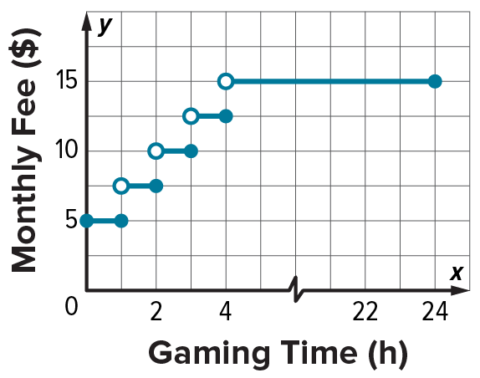
the value of one transaction.

35. GAMING The graph shows the monthly fee that an online
gaming site charges based on the average number of hours spent
online per day. Write the function represented by the graph.

36. ROUNDING A science teacher instructs students to round their
measurements as follows: If the decimal portion of a measurement is
less than 0.5 mm, round down to the nearest whole millimeter. If the
decimal portion of a measurement is exactly 0.5 or greater, round up to the next whole millimeter. Write a formula to represent the rounded measurements.

37. REUNIONS The cost to reserve a banquet hall is $500. The catering cost per guest is
$17.50 for the first 40 guests and $14.75 for each additional guest.
a. Write a piecewise-defined function describing the cost C of the reunion.
b. Use a graphing calculator to graph the function.
c. If the Cramers can spend up to $900 on the event, what is the greatest number of guests that can attend? Explain.

38. SAVINGS Nathan puts $200 into a checking account when he gets his paycheck each month. The value of his checking account is modeled by v = 200$⟦m⟧$, where m is the number of months that Nathan has been working. After 105 days, how much money is in the account?

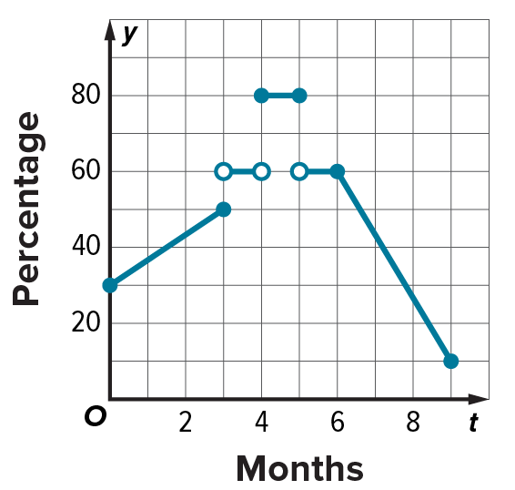
39. POLITICS The approval rating R(t), measured as a percent, of a class officer during her 9-month term starting in September is described by the graph, where t is her time in office.
a. Formulate a piecewise-defined function R(t) describing the approval rating of this class officer. Then, identify the range.
b. During which months is the approval rating increasing?

40. STUCTURE Consider the functions f(x) = $3⟦x⟧$ and g(x) = $⟦3x⟧$ for 0 ≤ x ≤ 2.
a. Graph each function.
b. What effect does this 3 appear to have on the graphs?
c. Consider the functions f(x) = $4⟦x⟧$ and g(x) = $⟦4x⟧$ for 0 ≤ x ≤ 2. Graph
each function.
d. What effect does this 4 appear to have on the graphs?
e. Generalize your findings from parts a through d to explain the differences between f(x) = $n⟦x⟧$ and g(x) = $⟦nx⟧$ for 0 ≤ x ≤ 2, where n is any positive integer greater than or equal to 2.

41. USE TOOLS Use a graphing calculator to graph the absolute value of the greatest integer of x, or f(x) = |$⟦x⟧$|. Is the graph what you expected? Explain.

Write a piecewise-defined function for each graph.
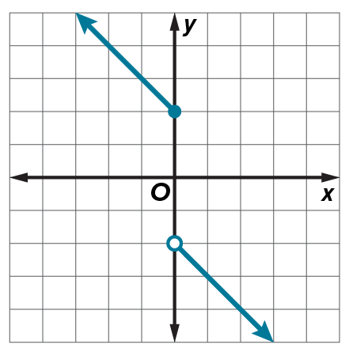
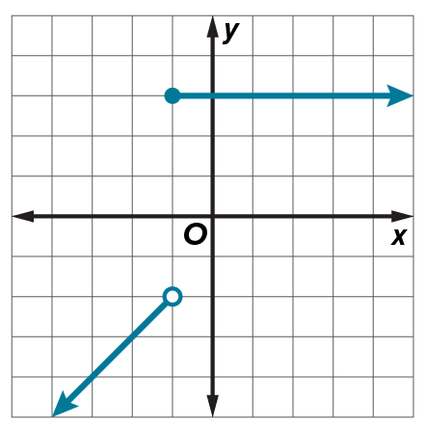
42. 43.

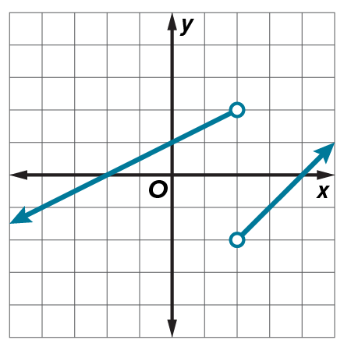
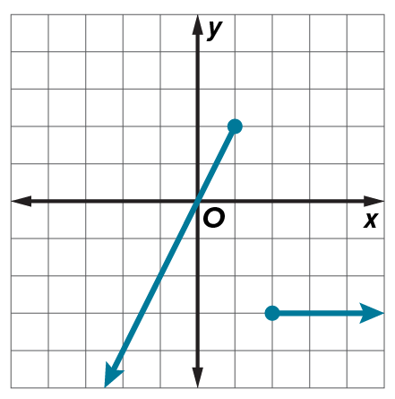
44. 45.

46. SKYSCRAPERS To clean windows of skyscrapers, some companies use a
carriage. A carriage is mounted on a railing on the roof of a skyscraper and
moves up and down using cables. A crew plans to start at the 12th floor and move
the carriage down as they clean the windows on the west side of a building. If the
crew members clean windows at a constant rate of 0.75 floor per hour, the
absolute value function f(t) = |0.75t – 12| represents the number of floors
above ground level that the carriage is after t hours. Graph the function.
How far above ground level is the carriage after 4 hours?

47. TAXIS The table shows the cost C of a taxi ride of m miles. Graph the function. State the domain and range.
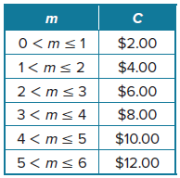

48. WALKING Jackson left his house and walked at a constant rate. After 20 minutes, he was 2 miles from his house. Jackson then walked back towards his house at a constant rate. After another
30 minutes he arrived at his house.
a. Jackson wants to write a function to model the distance from his house d as after t minutes. Should Jackson write an absolute value function or a piecewise-defined function? Explain your reasoning.
b. Write an appropriate function to model the distance from his house d as after
t minutes.
c. Graph the function.
d. State the domain and range.

49. CREATE Write an absolute value relation in which the domain is all nonnegative numbers and the range is all real numbers.

50. PERSEVERE Graph |y| = 2|x + 3| – 5.

51. ANALYZE Find a counterexample to the statement and explain your reasoning.

In order to find the greatest integer function of x when x is not an integer, round x to the
nearest integer.

52. CREATE Write an absolute value function in which f(5) = –3.

53. WRITE Explain how piecewise functions can be used to accurately represent
real-world problems.

54. WRITE Explain the difference between a piecewise function and step function.

