Transformations of Functions ⸱ Practice

Example 1
Describe each translation as it relates to the graph of the parent function.
1. y = x² + 4 2. y = |x| – 3

3. y = x – 1 4. y = x + 2

5. y = (x – 5)² 6. y = |x + 6|

Example 2
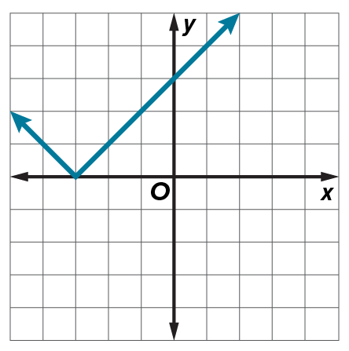
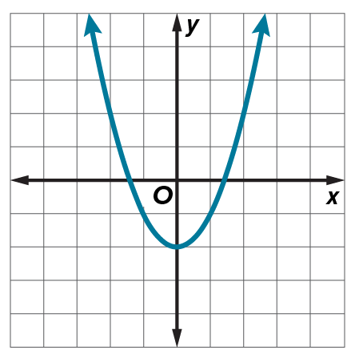
Use the graph of each translated parent function to write its equation.
7. 8.

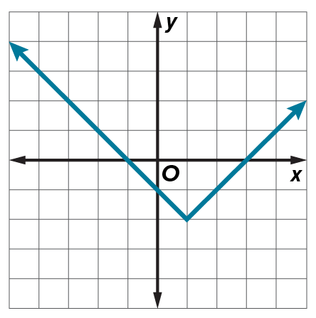
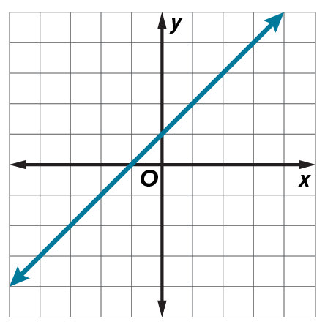
9. 10.

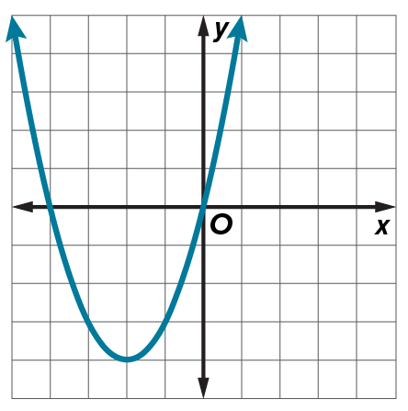
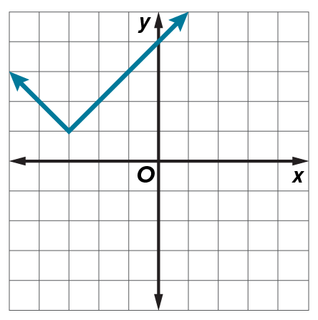
11. 12.

Examples 3 and 4
Describe each dilation and reflection as it relates to the parent function.
13. y = (–3x)² 14. y = –6x

15. y = –4|x| 16. y = |–2x|

17. y = $-\frac{2}{3}$x 18. y = $-\frac{1}{2}$x²

19. y = $\left|-\frac{1}{3}x\right|$ 20. y = ${\left(-\frac{3}{4}x\right)}^{2}$

Example 5
Describe each transformation as it relates to the graph of the parent function.
21. y = –6|x| – 4 22. y = 3x + 11

23. y = $\frac{1}{3}$x² – 2 24. y = $\frac{1}{2}$|x – 1| + 14

25. y = –0.8(x + 3) 26. y = (1.5x)² + 22

Example 6
27. BILLIARDS The function g(x) = |0.5x| models the path of a cue ball in a certain shot on a pool table, where the x-axis represents the edge of the table. Describe how g(x) is related to its parent function and interpret the function in the context of the situation.

28. SALAD The cost for a salad depends on its weight, x, in ounces, and is described by
c(x) = 4.5 + 0.32x. Describe how c(x) is related to its parent function and interpret the function
in the context of the situation.

29. TRAVEL The cost to travel x miles east or west on a train is the same. The function for the cost is c(x) = 0.75|x|+ 25. Describe how c(x) is related to its parent function and interpret the function in the context of the situation.

30. ARCHERY The path of an arrow can be modeled by h(x) = –0.03x² + 6, where x is distance and h(x) is height, both in feet. Describe how h(x) is related to its parent function and interpret the function in the context of the situation.

Example 7
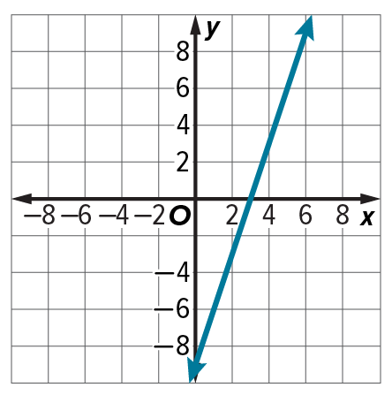
Write an equation for each function.
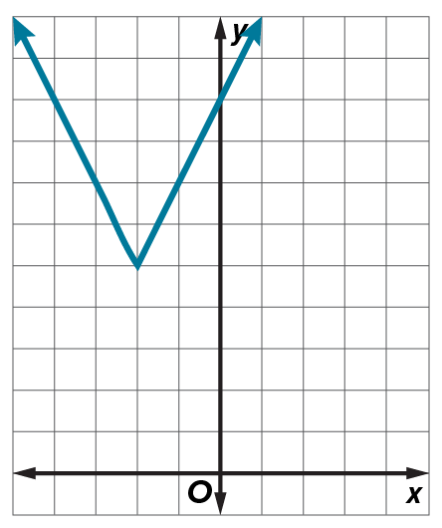
31. 32.

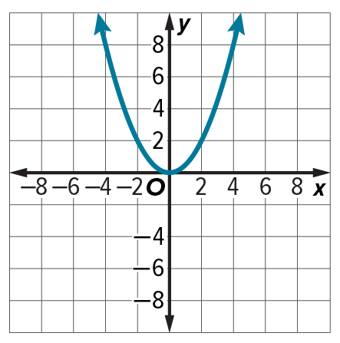
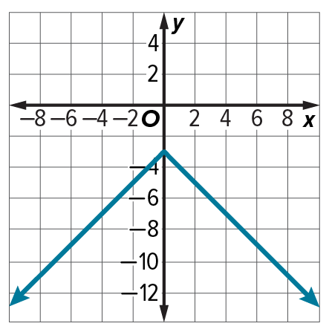
Write an equation for each function.
33. 34.

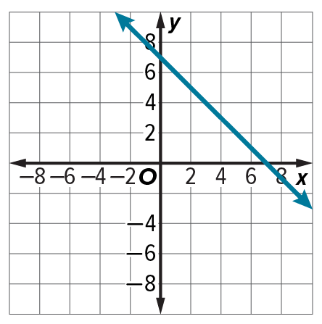
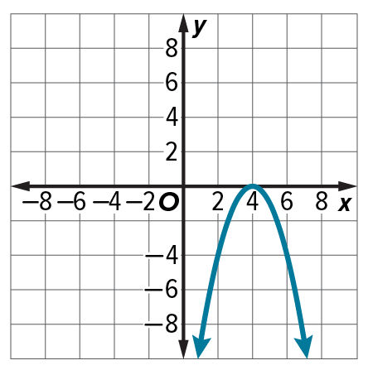
35. 36.

Mixed Exercises
Describe each transformation as it relates to the graph of the parent function. Then graph
the function.
37. y = |x| – 2 38. y = ${(x + 1)}^{2}$

39. y = –x 40. y = –|x|

41. y = 3x 42. y = 2x²

43. Describe the translation in y = x² – 4 as it relates to the parent function.

44. Describe the reflection in y = –x³ as it relates to the parent function.

45. Describe the type of transformation in the function f(x) = ${(5x)}^{2}$.

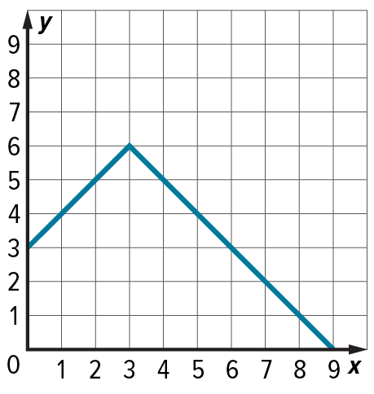
46. ARCHITECTURE The cross-section of a roof is shown in the figure. Write an absolute value function that models the shape of the roof.

47. SPEED The speedometer in Henry’s car is broken. The function
y = |x – 8| represents the difference y between the car’s actual speed x
and the displayed speed.
a. Describe the translation. Then graph the function.
b. Interpret the function and the translation in terms of the context of the
situation.

48. GRAPHIC DESIGN Kassie sketches the function f(x) = ‒1.25(x ‒ 1)² + 18.75 as part of a new logo design. Describe the transformations she applied to the parent function in creating her function.

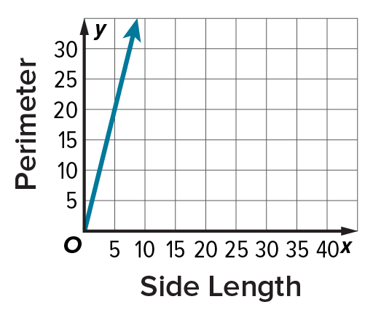
49. GEOMETRY Chen made a graph to show how the perimeter of a square changes as the length of sides increase. How is this graph related to the parent function y = x?

50. REASONING Compare the graph of the parent function f(x) = |x| with the graphs of g(x) = |x + 2| and h(x) = |x – 3|. How are the graphs similar? How are they different?

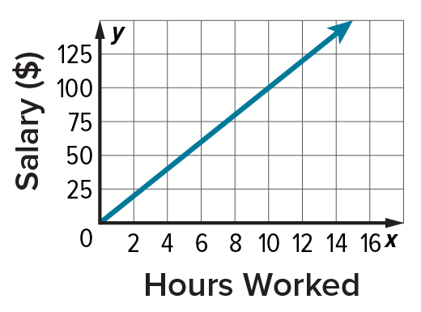
51. BUSINESS Maria earns $10 an hour working as a lifeguard. She drew the graph to show the relation of her income as a function of the hours she works. How did she modify the function y = x to create her graph?

52. ANALYZE What determines whether a transformation will affect the graph vertically or horizontally? Use the family of quadratic functions as an example.

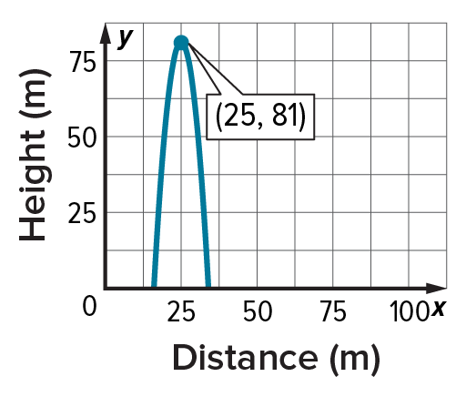
53. PERSEVERE Laura ketches the path of a model rocket that she launches.
a. What type of function does the graph show?
b. In which axis has the parent function been reflected?
c. How has the graph been translated? Assume that the function has not been dilated.
d. What is the equation for the curve shown on the graph?

54. ANALYZE Graph g(x) = –3|x + 5| – 1. Describe the transformations of the parent function
f(x) = |x| that produce the graph of g(x). What are the domain and range?

55. ANALYZE Consider f(x) = |2x|, g(x) = x + 2, h(x) = 2x², and k(x) = 2x³.
a. Graph each function and its reflection in the y-axis.
b. Analyze the functions and the graphs. Determine whether each function is odd, even,
or neither.
c. Recall that if for all values of x, f(–x) = f(x) the function f(x) is an even function. If for all values of x, f(–x) = –f(x) the function f(x) is an odd function. Explain why this is true.

56. PERSEVERE Explain why performing a horizontal translation followed by a vertical translation has the same results as performing a vertical translation followed by a horizontal translation.

57. CREATE Draw a graph in Quadrant II. Use any of the transformations you learned in this lesson to move your figure to Quadrant IV. Describe your transformation.

58. ANALYZE Study the parent graphs at the beginning of this lesson. Select a parent graph with positive y-values when x → ─∞ and positive y-values when x → ∞.

59. WRITE Explain why the graph of g(x) = (─x)² appears the same as the graph of f(x) = x². Is this true for all reflections of quadratic functions? If not, describe a case when it is false.

