Solving Linear Equations and Inequalities ⸱ Practice

Example 1
Solve each equation. Check your solution.
1. 6x – 5 = 7 – 9x 2. –1.6r + 5 = –7.8 3. $\frac{3}{4}$ – $\frac{1}{2}$n = $\frac{5}{8}$

4. $\frac{5}{6}$c + $\frac{3}{4}$ = $\frac{11}{12}$ 5. 2.2n + 0.8n + 5 = 4n 6. 6y – 5 = –3(2y + 1)

7. –6(2x + 4) + $\frac{1}{2}$ (8 + 3x) = –20 8. 7(–1 + 4x) – 12x = 5 9. –4(10 + 3x) – (x + 8) = –9

Example 2
Solve each problem.

10. REASONING The length of a rectangle is twice the width. Find the width if the perimeter is 60 centimeters. Define a variable, write an equation, and solve the problem.

11. GOLF Sergio and three friends went golfing. Two of the friends rented clubs for $6 each. The total cost of the rented clubs and the green fees was $76. What was the cost of the green fees for each person? Define a variable, write an equation, and solve the problem.

Example 3
Solve each equation or formula for the specified variable.

12. BANKING The formula for simple interest I is I = Prt, where P is the principal,
r is the interest rate, and t is time. Solve for P.

13. MEAN The mean A of two numbers, x and y, is given by A = $\frac{x+y}{2}$ . Solve for y.

14. SLOPE The slope m between two points (x₁, y₁) and (x₂, y₂) is m = $\frac{y2-y1}{x2-x1}$. Solve for y₂.

15. CYLINDERS The surface area of a cylinder A is given by A = 2πr² + 2πrℎ,
where r is radius and h is height. Solve for h.

16. PHYSICS The height h of a falling object is given by ℎ = vt − gt², where v is
the initial velocity of the object, t is time, and g is the gravitational constant.
Solve for v.

Example 4
Find the related function for each equation. Then graph the related function. Use the graph to solve the equation.
17. 2x + 5 = ‒7 18. ‒x + 3 = 6 19. $\frac{1}{2}x+4=10$

20. $\frac{1}{3}x+1=-5$ 21. ‒3x ‒ 1 = 1 22. $-\frac{1}{4}x+1=-2$

Example 5
Solve each problem.
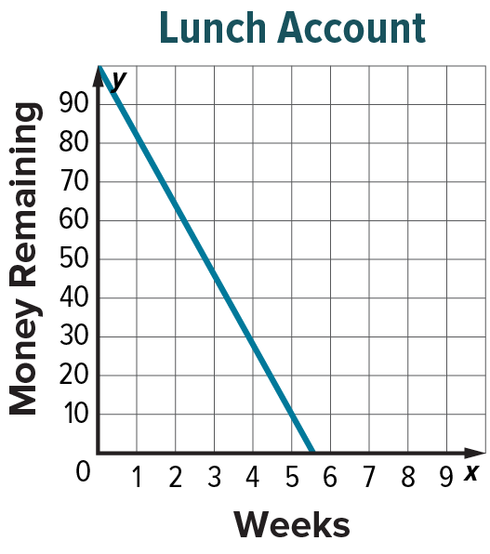
23. LUNCH ACCOUNT At the beginning of the quarter, Nahla deposited $100 into her lunch account. If Nahla spends an average of $18 per week on lunches, then m = 100 ‒ 18w represents the amount of money Nahla has left in her lunch account m after w weeks of school.
a. Use the graph to estimate to the nearest tenth the number of weeks that Nahla can purchase school lunches with the money she deposited at the beginning of the quarter.

b. Solve algebraically to verify your estimate. Round to the nearest hundredth.

24. READING Mario has a 500-page novel which he is required to read over summer for his upcoming language arts class.
a. If Mario reads 24 pages each day, write and graph a function to represent the number of pages that Mario has left to read p after d days.
b. Estimate the zero of the function by using the graph. Justify your response.
c. Find the zero algebraically. Interpret its meaning in the context of the situation.

Example 6
Solve each inequality. Graph the solution set on a number line.

25. $\frac{z}{-4}$ ≥ 2 26. 3a + 7 ≤ 16 27. 20 – 3n > 7n

28. 7f – 9 > 3f – 1 29. 0.7m + 0.3m ≥ 2m – 4 30. 4(5x + 7) ≤ 13

Example 7
Solve each problem.
31. INCOME Manuel takes a job translating English instruction manuals to Spanish. He will receive $15 per page plus $100 per month. Manuel plans to work for 3 months during the summer and wants to make at least $1500. Write and solve an inequality to find the minimum number of pages Manuel must translate in order to reach his goal. Then, interpret the solution in the context of the situation.

32. STRUCTURE On a conveyor belt, there can only be two boxes moving at a time. The total weight of the boxes cannot be more than 300 pounds. Let x and y represent the weights of the two boxes on the conveyer belt.
a. Write an inequality that describes the weight limitation in terms of x and y.

b. Write an inequality that describes the limit on the average weight a of the two boxes.

c. Two boxes are to be placed on the conveyor below. The first box weighs 175 pounds. What is the maximum weight of the second box?

Mixed Exercises
Solve each equation. Check your solution by graphing the related function.

33. –3b + 7 = –15 + 2b 34. a – $\frac{2a}{5}$ = 3 35. 2.2n + 0.8n + 5 = 4n

Solve each inequality. Graph the solution set on a number line.

36. $\frac{4x-3}{2}$ ≥ –3.5 37. 1 + 5(x – 8) ≤ 2 – (x + 5) 38. –36 – 2(w + 77) > –4(2w + 52)

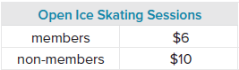
39. REASOINING An ice rink offers open skating several times a week. An annual membership to the skating rink costs $60. The table shows the cost of one session for members and non-members.

Kaliska plans to spend no more than $90 on skating this year. Define a variable then write and solve inequalities to find the number of sessions she can attend with and without buying a membership. Should Kaliska buy a membership?

40. PRECISION The formula to convert temperature in degrees Fahrenheit to degrees Celsius is $\frac{5}{9}\left(F-32\right)=C$.
a. Solve the equation for F.

b. Use your result from part a to determine the temperature in degrees Fahrenheit when the Celsius temperature is 30.

c. At a certain temperature, a Fahrenheit thermometer and a Celsius thermometer will read the same temperature. Write and solve an equation to find the temperature.

41. FIND THE ERROR Steven and Jade are solving $A=\frac{1}{2}h(b_{1}+b_{2})$ for b₂. Is either of them correct? Explain your reasoning.

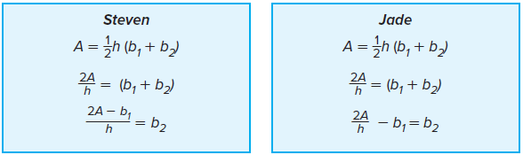

42. CREATE Write an equation involving the Distributive Property that has no solution and another example that has infinitely many solutions.

43. PERSEVERE Solve d = $\sqrt{{(x_{2}-x_{1})}^{2}+{\left(y_{2}-y_{1}\right)}^{2}}$ for y₁.

44. ANALYZE Vivek’s teacher made the statement, “Four times a number is less than three times a number.” Vivek quickly responded that the answer is no solution. Do you agree with Vivek? Write and solve an inequality to justify your answer.

4 5. WRITE Why does the inequality symbol need to be reversed when multiplying or dividing by a negative number?

46. PERSEVERE Given $△$ABC with sides AB = 3x + 4, BC = 2x + 5, and AC = 4x, determine the values of x such that $△$ABC exists.

