Equations of Linear Functions ⸱ Practice

Example 1
Write each equation in standard form. Identify A, B, and C.
1. ‒7x ‒ 5y = 35 2. 8x + 3y + 6 = 0 3. 10y ‒ 3x + 6 = 11

4. $\frac{2}{3}y-\frac{3}{4}x+\frac{1}{6}=0$ 5. $\frac{4}{5}y+\frac{1}{8}x=4$ 6. ‒0.08x = 1.24y ‒ 3.12

Example 2
Write each equation in slope-intercept form. Identify the slope m and the y-intercept b.
7. 6x + 3y = 12 8. 14x ‒ 7y = 21 9. $\frac{2}{3}x$ + $\frac{1}{6}y=2$

10. 5x + 10y = 20 11. 6x + 9y = 15 12. $\frac{1}{5}x+\frac{1}{2}y=4$

Example 3
13. CHARITY The linear equation y – 20x = 83 relates the number of shirts collected during a charity clothing drive, where x is the number of hours since noon and y is the total number of shirts collected. Write the equation in slope-intercept form and interpret the parameters of the equation in the context of the situation.

14. GROWTH Suppose the body length y in inches of a baby snake is given by 4x – 2y = –3, where x is the age of the snake in months until it becomes 1 year old. Write the equation in slope-intercept form and interpret the parameters of the equation in the context of the situation.

Example 4
15. PLUMBER Two neighbors, Camila and Conner, hire the same plumber for household repairs. The plumber worked at Camila’s house for 3 hours and charged her $191. The plumber worked at Conner’s house for 1 hour and charged him $107.
- Define variables to represent the situation.

- Find the slope and y-intercept. Then, write an equation.

- How much would it cost to hire the plumber for 5 hours of work?

16. HIKING Tim began a mountain hike near Big Bear Lake, California at 9:00 A.M. By 10:30 A.M., his elevation is 7200 feet above sea level. At 11:15 A.M., he is at an elevation of 7425 feet above sea level.
a. Define variables to represent the situation.

b. Write an equation in slope-intercept form that represent Tim’s elevation since he began hiking.

c. If Tim’s altitude continues to increase at the same rate, estimate his altitude at 12:30 p.m.

Example 5
Write an equation in point-slope form for the line that satisfies each set of conditions.
17. slope of ‒5, passes through (‒3, ‒8) 18. slope of $\frac{4}{5}$, passes through (10, ‒3)

19. slope of $-\frac{2}{3}$, passes through (6, ‒8) 20. slope of 0, passes through (0, ‒10)

Example 6
Write an equation in point-slope form for a line that passes through each set of points.
21. (2, ‒3) and (1, 5) 22. (3, 5) and (‒6, ‒4)

23. (‒1, ‒2) and (‒3, 1) 24. (‒2, ‒4) and (1, 8)

Example 7
Solve each problem.
25. SALES Light truck is a vehicle classification for trucks weighing up to 8500 pounds. In 2011, 5.919 million light trucks were sold in the U.S. In 2017, 11.055 million light trucks were sold. Write an equation in point-slope form that represents the number of light trucks y sold x years after 2010.

26. RESTAURANTS In 2012, a popular pizza franchise had 2483 restaurants. In 2017, there were 2606 franchised restaurants. Write an equation in point-slope form that represents the number of restaurants y that are franchised x years after 2010.

Mixed Exercises
REGULARITY Write linear equations in standard form, slope-intercept form, and point-slope form that satisfy each set of conditions.
27. slope of ‒2, passes through (6, ‒7) 28. x-intercept: 3, y-intercept: 5

29. passes through (4, ‒1) and (8, 3) 30. slope of 0.6, passes through (1, 1)

31. STATE YOUR ASSUMPTION The surface of Grand Lake is at an elevation of 648 feet. During a drought, the water level drops at a rate of 3 inches per day. Write an equation in slope-intercept form that gives the elevation in feet y of the surface of Grand Lake after x days. Explain any assumptions you made to write the equation.

32. USE A SOURCE Go online to find the population of your city in 2010 and 2015. Write an equation in slope-intercept form to represent the population y of the city x years after 2010. State assumptions you made to write the equation.

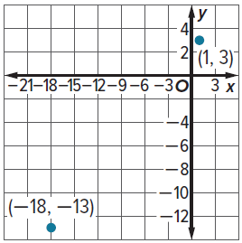
33. PRECISION Use the graph shown to write the equation of the line in standard form that passes through the two points.

34. USE ESTIMATION In May, Jacalyn opens a savings account with an initial balance of $200 and deposits about the same amount each month. The table shows her account balance at the beginning of each month.

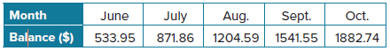
a. Write a linear equation in slope-intercept form that relates the balance of her savings account y in months x since she opened her account.

b. Estimate the balance of Jacalyn’s account at the beginning of December.

35. CONSTRUCT ARGUMENTS Consider the line that passes through (3, 1) and (0, 7).
a. Given the two points, find a third point on the line. Justify your argument.

b. Explain why both y ‒ 1 = ‒2(x ‒ 3) and y ‒ 7 = ‒2(x ‒ 0) can be used to represent the line.

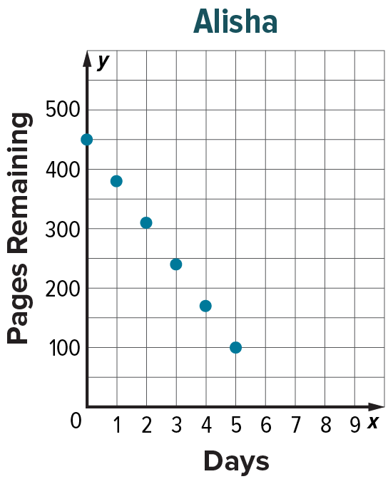
36. USE A MODEL Joe and Alisha are reading novels for book reports. Joe records the number of pages he has remaining to read after each day in the table below. Alisha records the number of pages she has remaining each day on the graph at the right.
Joe
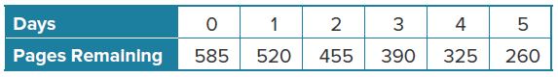
a. Describe the function that models the number of pages remaining for each student.
b. What is the y-intercept for each function? Interpret its meaning in the context of the problem.
c. Write a linear equation in slope-intercept form for the function that can be used to model the pages remaining for each student. Then write each equation in standard form.
d. After how many days will each finish with their reading? What feature of the function represents this event? Explain your answer.
e. Who is the faster reader and by how many pages per day? Support your answer.

37. CONSTRUCT ARGUMENTS Determine whether an equation in the form x = a, where a is a constant is sometimes, always, or never a function. Explain your reasoning.

38. PERSEVERE Write an equation in point-slope form of a line that passes through (a, 0) and (0, b).

39. CREATE Write an equation in point-slope form of a line with an x-intercept of 3.

40. WRITE Consider the relationship between hours worked and earnings. When would this situation represent a linear relationship? When would this situation represent a nonlinear relationship? Explain your reasoning.

41. FIND THE ERROR Dan claims that since y = x + 1 and y = 3x + 2 are both linear functions, the function y = (x + 1)(3x + 2) must also be linear. Is he correct? Explain your reasoning.

42. PERSEVERE Write y = ax + b in point-slope form.

43. WRITE Why is it important to be able to represent linear equations in more than one form?

