Solving Systems of Equations Algebraically ⸱ Practice

Examples 1 and 2
Use substitution to solve each system of equations.
1. 2x ‒ y = 9 2. 2x ‒ y = 7 3. 2x + y = 5
x + 3y = ‒6 6x ‒ 3y = 14 3x ‒ 3y = 3

4. 3x + y = 7 5. 4x ‒ y = 6 6. 2x + y = 8
4x + 2y = 16 2x ‒ $\frac{y}{2}$ = 4 3x + $\frac{3}{2}y$ = 12

Example 3
Solve each problem.
7. BAKE SALE Cassandra and Alberto are selling pies for a fundraiser. Cassandra sold 3 small pies and 14 large pies for a total of $203. Alberto sold 11 small pies and 11 large pies for a total of $220. Determine the cost of each pie.

a. Write a system of equations and solve using substitution.
b. What does the solution represent in terms of this situation?
c. How can you verify that the solution is correct?

8. STOCKS Ms. Patel invested a total of $825 in two stocks. At the time of her investment, one share of Stock A was valued at $12.41 and a share of Stock B was valued at $8.62. She purchased a total of 79 shares.
a. Write a system of equations and solve by substitution.
b. How many shares of each stock did Ms. Patel buy? How much did she invest in each of the two stocks?

Examples 4-6
Use elimination to solve each system of equations.
9. 3x ‒ 2y = 4 10. 5x + 2y = 12 11. 7x + 2y = ‒1
5x + 3y = ‒25 ‒6x ‒ 2y = ‒ 14 21x + 6y = ‒9

12. 3x – 5y = –9 13. x – 3y = –12 14. 6w – 8z = 16
‒7x + 3y = 8 2x + y = 11 3w – 4z = 8

Mixed Exercises
Use substitution or elimination to solve each system of equations.
15. 0.5x + 2y = 5 16. h ‒ z = 3 17. ‒r + t = 5
x ‒ 2y = ‒8 ‒3h + 3z = 6 ‒2r + t = 4

18. 3r – 2t = 1 19. 5g + 4k = 10 20. 4m – 2p = 0
2r – 3t = 9 –3g – 5k = 7 –3m + 9p = 5

21. The sum of two numbers is 12. The difference of the same two numbers is ‒4. Find the
two numbers.

22. Twice a number minus a second number is ‒1. Twice the second number added to three times the first number is 9. Find the two numbers.

23. REASONING Mr. Janson paid for admission to the high school football game for his family. He purchased 3 adult tickets and 2 student tickets for a total of $22. Ms. Pham purchased 5 adult tickets and 3 student tickets for a total of $35.75. What is the cost of each adult ticket and each student ticket?

24. USE A MODEL The Newton City Park has 11 basketball courts, which are all in use. There are 54 people playing basketball. Some are playing one-on-one, and some are playing in teams. A one-on-one game requires 2 players, and a team game requires 10 players.
a. Write a system of equations that represents the number of one-on-one and team games being played.

b. Solve the system of equations and interpret your results.

25. FIND THE ERROR Gloria and Syreeta are solving the system 6x ‒ 4y = 26 and ‒3x + 4y = ‒17. Is either of them correct? Explain your reasoning.
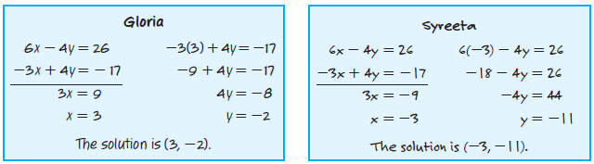

26. CREATE Write a system of equations in which one equation should be multiplied by 3 and
the other should be multiplied by 4 in order to solve the system with elimination. Then solve your system.

27. WRITE Why is substitution sometimes more helpful than elimination?

