Solving Absolute Value Equations and Inequalities by Graphing ⸱ Practice

Example 1
Solve each equation by graphing.
1. ​​|x – 4| = 5 2. ​​|2x – 3| = 17 3. 3 +​​|2x + 1|= 3

4. ​|x – 1|+ 6 = 4 5. 7 +​​|3x ‒ 1|= 7 6. ​|x + 2|+ 5 = 13

Example 2
USE TOOLS Use a graphing calculator to solve each equation.
7. $\frac{1}{2}$​​|x – 1| + 5 = 9 8. $\frac{3}{4}$​​|x + 1| + 1 = 7 9. $\frac{2}{3}$​​|x ‒ 2| ‒ 4 = 4

10. 2|x + 2| = 10 11. $\frac{1}{5}$​​|x + 6| ‒ 1 = 9 12. 3|x + 5| ‒ 1 = 11

Example 3
USE TOOLS Solve each equation algebraically. Use a graphing calculator to check your solutions.
13. |3x – 6| = 42 14. 7|x + 3| = 42 15. –3|4x – 9| = 24

16. –6|5 – 2x| = –9 17. 5|2x + 3| – 5 = 0 18. |15 – 2x| = 45

Example 4
Solve each inequality by graphing.
19. |2x – 6| – 4 ≤ 0 20. |x – 1| – 3 ≤ 0 21. |2x – 1| ≥ 4

22. |3x + 2| ≥ 6 23. 2|x + 2| < 8 24. 3|x ‒ 1| < 12

Example 5
USE TOOLS Use a graphing calculator to solve each inequality.
25. $\left|\frac{1}{4}x+4\right|$ – 1 > 0 26. $\frac{2}{5}\left|x-5\right|$ + 1 > 0 27. |3x – 1| < 2

28. |4x + 1| ≤ 1 29. $\frac{1}{6}$​​|x – 1| + 1 ≤ 0 30. $\frac{1}{4}$​​|x +5| ‒ 1 ≤ 1

Mixed Exercises
Solve by graphing.
31. 0.4|x ‒ 1|= 0.2 32. 0.16|x + 1|= 4.8 33. 0.78|2x + 0.1|+ 2.3 = 0

34. $\left|\frac{1}{3}x+3\right|$ + 1 = 0 35. $\frac{1}{2}$|6 – 2x| ≤ 1 36. |3x – 2| < $\frac{1}{2}$

USE TOOLS Solve each equation or inequality algebraically. Use a graphing calculator to check your solutions.
37. $\left|\frac{5}{9}x+1\right|-5>0$ 38. $\frac{2}{7}\left|\frac{1}{2}x-1\right|<1$ 39. 0.28|0.4x ‒ 2| = 10.08

40. REASONING A pet store sells bags of dog food that are labeled as weighing 50 pounds. The equipment used to package the dog food produces bags with a weight that is within 0.75 lbs of the advertised weight. Write an absolute value equation to determine the acceptable maximum and minimum weight for the bags of dog food. Then, use a graph to find the minimum and maximum weights.

41. SPACE The mean distance from Mars to the Sun is 1.524 astronomical units (au). The distance varies during the orbit of Mars by 0.147 au. Write an absolute value inequality to represent the distance of Mars from the Sun as it completes an orbit. Then, use a graph to solve the inequality.

42. CONSTRUCT ARGUMENTS Ms. Uba asked her students to write an absolute value equation with the solutions and related function shown in the graph. Sawyer wrote |x + 2| = 6 and Kaleigh wrote 2|x + 2| = 12. Is either student correct? Justify your argument.
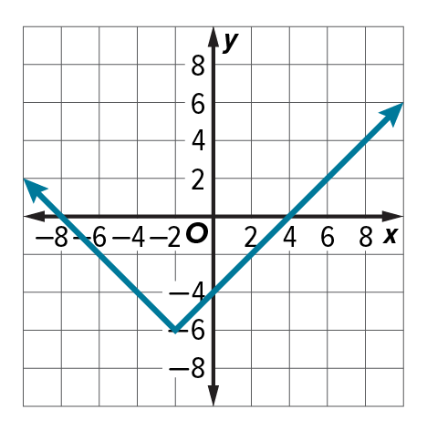

43. WRITE Compare and contrast the solution sets of absolute value equations and absolute value inequalities.

44. ANALYZE How can you tell that an absolute value equation has no solutions without graphing or completely solving it algebraically?

45. CREATE Create an absolute value equation for which the solution set is {9, 11}.

