Multiplication Properties of Exponents ⸱ Practice

Examples 1, 3, 4
Simplify each expression.
1. (q²)(2q⁴) 2. (–2u²)(6u⁶)

3. (9w²x⁸)(w⁶x⁴) 4. (y⁶z⁹)(6y⁴z²)

5. (b⁸c⁶d⁵)(7b⁶c²d) 6. (14fg²h²)(3f⁴g²h²)

7. (j⁵k⁷)⁴ 8. (n³p)⁴

9. [(2²)²]² 10. [(3²)²]⁴

11. [(4r²t)³]² 12. [(–2xy²)³]²

13. (y²z)(yz²) 14. ($l^{2}$k²)($l^{3}$k)

15. (–5m³)(3m⁸) 16. (–2c⁴d)(–4cd)

17. (3pr²)² 18. (2b³c⁴)²

Example 2
19. COMMUNITY SERVICE During the school year, each student planted 1.2 × 10² flowers as part of a community service project. If there are 1.5 × 10³ students in the school, how many flowers did they plant in total?

20. CHERRIES A farmer has 350 cherry trees on his farm. If each cherry tree yields 6200 cherries per year, how many cherries can the farmer harvest per year? Write your answer in scientific notation.

21. PANDAS When born, a panda cub only weighs 2.2 × 10^{–1} pounds. As they grow older, adult pandas, on average, weigh 1.1 × 10³ times more than a newborn panda. How much does an average adult panda weigh?

22. SALES An automobile company sold 2.3 million new cars in a year. If the average price per car was $21,000, how much money did the company make that year? Write your answer in scientific notation.


23. APPLE JUICE An apple juice company produced 8.3 billion individual-size bottles of apple juice last year. If each bottle contains 355 milliliters of juice, how many milliliters of apple juice did the company produce?

Example 5
24. BLOCKS Building blocks are in the shape of a cube. The dimensions of the building blocks are based on the length of the packaging box, which is defined as $\frac{1}{12}$x² centimeters, where x is the length of the packaging box. What is the volume of a building block in terms of x?

25. FIELDS A field is in the shape of a square. The length of the field is 5x³y⁵. What is the area of the field in terms of x and y?

26. PICTURE FRAME Michelle is purchasing a new picture frame to hang in her bedroom. The picture frame is square shaped. What is the area of the interior of the picture frame in terms of c and d?  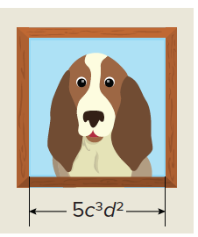 | 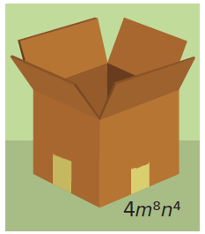  27. SHIPPING A shipping box is in the shape of a cube. What is the volume of the shipping box in terms of m and n?

Mixed Exercises
Simplify each expression.
28. (2a³)⁴(a³)³ 29. (c³)²(–3c⁵)²

30. (2gh⁴)³[(–2g⁴h)³]² 31. (5k²m)³[(4km⁴)²]²

32. (p⁵r²)⁴(–7p³r⁴)(6pr³) 33. (5x²y)²(2xy³z)³(4xyz)

34. (5a²b³c⁴)⁴(6a³b⁴c²) 35. (10xy⁵z³)(3x⁴y⁶z³)

36. (0.5x³)² 37. (0.4h⁵)³

38. ${\left(-\frac{3}{4c}\right)}^{3}$ 39. ${\left(\frac{4}{5}a^{2}\right)}^{2}$

40. (8y³)(–3x²y²)$\left(\frac{3}{8}xy^{4}\right)$ 41. ${\left(\frac{4}{7}m\right)}^{2}$(49m)(17p)$\left(\frac{1}{34}p^{5}\right)$

42. (–3r³w⁴)³(2rw)²(–3r²)³(4rw²)³(2r²w³) 43. (3ab²c)²(–2a²b⁴)²(a⁴c²)³(a²b⁴c⁵)²(2a³b²c⁴)³

STRUCTURE Determine whether each pair of expressions is equivalent. Write yes or no.
44. (a⁷)(a⁷)(a⁷)(a⁷) and a²⁴⁰¹ 45. (–j⁹)(–j⁹)(–j⁹)(–j⁹) and –j²⁷

46. (5p³q)(4p⁵q⁹) and 20p⁸q¹⁰ 47. (6w⁵)² and 36w²⁵

48. (x¹⁰)³ and (x³)¹⁰ 49. [(2n²)³]² and (4n⁴)³

50. GRAVITY An object that has been falling for x seconds has dropped at an average speed of 16x feet per second. If the object is dropped from a great height, its total distance traveled is the product of the average rate times the time. Write a simplified expression to show the distance the object has traveled after x seconds.

51. ELECTRICITY An electrician uses the formula W = I²R, where W is the power in watts, I is the
current in amperes, and R is the resistance in ohms.

a. Find the power in a household circuit that has 2x² amperes of current and 5x³ ohms
of resistance.

b. If the current is reduced by one-half, what happens to the power?

52. MOLECULES A glass of water contains 0.25 liter of water. If 1 milliliter of water contains
3.3 × 10²² water molecules, how many water molecules are there in the glass of water?

53. CIVIL ENGINEERING A developer is planning a sidewalk for a new development. The sidewalk can be installed in rectangular sections that have a fixed width of 3 feet and a length that can vary. Assuming that each section is the same length, express the area of a 4-section sidewalk as a monomial.

54. USE A SOURCE Suppose each student in your school is required to complete 60 hours of community service before they graduate. Find the number of students in the senior class at your school. Based on this number, calculate total minimum number of community service hours completed by the senior class by the time they graduate. Write your answer in scientific notation.

55. REGULARITY Recall that both multiplication and addition are commutative and associative. Multiplication also distributes over addition.

a. What would it mean for the operation of raising one number to an exponent to be commutative? Decide and explain whether this operation is commutative.

b. What would it mean for the operation of raising one number to an exponent to be associative? Decide and explain whether this operation is associative.

c. What would it mean for the process of raising one exponent to another to distribute over addition? Decide and explain whether this is true.

d. What would it mean for the process of raising one exponent to another to distribute over multiplication? Decide and explain whether this is true.

56. STATE YOUR ASSUMPTION Consider the expressions (m^{p})(m^{q}) and (m^{p})^{q}.

a. What must be true about p and q for (m^{p})(m^{q}) = (m^{p})^{q}? Give an example.

b. Assuming m, p, and q are all positive integers, can (m^{p})(m^{q}) > (m^{p})^{q} ever be true? Explain.

57. PERSEVERE For any nonzero real numbers a and b and any integers m and t, simplify the expression ${\left(-\frac{a^{m}}{b^{t}}\right)}^{2t}$. Explain.

58. ANALYZE Consider the equations in the table.

a. For each equation, write the related expression and record the power of x.
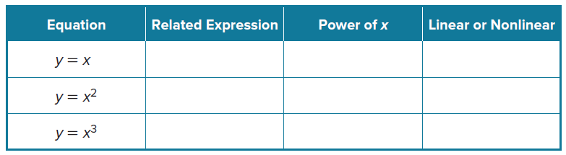

b. Graph each equation using a graphing calculator.

c. Classify each graph as linear or nonlinear.

d. Explain how to determine whether an equation, or its related expression, is linear or nonlinear without graphing.

59. CREATE Write three different expressions that can be simplified to x⁶.

60. WRITE Write a product of powers that is positive for all nonzero values of the variable. Explain your reasoning.

61. FIND THE ERROR Jade and Sal are each writing an equivalent form of g⁵gh⁶. Is either correct? Explain your reasoning.
