Division Properties of Exponents ⸱ Practice

Example 1, 3, 4
Simplify each expression. Assume that no denominator equals zero.
1. $\frac{m^{4}p^{2}}{m^{2}p}$ 2. $\frac{p^{12}t^{3}r}{p^{2}tr}$

3. $\frac{c^{4}d^{4}f^{3}}{c^{2}d^{4}f^{3}}$ 4. ${\left(\frac{3xy^{4}}{5z^{2}}\right)}^{2}$

5. ${\left(\frac{p^{2}t^{7}}{10}\right)}^{3}$ 6. $\frac{a^{7}b^{8}c^{8}}{a^{5}bc^{7}}$

7. ${\left(\frac{3np^{3}}{7q^{2}}\right)}^{2}$ 8. ${\left(\frac{{2r}^{3}t^{6}}{5u^{9}}\right)}^{4}$

9. ${\left(\frac{3m^{5}r^{3}}{4p^{8}}\right)}^{4}$ 10. $\frac{p^{12}t^{7}r^{2}}{p^{2}t^{7}r}$

11. $\frac{k^{4}m^{3}p^{2}}{k^{2}m^{2}}$ 12. $\frac{m^{7}p^{2}}{m^{3}p^{2}}$

13. $\frac{32x^{3}y^{2}z^{5}}{-8xyz^{2}}$ 14. ${\left(\frac{4p^{7}}{7r^{2}}\right)}^{2}$

15. $\frac{9d^{7}}{3d^{6}}$ 16. $\frac{12n^{5}}{36n}$

17. $\frac{w^{4}x^{3}}{w^{4}x}$ 18. $\frac{a^{3}b^{5}}{ab^{2}}$

Example 2
19. SPACE The Moon is approximately 25⁴ kilometers away from Earth on average. The Olympus Mons volcano on Mars stands 25 kilometers high. How many Olympus Mons volcanoes, stacked on top of one another, would fit between the surface of the Earth and the Moon?

20. GEOMETRY Write the ratio of the area of a circle with radius r to the circumference of the
same circle.

21. COMBINATIONS The number of four-letter combinations that can be formed with the English alphabet is 26⁴. The number of six-letter combinations that can be formed is 26⁶. How many times more six-letter combinations can be formed than four-letter combinations?

22. BLOOD COUNT A lab technician draws a sample of blood. A cubic millimeter of the blood contains 22⁵ red blood cells and 22³ white blood cells. How many times more red blood cells are there than white blood cells?

Mixed Exercises
Simplify each expression. Assume that no denominator equals zero.
23. $\frac{{-4w}^{12}}{12w^{3}}$ 24. $\frac{{13r}^{7}}{39r^{4}}$

25. ${\left(\frac{2a^{4}c^{3}}{5b^{2}d^{2}}\right)}^{2}$ 26. $\frac{m^{6}n^{3}}{m^{2}n^{6}}$

27. ${\left(\frac{24a^{11}b^{16}c^{6}}{18a^{6}b^{6}c^{6}}\right)}^{3}$ 28. ${\left(\frac{q^{2}r^{3}}{qr^{2}}\right)}^{5}$

29. $\frac{{-16x}^{7}y^{2}}{-6xy^{5}}$ 30. $\frac{{21d}^{18}e^{5}}{{7d}^{11}e^{6}}$

31. ${\left(\frac{2x^{3}y^{2}z^{5}}{3xyz}\right)}^{3}$ 32. $\frac{8c^{4}d^{2}f^{9}}{4{cd}^{2}f^{3}}$


33. ${\left(\frac{7c^{4}}{14d^{2}}\right)}^{6}$ 34. ${\left(\frac{6j^{5}}{7m^{6}n^{3}}\right)}^{2}$

35. SOUND Decibels are used to measure sound. The softest sound that can be heard is rated at 0 decibels, or a relative loudness of 1. Ordinary conversation is rated at about 60 decibels, or a relative loudness of 10⁶. A stock car race is rated at about 130 decibels, or a relative loudness of 10¹³. How many times greater is the relative loudness of a stock car race than the relative loudness of ordinary conversation?

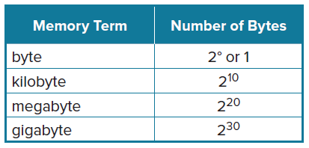
36. COMPUTERS The byte is the fundamental unit of computer processing. Almost all aspects of a computer’s performance and specifications are measured in bytes or multiples of bytes. The byte is based on powers of 2, as shown in the table. How many times greater is a megabyte than a kilobyte?
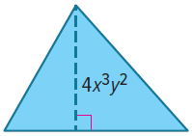

37. AREA The area of the triangle shown is 6x⁵y³ square units. Find the base of the triangle.

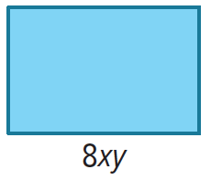
38. AREA The area of the rectangle in the figure is 32xy³ square units. Find the width of the rectangle.

39. USE A MODEL An investment is expected to increase in value by 4% every year.
a. Write an expression that represents the value of the investment after t years if the initial value was n dollars.

b. By what percent does the value of the investment change between the end of year 2 and the end of year 8? Round your answer to the nearest tenth of a percent, and show your work.

40. INVESTMENTS A poor investment is expected to decrease in value by 5% every year.

a. If the initial value of the investment was $100, what does it mean for it to decrease in value by 5% in the first year?

b. Erik claims that rather than multiplying by 0.05 and subtracting, we can simply multiply the investment by 0.95. Is he correct? Explain.
c. Write an expression that represents the value of the investment after t years if the initial value was n dollars.

d. By what percent does the value of the investment change between the end of year 2 and the end of year 10? Round your answer to the nearest tenth of a percent, and show your work.

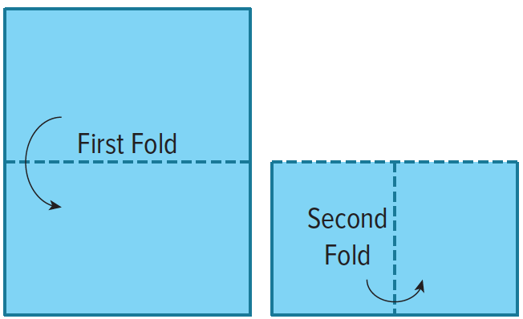
41. PAPER FOLDING If you fold a sheet of paper in half, you have a thickness of 2 sheets. Folding again, you have a thickness of 4 sheets. Fold the paper in half one more time. How many times thicker is a sheet that has been folded 3 times than a sheet that has not been folded?

42. USE TOOLS Create a table in a computer spreadsheet program to show the powers of 2⁰ through 2¹⁰. Use the formula functions in the program to show the Quotient of Powers Property is true for five different division problems using the powers you already entered.

43. CONSTRUCT ARGUMENTS Is ${\left(\frac{x}{y^{2}}\right)}^{3}$the same as ${\left(\frac{x}{y^{3}}\right)}^{2}$? Justify your argument.

44. STRUCTURE Find the value of x that makes $\frac{8^{5x}}{8^{4x + 1}}=8^{9}$ true. Explain.

45. REASONING Which expression does not have the same answer as the others when simplified using exponent rules?
A. ${\left(\frac{3x^{4}y}{5}\right)}^{2}$ B. $\frac{-18x^{14}y^{10}}{-50x^{6}y^{8}}$ C. $\frac{-3^{2}x^{9}y^{5}}{{(-5)}^{2}xy^{3}}$

46. PRECISION What error did the student make in simplifying the expression $\frac{5^{4}}{5}=1^{4}=1$? What is the correct value of the expression?

47. REGULARITY Simplify the expression $\frac{a^{x+y}}{a^{y}}$.

48. CREATE Write three quotients of powers expressions that are equivalent to 2⁵.

49. REGULARITY Consider the equation $\frac{3^{h}}{3^{k}}$ = 3².
a. Find two numbers h and k that satisfy the equation.

b. Are there any other pairs of numbers that satisfy the equation? Explain.

50. FIND THE ERROR Kathryn and Salvador used different methods to simplify ${\left(\frac{p^{9}}{p^{5}}\right)}^{2}$. Is either correct? Explain your reasoning.
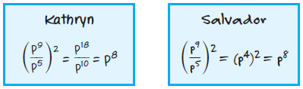

51. ANALYZE Is x^{y} $∙$ x^{z} = x^{yz} sometimes, always, or never true? Justify your argument.

52. CREATE Write two monomials with a quotient of 24a²b³.

53. WRITE Explain how to use the Quotient of Powers Property and the Power of a Quotient Property.

54. PERSEVERE Is the expression ${\left(\frac{p^{7}}{p^{3}}\right)}^{5}$ positive or negative for all nonzero values of p? Explain.

55. WHICH ONE DOESN’T BELONG? Which quotient does not belong with the other three? Justify your conclusion.

56. FIND THE ERROR Andrew and Mateo are trying to simplify the expression $\frac{9^{5}}{9^{3}}$. Is either of them correct? Explain your reasoning.
