Negative Exponents ⸱ Practice

Examples 1–3
Simplify each expression. Assume that no denominator equals zero.
1. $\frac{r^{6}n^{-7}}{r^{4}n^{2}}$ 2. $\frac{h^{3}}{h^{-6}}$

3. $\frac{f^{-7}}{f^{4}}$ 4. ${\left(\frac{16p^{5}w^{2}}{2p^{3}w^{3}}\right)}^{0}$

5. $\frac{f^{-5}g^{4}}{h^{-2}}$ 6. $\frac{15x^{6}y^{-9}}{5xy^{-11}}$

7. $\frac{-15t^{0}u^{-1}}{5u^{3}}$ 8. $\frac{{\left(z^{2}w^{-1}\right)}^{3}}{{\left(z^{3}w^{2}\right)}^{2}}$

9. $\frac{-10m^{-1}y^{0}r}{-14m^{-7}y^{-3}r^{-4}}$ 10. $\frac{51x^{-1}y^{3}}{17x^{2}y}$

11. $\frac{3m^{-3}r^{4}p^{2}}{12t^{4}}$ 12. ${\left(\frac{3t^{6}u^{2}v^{5}}{9tuv^{21}}\right)}^{0}$

13. $\frac{x^{-4}y^{9}}{z^{-2}}$ 14. ${\left(-\frac{5f^{9}g^{4}h^{2}}{fg^{2}h^{3}}\right)}^{0}$

15. $\frac{p^{4}t^{-3}}{r^{-2}}$ 16. $-\frac{5c^{2}d^{5}}{8cd^{5}f^{0}}$

17. $\frac{-2f^{3}g^{2}h^{0}}{8f^{2}g^{2}}$ 18. $\frac{g^{0}h^{7}j^{-2}}{g^{-5}h^{0}j^{-2}}$

Example 4
19. METRIC MEASUREMENT Consider a dust mite that measures ${10}^{-3}$ millimeters in length and a gecko that measures 10 centimeters long. How many orders of magnitude as long as the mite is the gecko?

20. CHEMISTRY The nucleus of a certain atom is 10^{–13} centimeters across. If the nucleus of a different atom is 10^{–11} centimeters across, how many orders of magnitude as great is the second nucleus?

21. WEIGHT A paper clip weighs about 10^{–3} kilograms. A draft horse weighs about 10³ kilograms. How many orders of magnitude as heavy is a draft horse than a paperclip?

22. GDP Gross Domestic Product (GDP) is a measure of a country’s wealth. Indonesia had an estimated GDP in 2017 of 1,020,515,000,000. Madagascar had an estimated GDP of 10,372,000,000 in 2017. About how many orders of magnitude as great is Indonesia’s GDP?

23. GROWTH An old oak tree is 1012 inches tall. A younger oak tree near it is 98 inches tall. About how many orders of magnitude as tall is the old oak tree?

Mixed Exercises
Simplify each expression. Assume that no denominator equals zero.
24. $\frac{{3wy}^{–2}}{{(w^{–1}y)}^{3}}$ 25. $\frac{{(4k^{3}m^{2})}^{3}}{{(5k^{2}m^{–3})}^{–2}}$

26. $\frac{-12c^{3}d^{0}f^{–2}}{6c^{5}d^{–3}f^{4}}$ 27. $\frac{20qr^{–2}t^{–5}}{4q^{0}r^{4}t^{–2}}$

28. $\frac{{(5pr^{–2})}^{–2}}{{(3p^{–1}r)}^{3}}$ 29. $\frac{{(2g^{3}h^{–2})}^{2}}{{(g^{2}h^{0})}^{–3}}$

30. ${\left(\frac{2a^{–2}b^{4}c^{2}}{-4a^{–2}b^{–5}c^{–7}}\right)}^{-1}$ 31. ${\left(\frac{-3x^{–6}y^{–1}z^{–2}}{6x^{–2}yz^{–5}}\right)}^{-2}$

32. ${\left(\frac{4^{0}c^{2}d^{3}f}{2c^{–4}d^{–5}}\right)}^{-3}$ 33. $\frac{{(16x^{2}y^{–1})}^{0}}{{(4x^{0}y^{–4}z)}^{–2}}$

34. RATIOS Yvonne is comparing the weights of a semi-truck trailer tire and a mobile home. A semi-truck trailer tire weighs about 10² pounds, and a mobile home weighs about 10⁴ pounds. What is the ratio of the weight of a semi-truck trailer tire compared to the weight of a mobile home? Write your answer as a monomial.

35. MARKETING Jana’s marketing plan has a goal that each person who hears of their new product tells 10 people about it, each of those 10 people tells another 10, and so on. The level of spread is the number of times this repeats, as shown in the table. How many orders of magnitude greater is the level 4 spread compared to the level 1 spread?
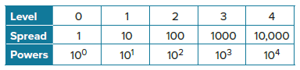

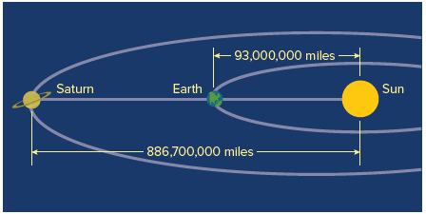
36. ASTRONOMY The diagram shows the distance from the Earth to the Sun and the distance from Saturn to the Sun. Approximately what portion of the distance from Saturn to the Sun is the distance from Earth to the Sun?

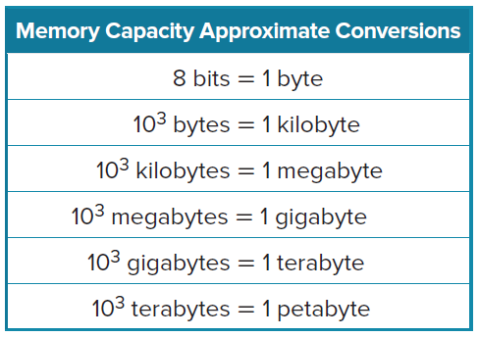
37. COMPUTERS In 1995, standard capacity for a personal computer hard drive was 40 megabytes (MB). In 2010, a standard hard drive capacity was 500 gigabytes (GB). Refer to the table.
a. The newer hard drives have about how many times the capacity of the 1995 drives?

b. Predict the hard drive capacity in the year 2025 if the capacity continues to grow by the same factor you found in part a.

c. One kilobyte of memory is what fraction of one terabyte?


38. MICROSCOPES Cheveyo is looking at a slide of red blood cells under a microscope. One of the red blood cells has an actual radius of about one millionth of a meter, or 10^{–6} meters. Through the microscope, the radius of that red blood cell appears to be 10^{–2} meters. How many times larger does the microscope make the blood cells appear?

39. STRUCTURE Are 4n⁵ and 4n^{–5} reciprocals? Explain.

40. REGULARITY Explain why 3⁰ = 1.

41. STRUCTURE Use the Power of a Power Property to rewrite $\frac{1}{p^{-3}}$ with only positive exponents.

42. REASONING Angelo believes that y⁶ ≥ y^{–6} for all nonzero values of y. Do you agree? Explain.

43. BACTERIA The bacterial population in a petri dish was measured at 1500 per cubic centimeter on Monday morning. Each day the population doubled from the previous day. This can be modeled by P = 1500(2^{d}), where d is the day and P is the population. If the population was first measured when d = 0, find the population of the bacteria the day before, when d = –1.

44. VEHICLE DEPRECIATION Jay buys a used car for $12,000. If the car loses about 10% of its value every year, the value of the car can by modeled by the equation V = 12,000(0.90y), where y is the number of years and V is the value of the car.
a. Use the equation to determine the value of Jay’s car 2 years before he purchases it.

b. How much money did Jay save by waiting to purchase the car?

45. Consider the expression ${\left(\frac{{4a}^{3}}{2a^{-2}}\right)}^{4}$.
a. Simplify ${\left(\frac{{4a}^{3}}{2a^{-2}}\right)}^{4}$ by using the Quotient of Powers Property first. Then use the Power of a Power Property.

b. Simplify ${\left(\frac{{4a}^{3}}{2a^{-2}}\right)}^{4}$ by using the Power of a Quotient Property first. Then use the Quotient of Powers Property.

c. Write a statement that generalizes the results of part a and part b.

46. REASONING Dalip evaluated –5⁰ on his calculator.
a. What answer did the calculator give Dalip when he evaluated –5⁰?

b. Is this a counterexample that contradicts the Zero Exponent Property? Explain.

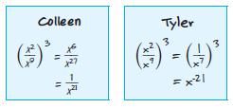
47. FIND THE ERROR Colleen and Tyler are using different steps to simplify ${\left(\frac{x^{2}}{x^{9}}\right)}^{3}$. Their work is shown in the boxes.
a. Which student is correct? Explain your reasoning.
b. Which student’s answer is in simplest form?

48. PERSEVERE Use the Quotient of Powers Property to explain why x^{–n} = $\frac{1}{x^{n}}$.

49. FIND THE ERROR Lola claims that we never need to use the Division Property of Exponents. She says that exponents in the denominator can be written as negative exponents, and then the Multiplication Property of Exponents can be used instead. Is Lola correct? If so, give an example. If not, explain why.

50. WRITE Explain how to evaluate the expression 0⁰.

51. CREATE Measure something large and something very small in the same units. Write and solve a problem comparing the order of magnitude of the two measurements.

52. ANALYZE Consider the expression, $\frac{a^{b}c^{-d}}{w^{x}y^{-z}}$, where all values are nonnegative. Make a conjecture about why only c and w cannot be zero.

53. ANALYZE Dale wrote the value of several powers of 2 on a piece of paper. Describe the pattern shown. Then explain how to use the pattern to find 2⁰.

2⁴ = 2 $×$ 2 $×$ 2 $×$ 2 = 16
2³ = 2 $×$ 2 $×$ 2 = 8
2² = 2 $×$ 2 = 4
2¹ = 2 = 2

