Rational Exponents ⸱ Practice

Example 1
Write each expression in radical or exponential form.
1. ${15}^{\frac{1}{2}}$ 2. ${24}^{\frac{1}{2}}$

3. ${4k}^{\frac{1}{2}}$ 4. ${\left(12y\right)}^{\frac{1}{2}}$

5. $\sqrt{26}$ 6. $\sqrt{44}$

7. $2\sqrt{ab}$ 8. $\sqrt{3xyz}$

Examples 2-4
Evaluate each expression.
9. ${\left(\frac{1}{16}\right)}^{\frac{1}{4}}$ 10. $\sqrt[5]{3125}$

11. ${729}^{\frac{1}{3}}$ 12. ${\left(\frac{1}{32}\right)}^{\frac{1}{5}}$

13. $\sqrt[6]{4096}$ 14. ${1024}^{\frac{1}{5}}$

15. ${\left(\frac{16}{625}\right)}^{\frac{1}{4}}$ 16. $\sqrt[6]{15,625}$

17. ${117,649}^{\frac{1}{6}}$ 18. $\sqrt[4]{\frac{16}{81}}$

19. ${\left(\frac{1}{81}\right)}^{\frac{1}{4}}$ 20. ${\left(\frac{3125}{32}\right)}^{\frac{1}{5}}$

21. ${729}^{\frac{5}{6}}$ 22. ${256}^{\frac{3}{8}}$

23. ${125}^{\frac{4}{3}}$ 24. ${49}^{\frac{5}{2}}$

25. ${\left(\frac{9}{100}\right)}^{\frac{3}{2}}$ 26. ${\left(\frac{8}{125}\right)}^{\frac{4}{3}}$

Example 5
27. VELOCITY The velocity v in feet per second of a freely falling object that has fallen h feet can be represented by v = ${8h}^{\frac{1}{2}}$. Find the velocity an object if it has fallen a distance of 144 feet.
28. GEOMETRY The surface area S of a cube in square inches can be determined by S = 6$V^{\frac{2}{3}}$, where V is the volume of the cube in cubic inches. Find the surface area of a cube that has a volume
of 4096 cubic inches.

29. PLANETS The average distance d in astronomical units that a planet is from the Sun can be modeled by d = $t^{\frac{2}{3}}$, where t is the number of Earth years that it takes for the planet to orbit the Sun. Find the average distance a planet is from the Sun if the planet has an orbit of
27 Earth years.

30. BIOLOGY The relationship between the mass m in kilograms of an organism and its metabolism P in Calories per day can be represented by P = 73.3$\sqrt[4]{m^{3} }$. Find the metabolism of an organism that has a mass of 16 kilograms.

31. PROFIT The profit P of a company, in thousands of dollars, can be modeled by
P = 12.75$\sqrt[5]{c^{2} }$, where c is the number of customers in hundreds. What is the profit of the company if the company has 3200 customers?

32. TIRE MARKS When a driver applies the brakes, the tires lock but the car will continue to slide, leaving skid marks on the road. You can approximate the speed at which a car was traveling on a dry road based on the length of a skid mark left by a car using the formula
$\text{Speed}={\left(30∙\text{length}∙0.75\right)}^{\frac{1}{2}}$, where speed is measured in miles per hour and length is measured in feet. At approximately what speed was a car traveling if it left a 50-foot long skid mark? Round to the nearest tenth.

Mixed Exercises
Write each expression in radical form, or write each radical in exponential form.
33. ${17}^{\frac{1}{3}}$ 34. $q^{\frac{1}{4}}$

35. ${7b}^{\frac{1}{3}}$ 36. $m^{\frac{2}{3}}$

37. $\sqrt[3]{29}$ 38. $\sqrt[5]{h}$

39. $2\sqrt[3]{a}$ 40. $\sqrt[3]{xy^{2}}$

Simplify.
41. $\sqrt[3]{0.027}$ 42. $\sqrt[4]{\frac{n^{4}}{16}}$

43. $a^{\frac{1}{3}}∙a^{\frac{2}{3}}$ 44. $c^{\frac{1}{2}}∙c^{\frac{3}{2}}$

45. ${\left(8^{2}\right)}^{\frac{2}{3}}$ 46. ${\left(y^{\frac{3}{4}}\right)}^{\frac{1}{2}}$

47. $9^{-\frac{1}{2}}$ 48. ${16}^{-\frac{3}{2}}$

49. ${\left(3^{2}\right)}^{-\frac{3}{2}}$ 50. ${\left({81}^{\frac{1}{4}}\right)}^{-2}$

51. $k^{-\frac{1}{2}}$ 52. ${\left(d^{\frac{4}{3}}\right)}^{0}$

53. USE A MODEL In economics, the Cobb-Douglas production function is commonly used to relate input to output. The general form of the function is P = bL^{ax}K^{y}. The values in the table are given for the U.S. economy for the years 1900 and 1920. For both parts, assume a is 1.
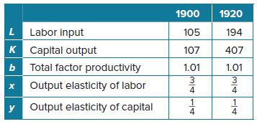
- Find the total production P for 1900, to the nearest whole number.

- Find the total production P for 1920, to the nearest whole number.

54. BASKETBALL The formula, SA = 4$π{\left(\frac{3V}{4π}\right)}^{\frac{2}{3}}$ can be used to find the surface area of a sphere, where V represents its volume. A regulation basketball has a volume of about 456 cubic inches. How much leather is needed (surface area) to make a regulation basketball? Round your answer to the nearest tenth.

55. BIOLOGY The function h(x) = 0.4$x^{\frac{2}{3}}$ can be used to find the height h in meters of a female giraffe with mass x kilograms. What is the height of a female giraffe with a mass of 32.8 kilograms? Round your answer to the nearest tenth of a meter.

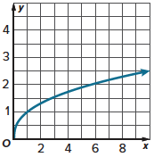
56. GRAPH The graph of y = $x^{\frac{2}{5}}$ is shown over the interval 0 < x < 10. Find the values to complete the table. Round to the nearest tenth if necessary.
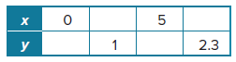

57. CONSTRUCT ARGUMENTS Use the properties of exponents to show which of the expressions are equivalent. Explain your reasoning.
A. $p^{\frac{f}{k}}$ B. $p^{\frac{f}{5}}$ C. $\sqrt[k]{p^{f}}$ D. ${\left(\sqrt[k]{p}\right)}^{f}$

58. USE TOOLS The amount of material needed to make a party hat in the shape of a cone can be found by calculating the hat’s lateral area. The formula LA = $πr{\left(h^{2}+r^{2}\right)}^{\frac{1}{2}}$ represents the lateral area of a cone for a given height h and radius r. Use your calculator to find the lateral area of a party hat that has a radius of 2 inches and a height of 7 inches. Round the answer to the nearest tenth of a square inch.

59. GEOMETRY The surface area S of a cylinder in square centimeters can be determined by
S = 2$\left(\frac{V}{h}\right)$ + 2$π{\left(\frac{V}{πh}\right)}^{\frac{1}{2}}h$, where V is the volume of the cylinder in cubic centimeters and h is the height of the cylinder is centimeters. Find the surface area of a cylinder that has a volume of $160π$ cubic centimeters and a height of 10 centimeters. Write the surface area in terms of $π$.

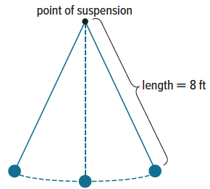
60. PENDULUMS A pendulum is a weight hanging from a point of suspension so that it can swing freely. The formula T = 2$π{\left(\frac{L}{32}\right)}^{\frac{1}{2}}$ gives the time T in seconds it takes for a pendulum of length L in feet to complete one full cycle. How long will it take the pendulum shown to complete one full cycle? Write the length of time in terms of $π$.

61. CREATE Write two different expressions with rational exponents equal to $\sqrt{2}$.

62. ANALYZE Determine whether each statement is sometimes, always, or never true. Assume that x > 0. Justify your argument.
a. x² = $x^{\frac{1}{2}}$ b. x^{–2} = $x^{\frac{1}{2}}$

c. $x^{\frac{1}{3}}=x^{\frac{1}{2}}$ d. $\sqrt{x}$ = $x^{\frac{1}{2}}$

e. ${\left(x^{\frac{1}{2}}\right)}^{2}$ = x f. $x^{\frac{1}{2}}∙$ x² = x

63. PERSEVERE For what values of x is x = $x^{\frac{1}{3}}$?

64. WRITE Explain why ${16}^{\frac{1}{4}}$ will be less than 3.

65. FIND THE ERROR Sachi and Makayla are evaluating ${27}^{\frac{2}{3}}$. Is either correct? Explain your reasoning.
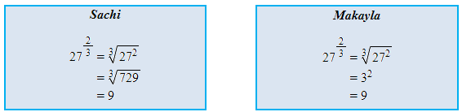

66. WHICH ONE DOESN’T BELONG? Consider the four expressions shown. Which one does not belong? Explain your reasoning.
