Operations with Radical Expressions ⸱ Practice

Examples 1 and 2
Simplify.
1. $7\sqrt{7}$ – $2\sqrt{7}$ 2. $3\sqrt{13}$ + $7\sqrt{13}$

3. $7\sqrt{5}$ + $4\sqrt{5}$ 4. $2\sqrt{6}$ + $9\sqrt{6}$

5. $12\sqrt{r}$ – $9\sqrt{r}$ 6. $9\sqrt{6a}$ – $11\sqrt{6a}$ + $4\sqrt{6a}$

7. $3\sqrt{5}$ – $2\sqrt{20}$ 8. $3\sqrt{50}$ – $3\sqrt{32}$

9. $2\sqrt{13}$ + $4\sqrt{2}$ – $5\sqrt{13}$ + $\sqrt{2}$ 10. $5\sqrt{8}$ + $2\sqrt{20}$ – $\sqrt{8}$

11. $7\sqrt{3}$ – $2\sqrt{2}$ + $3\sqrt{2}$ + 5$\sqrt{3}$ 12. $8\sqrt{12}$ – $\sqrt{5}$ – $4\sqrt{3}$

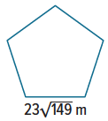
Example 3
13. ARCHITECTURE The Pentagon is the building that houses the U.S. Department of Defense. If the building is a regular pentagon with each side measuring 23$\sqrt{149}$meters, find the perimeter. Leave your answer as a radical expression.

14. BIKING Iker rode his bike on three trails this week. The first was 2$\sqrt{3}$ kilometers, the second was 4$\sqrt{3}$ kilometers, and the third was 3$\sqrt{3}$ kilometers. How long did Iker ride this week? Give your answer as a radical expression.

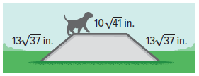
15. RAMP A ramp at a dog park is made of three sections. The incline and decline pieces are the same length, 13$\sqrt{37}$ inches. The center is 10$\sqrt{41}$ inches long. What is the total length of the ramp? Give your answer as a radical expression.

16. DISTANCE The diagonal length of a football field, including both end zones, is 40$\sqrt{97}$ feet. The diagonal length of a practice field is 29$\sqrt{97}$ feet. How much longer is the diagonal length of a football field than the diagonal length of the practice field? Give your answer as a radical expression.

17. CIRCLES A large circle has an area of 400 cm² and a small circle has an area of 200 cm². The radius of the large circle is $\sqrt{\frac{400}{π}}$ cm. The radius of the small circle is $\sqrt{\frac{200}{π}}$ cm. Find the difference of the radius of the large circle and the radius of the small circle.

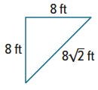
18. GARDEN Camila put a frame around a triangular garden in her yard. The two legs of the triangle are 8 feet long each, and the third side is equal to the length of a leg times $\sqrt{2}$. What is the perimeter of the triangle? Give your answer as a simplified radical expression.

Examples 4 and 5
Simplify.
19. 2$\sqrt{3}$ $⋅$ 3$\sqrt{15}$ 20. 5$\sqrt{3}$ $⋅$ 2$\sqrt{21}$

21. 6$\sqrt{7}$ $⋅$ 2$\sqrt{8}$ 22. 7$\sqrt{10}$ $⋅$ 4$\sqrt{10}$

23. 11$\sqrt{6}$ $⋅$ 3$\sqrt{12}$ 24. 10$\sqrt{5}$ $⋅$ 5$\sqrt{11}$

25. $\sqrt{2}$($\sqrt{8}$ + $\sqrt{6}$) 26. $\sqrt{5}$($\sqrt{10}$ – $\sqrt{3}$)

27. $\sqrt{5}$($\sqrt{2}$ + 4$\sqrt{2}$) 28. $\sqrt{6}$(2$\sqrt{10}$ + 3$\sqrt{2}$)

29. 4$\sqrt{5}$(3$\sqrt{5}$ + 8$\sqrt{2}$) 30. 5$\sqrt{3}$(6$\sqrt{10}$ – 6$\sqrt{3}$)

Mixed Exercises
Simplify.
31. $\sqrt{\frac{1}{25}}$ – $\sqrt{5}$ 32. $\sqrt{\frac{2}{9}}$ + $\sqrt{6}$

33. 2 + 2$\sqrt{2}$ – $\sqrt{8}$ 34. 8$\sqrt{\frac{5}{4}}$ + 3$\sqrt{20}$ – $\sqrt{45}$

35. $\sqrt{24}$ – 5$\sqrt{12}$ + 4$\sqrt{2}$ – 3$\sqrt{3}$ 36. $\frac{1}{2}\sqrt{8}$ – $\sqrt{\frac{2}{9}}$ + 9$\sqrt{2}$

37. 5$\sqrt{3}∙$ 3$\sqrt{5}$ 38. 8$\sqrt{7}∙\frac{2}{3}\sqrt{7}$

39. $\sqrt{\frac{3}{4}}$($\sqrt{6}$ + 2$\sqrt{20}$) 40. 6$\sqrt{6}$(9$\sqrt{2}$ – 5$\sqrt{12}$)

41. (a$\sqrt{3}$ + b$\sqrt{5}$)(c$\sqrt{8}$ + d$\sqrt{5}$) 42. (6$\sqrt{2}$ + 2$\sqrt{3}$)($\sqrt{10}$ – 4$\sqrt{7}$)
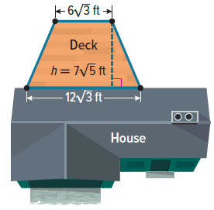
43. GEOMETRY The area of a trapezoid is found by multiplying its height by the average length of its bases. Find the area of the deck attached to Mr. Wilson’s house. Give your answer as a simplified radical expression.

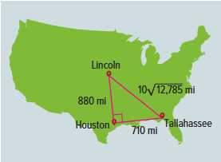
44. TRAVEL Lucia used the straight-line distance between Lincoln, Nebraska, and Houston, Texas, and the straight-line distance between Houston and Tallahassee, Florida, to estimate the straight-line distance between Lincoln and Tallahassee, as shown on the map. Lucia traveled from Lincoln to Tallahassee for vacation. A week after traveling home from vacation, Lucia traveled from Lincoln to Houston to visit a relative. About how far did Lucia travel after returning home from Houston? Give your answer as a radical expression.

45. FREE FALL A ball is dropped from a building window 800 feet above the ground. Another ball is dropped from a lower window 288 feet high. Both balls are released at the same time. Assume air resistance is not a factor, and use the formula t = $\frac{1}{4}\sqrt{h}$ to find how many seconds t it will take a ball to fall h feet.

a. How much longer after the first ball hits the ground does the second ball land?

b. Find a decimal approximation of the answer for part a. Round your answer to the nearest tenth.

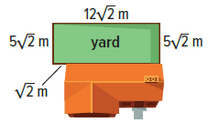
46. REASONING Deja is putting a fence around her yard. The long side of the yard is 12$\sqrt{2}$ meters, the two shorter sides are each 5$\sqrt{2}$ meters, and there is a $\sqrt{2}$-meter section that runs up to the house. When Deja buys the fencing, she approximates the length of fencing she needs. Write and solve an equation to find the total length of fencing f needed for the yard. Give your answer as a radical expression. Then approximate the amount of fencing Deja should buy to the nearest meter.

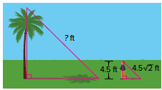
47. SHADOWS The distance from the top of Gino’s head to the end of his head’s shadow is the hypotenuse of a 45°-45°-90° triangle, or Gino’s height times $\sqrt{2}$. Gino is 4.5 feet tall. The distance from a nearby tree to the end of its shadow is 2.5 times as long as the distance from the top of Gino’s head to the end of his shadow. How far is it from the top of the tree to the end of its shadow? Give your answer as a radical expression.

48. STRUCTURE The table shows several radical expressions. Complete the table by writing yes or no in each row to indicate whether the expression in column A and the expression in column B have the same radicand when simplified.
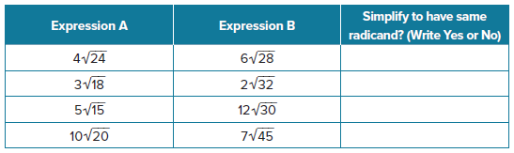

49. SCALING Austin has a model car that uses a 1:24 scale. The real car’s hood is 20$\sqrt{5}$ inches long. How long is the model car’s hood? Give your answer as a radical expression.

50. Find the Error Jhumpa said $3\sqrt{32}$ cannot be subtracted from $8\sqrt{8}$ because they have different radicands. Kenyon said they can be subtracted. Is either correct? Explain your reasoning.

51. PERSEVERE Determine whether the following statement is true or false. Provide a proof or a counterexample to support your answer.
(x + y)² > ${\left(\sqrt{x^{2}+y^{2}}\right)}^{2}$ when x > 0 and y > 0

52. CONSTRUCT ARGUMENTS Make a conjecture about the sum of a rational number and an irrational number. Is the sum rational or irrational? Is the product of a nonzero rational number and an irrational number rational or irrational? Explain your reasoning.

53. CREATE Write an equation that shows a sum of two radicals with different radicands. Explain how you could combine these terms.

54. WRITE A radical expression is an exact value. Rounding a radical gives an approximate value. Give examples of when an exact answer is preferred and when an approximate answer is acceptable.

55. WHICH ONE DOESN’T BELONG? Consider the expressions. Identify which one does not belong and explain your reasoning.


