Multiplying Polynomials by Monomials ⸱ Practice

Example 1
Simplify each expression.
1. b(b² – 12b + 1) 2. f(f² + 2f + 25)

3. –3m³(2m³ – 12m² + 2m + 25) 4. 2j²(5j³ – 15j² + 2j + 2)

5. 2pr²(2pr + 5p²r – 15p) 6. 4t³u(2t²u² – 10tu⁴ + 2)

Example 2
Simplify each expression.
7. –3(5x² + 2x + 9) + x(2x – 3) 8. a(–8a² + 2a + 4) + 3(6a² – 4)

9. –4d(5d² – 12) + 7(d + 5) 10. –9g(–2g + g²) + 3(g³ + 4)

11. 2j(7j²k² + jk² + 5k) – 9k(–2j²k² + 2k² + 3j)

12. 4n(2n³p² – 3np² + 5n) + 4p(6n²p – 2np² + 3p)

Example 3
13. NUMBER THEORY The sum of the first n whole numbers is given by the expression $\frac{1}{2}$(n² + n).
Expand the equation by multiplying, then find the sum of the first 12 whole numbers.

14. COLLEGE Troy’s grandfather gave him $700 to start his college savings account. Troy’s grandfather also gives him $40 each month to add to the account. Troy’s mother gives him $50 each month, but has been doing so for 4 fewer months than Troy’s grandfather. Write a simplified expression for the amount of money Troy has received from his grandfather and mother after m months.

15. MARKET Sophia went to the farmers’ market to purchase some vegetables. She bought peppers and potatoes. The peppers were $0.39 each and the potatoes were $0.29 each. She spent $3.88 on vegetables, and bought 4 more potatoes than peppers. If x = the number of peppers, write and solve an equation to find out how many of each vegetable Sophia bought.
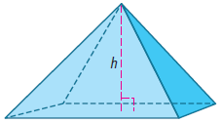
16. GEOMETRY The volume of a pyramid can be found by multiplying the area of its base B by one-third of its height. The area of the rectangular base of a pyramid is given by the polynomial equation
B = x² – 4x – 12.
a. Write a polynomial equation to represent the volume of the pyramid V if its height is 10 meters.

b. Find the volume of the pyramid if x = 12 m.

Example 4
Solve each equation.
17. 7(t² + 5t – 9) + t = t(7t – 2) + 13

18. w(4w + 6) + 2w = 2(2w² + 7w – 3)

19. 5(4z + 6) – 2(z – 4) = 7z(z + 4) – z(7z – 2) – 48

20. 9c(c – 11) + 10(5c – 3) = 3c(c + 5) + c(6c – 3) – 30

21. 2f(5f – 2) – 10(f² – 3f + 6) = –8f(f + 4) + 4(2f² – 7f)

22. 2k(–3k + 4) + 6(k² + 10) = k(4k + 8) – 2k(2k + 5)

Mixed Exercises
Simplify each expression.
23. a(4a + 3) 24. –c(11c + 4)

25. x(2x – 5) 26. 2y(y – 4)

27. –3n(n² + 2n) 28. 4h(3h – 5)

29. 3x(5x² – x + 4) 30. 7c(5 – 2c² + c³)

31. –4b(1 – 9b – 2b²) 32. 6y(–5 – y + 4y²)

33. 2m²(2m² + 3m – 5) 34. –3n²(–2n² + 3n + 4)

Simplify each expression.
35. w(3w + 2) + 5w 36. f(5f – 3) – 2f

37. –p(2p – 8) – 5p 38. y²(–4y + 5) – 6y²

39. 2x(3x² + 4) – 3x³ 40. 4a(5a² – 4) + 9a

41. 4b(–5b – 3) – 2(b² – 7b – 4)

42. 3m(3m + 6) – 3(m² + 4m + 1)

43. –5q²w³(4q + 7w) + 4qw²(7q²w + 2q) – 3qw(3q²w² + 9)

44. –x²z(2z² + 4xz³) + xz²(xz + 5x³z) + x²z³(3x²z + 4xz)

Solve each equation.
45. 3(a + 2) + 5 = 2a + 4 46. 2(4x + 2) – 8 = 4(x + 3)

47. 5(y + 1) + 2 = 4(y + 2) – 6 48. 4(b + 6) = 2(b + 5) + 2

49. 6(m – 2) + 14 = 3(m + 2) – 10 50. 3(c + 5) – 2 = 2(c + 6) + 2
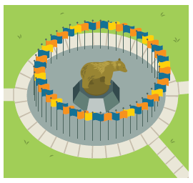

51. LANDMARKS The courtyard on a college campus has a sculpture surrounded by a circle of 50 flags. The university plans to install a new sidewalk 12 feet wide around the perimeter of the outside of the circle of flags. If the outside circumference of the sidewalk is 1.10 times the circumference of the circle of flags, write an equation for the outside circumference of the sidewalk. Solve the equation for the radius of the circle of flags. Recall that the circumference of a circle is 2πr.

52. STRUCTURE The base lengths of the trapezoid shown are given by polynomial expressions in terms of the trapezoid’s height h.
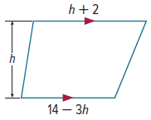
a. Write and simplify an expression for the area of the trapezoid.

b. If the height of the trapezoid is 4 units, what is the area of
the trapezoid?

53. FIND THE ERROR Andres simplified the expression 12y²(3y – 2y²) – 3y³(4 – 2y). Is he correct? Explain your reasoning.
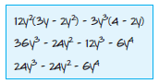

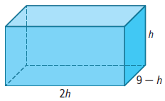
54. STRUCTURE The diagram shows the dimensions of a right rectangular prism.
a. Write and simplify an expression for the volume of the prism.

b. If the height of the rectangular prism is 6 units, what is the volume of the rectangular prism?

55. USE TOOLS Through market research, a company finds that it can expect to sell 45 – 5x products if each is priced at 1.25x dollars.
a. Write and simplify an expression for the expected revenue.
b. Determine the price of each product, to the nearest cent, when x = 4.5.

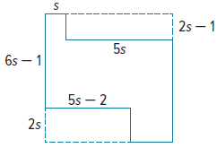
c. Determine the revenue when the expected number of products are sold, to the nearest cent, when x = 4.5.

56. STRUCTURE An area is enclosed by the fence shown at the right, represented by the solid line segments. Write and simplify an expression for the area of the enclosure.

57. FIND THE ERROR Pearl and Ted both simplified 2x²(3x² + 4x + 2). Is either of them correct? Explain your reasoning.
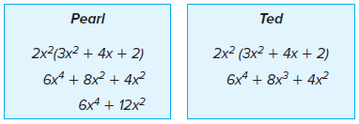

58. PERSEVERE Find p such that 3x^{p}(4x^{2p + 3} + 2x^{3p – 2}) = 12x¹² + 6x¹⁰.

59. PERSEVERE Simplify 4x^{–3}y²(2x⁵y^{–4} + 6x^{–7}y⁶ – 4x⁰y^{–2}).

60. ANALYZE Is there a value of x that makes the statement (x + 2)² = x² + 2² true? If so, find a value for x. Justify your argument.

61. CREATE Write a monomial and a polynomial using n as the variable. Find their product.

62. WRITE Describe the steps to multiply a polynomial by a monomial.

63. CREATE Write a polynomial equation, with variables on both sides, that has a solution of t = 9.

64. CREATE Write a polynomial expression that can be simplified to –3c³ + 74c² – 4c. Be sure your polynomial expression requires the use of the Distributive Property at least two times in order to simplify.

