Special Products ⸱ Practice

Examples 1 and 3
Find each product.
1. (a + 10)(a – 10) 2. (b – 6)(b – 6)

3. (h + 7)² 4. (x + 6)²

5. (8 – m)² 6. (9 – 2y)²

7. (2b + 3)² 8. (5t – 2)²

9. (8h – 4n)² 10. (4m – 5n)²

Example 2
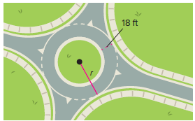
11. ROUNDABOUTS A city planner is proposing a roundabout to improve traffic flow at a busy intersection. Write a polynomial equation for the area A of the traffic circle if the radius of the outer circle is r and the width of the road is 18 feet.

12. NUMBER CUBES Kivon has two number cubes. Each edge of number cube A is 3 millimeters less than each edge of number cube B. Each edge of number cube B is x millimeters. Write an equation that models the surface area of number cube A.
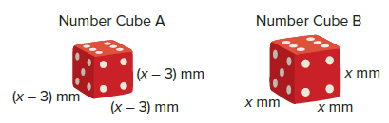

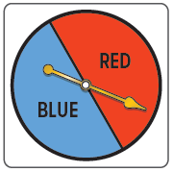
13. PROBABILITY The spinner has two equal sections, blue (B) and red (R). Use the square of a sum to determine the possible combinations of spinning the spinner two times.

14. BUSINESS The Combo Lock Company finds that its profit data from 2015 to the present can be modeled by the function y = (2n + 11)², where y is the profit n years since 2015. Which special product does this polynomial demonstrate? Simplify
the polynomial.

Example 4
Find each product.
15. (u + 3)(u – 3) 16. (b + 7)(b – 7)

17. (2 + x)(2 – x) 18. (4 – x)(4 + x)

19. (2q + 5r)(2q – 5r) 20. (3a² + 7b)(3a² – 7b)

Mixed Exercises
Find each product.
21. (n + 3)² 22. (x + 4)(x + 4)

23. (y – 7)² 24. (t – 3)(t – 3)

25. (b + 1)(b – 1) 26. (a – 5)(a + 5)

27. (p – 4)² 28. (z + 3)(z – 3)

29. (ℓ + 2)(ℓ + 2) 30. (r – 1)(r – 1)

31. (3g + 2)(3g – 2) 32. (2m – 3)(2m + 3)

33. (6 + u)² 34. (r + t)²

35. (3q + 1)(3q – 1) 36. (c – d)²

37. (2k – 2)² 38. (w + 3h)²

39. (3p – 4)(3p + 4) 40. (t + 2u)²

41. (x – 4y)² 42. (3b + 7)(3b – 7)

43. (3y – 3g)(3y + 3g) 44. (n² + r²)²

45. (2k + m²)² 46. (3t² – n)²

47. GEOMETRY The length of a rectangle is the sum of two whole numbers. The width of the rectangle is the difference of the same two whole numbers. Write a verbal expression for the area of the rectangle.

48. Find the product of (10 – 4t) and (10 + 4t). What type of special product does this represent?

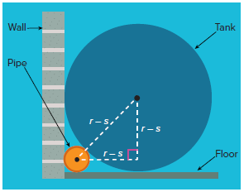
49. STORAGE A cylindrical tank is placed along a wall. A cylindrical PVC pipe will be hidden in the corner behind the tank. See the side-view diagram shown. The radius of the tank is r inches, and the radius of the PVC pipe
is s inches.

a. Use the Pythagorean Theorem to write an equation for the relationship between the two radii. Simplify your equation so that there is a zero on one side of the equal sign.

b. Write a polynomial equation you could solve to find the radius s of the PVC pipe if the radius of the tank is 20 inches.

Find each product.
50. (2a – 3b)² 51. (5y + 7)²

52. (8 – 10a)² 53. (10x – 2)(10x + 2)

54. (3t + 12)(3t – 12) 55. (a + 4b)²

56. (3q – 5r)² 57. (2c – 9d)²

58. (g + 5h)² 59. (6y – 13)(6y + 13)

60. (3a⁴ – b)(3a⁴ + b) 61. (5x² – y²)²

62. (8a² – 9b³)(8a² + 9b³) 63. ${\left(\frac{3}{4}k+8\right)}^{2}$

64. ${\left(\frac{2}{5}y-4\right)}^{2}$ 65. (7z² + 5y²)(7z² – 5y²)

66. (2m + 3)(2m – 3)(m + 4) 67. (r + 2)(r – 5)(r – 2)(r + 5)

Find each product.
68. (c + d)(c + d)(c + d) 69. (2a – b)³

70. (f + g)(f – g)(f + g) 71. (k – m)(k + m)(k – m)

72. (n – p)²(n + p) 73. (q – r)²(q – r)

74. Consider the product (a + b)(a – b)(a + b)(a – b).

- Show the steps required to determine the product.

b. Evaluate the original expression for a = 5 and b = 2.
c. Evaluate the simplified expression you wrote in part a for a = 5 and b = 2. Compare this to the result from part b.

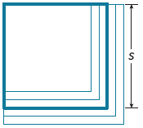
75. STRUCTURE Tanisha is investigating growth patterns for the area of a square. She begins with a square of side length s and looks at the effects of enlarging the side length by one unit at a time.

- How much more area does the square with side length s + 1 have compared to the square with side length s?

b. How much more area does the square with side length s + 2 have compared to the square with side length s + 1?

c. How much more area does the square with side length s + 3 have compared to the square with side length s + 2?

76. WHICH ONE DOESN’T BELONG? Which expression does not belong? Explain your reasoning.

77. PERSEVERE Does a pattern exist for the cube of a sum (a + b)³?

a. Investigate this question by finding the product (a + b)(a + b)(a + b).

b. Use the pattern you discovered in part a to find (x + 2)³.

c. Draw a diagram of a geometric model for (a + b)³.

d. What is the pattern for the cube of a difference (a – b)³?

78. ANALYZE The square of a sum is called a perfect square trinomial. Find c that makes
25x² – 90x + c a perfect square trinomial.

79. CREATE Write two binomials with a product that is a binomial. Then write two binomials with a product that is not a binomial.

80. WRITE Describe how to square the sum of two quantities, how to square the difference of two quantities, and how to find the product of a sum of two quantities and a difference of
two quantities.

