Factoring Quadratic Trinomials ⸱ Practice

Examples 1–4
Factor each polynomial, if possible. If the polynomial cannot be factored using integers, write prime.
1. x² + 17x + 42 2. y² – 17y + 72

3. a² + 8a – 48 4. n² – 2n – 35

5. 44 + 15h + h² 6. 40 – 22x + x²

7. –24 – 5x + x² 8. –42 – m + m²

9. t² + 8t + 12 10. d² + 5d – 13

11. y² – 6y + 17 12. n² + 7n + 12

13. b² – 12b – 101 14. p² + 9p + 20

15. h² + 9h + 18 16. c² + c + 21

Example 5
17. COSMETICS CASE The top of a cosmetics case is a rectangle in which the width is 2 centimeters greater than the length. The expression x² + 26x + 168 represents the area of the top of the case. Factor the expression.

18. CARPENTRY Miko wants to build a crate to hold record albums. The expression 2x² – 6x – 80 represents the volume of the crate. Factor the expression.

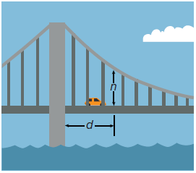
19. BRIDGE ENGINEERING A suspension bridge is a bridge in which the deck is supported by cables with towers spaced throughout the span of the bridge. The height of a cable n inches above the deck measured at distance d in yards from the first tower is given by
d² – 36d + 324. Factor the expression.

20. FINANCE The break-even point for a business occurs when the revenues equal the cost. A local children’s museum studied their costs and revenues from paid admission. They found that their break-even point is given by the expression 2h² – 2h – 24, where h is the number of hours the museum is open per day. Factor the expression.

Examples 6 and 7
Factor each polynomial, if possible. If the polynomial cannot be factored using integers, write prime.
21. 5x² + 34x + 24 22. 2x² + 19x + 24

23. 4x² + 22x + 10 24. 4x² + 38x + 70

25. 2x² – 3x – 9 26. 4x² – 13x + 10

27. 2x² + 3x + 6 28. 5x² + 3x + 4

29. 12x² + 69x + 45 30. 4x² – 5x + 7

31. 3x² – 8x + 15 32. 5x² + 23x + 24

33. 2x² + 3x – 6 34. 2t² + 9t – 5

35. 2y² + y – 1 36. 4h² + 8h – 5

Mixed Exercises
Factor each polynomial, if possible. If the polynomial cannot be factored using integers, write prime.
37. n² + 3n – 18 38. x² + 2x – 8

39. r² + 4r – 12 40. x² – x – 12

41. w² – w – 6 42. y² – 6y + 8

43. t² – 15t + 56 44. –4 – 3m + m²

45. 2x² + 5x + 2 46. 3n² + 5n + 2

47. 3g² – 7g + 2 48. 2t² – 11t + 15

49. 4x² – 3x – 3 50. 4b² + 15b – 4

Factor each polynomial, if possible. If the polynomial cannot be factored using integers, write prime.
51. 9p² + 6p – 8 52. 6q² – 13q + 6

53. a² – 10a + 21 54. x² + 2x – 15

55. 2x² + 7x + 3 56. 6x² + x + 2

57. x² + x – 20 58. x² – 6x – 7

59. p² – 10p + 21 60. 5x² – 6x + 1

61. q² + 11qr + 18r² 62. x² – 14xy – 51y²

63. x² – 6xy + 5y² 64. a² + 10ab – 39b²

65. –6x² – 23x – 20 66. –4x² – 15x – 14

67. –5x² + 18x + 8 68. –6x² + 31x – 35

69. –4x² + 5x – 12 70. –12x² + x + 20

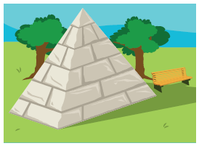
71. MONUMENTS Susan is designing a pyramidal stone monument for a local park. The design specifications tell her that the height needs to be 9 feet, and the width of the base must be 5 feet less than the length. The expression 3x² – 15x – 150 represents the volume of the pyramidal stone monument.

a. Factor the expression that represents the volume of the pyramidal stone monument that Susan is designing for a local park.

b. What does each factored expression represent?

72. PROJECTILES The height of a projectile in feet is given by –16t² + vt + h₀, where t is the time in seconds, v is the initial upward velocity in feet per second, and h₀ is the initial height in feet. A
T-shirt is propelled from 32 feet above ground level into the air at an initial velocity of 16 feet per second.

a. Write an expression to represent how much time the T-shirt is in the air.

b. Factor the expression that represents the amount of time the T-shirt is in the air.

73. WHICH ONE DOESN’T BELONG Which expression does not belong with the others? Explain your reasoning.

74. FIND THE ERROR Jamaall and Charles have factored x² + 6x – 16. Is either of them correct? Explain your reasoning.
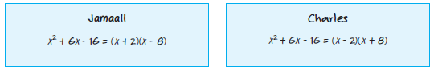

ANALYZE Find all values of k so that each polynomial can be factored using integers.
75. x² + kx – 19 76. x² + kx + 14

77. x² – 8x + k, k > 0 78. x² – 5x + k, k > 0

79. ANALYZE For any factorable trinomial, x² + bx + c, will the absolute value of b sometimes, always, or never be less than the absolute value of c? Justify your argument.

80. CREATE Give an example of a trinomial that can be factored using the factoring techniques presented in this lesson. Then factor the trinomial.

81. PERSEVERE Factor (4y – 5)² + 3(4y – 5) – 70.

82. WRITE Explain how to factor trinomials of the form x² + bx + c and how to determine the signs of the factors of c.

83. ANALYZE A square has an area of 9x² + 30xy + 25y² square inches. The dimensions are binomials with positive integers coefficients. What is the perimeter of the square? Explain.

84. PERSEVERE Find all values of k so that 2x² + kx + 12 can be factored as two binomials
using integers.

85. WRITE Explain how to determine which values should be chosen for m and p when factoring a polynomial of the form ax² + bx + c.

