Graphing Quadratic Functions ⸱ Practice

Examples 1 and 2
Identify the axis of symmetry, the vertex, and the y-intercept of each graph. Then describe the end behavior.
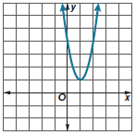
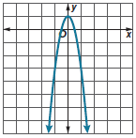
1. 2.

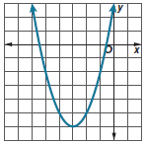
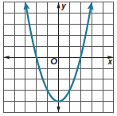
3. 4.

Example 3
Graph each function.
5. y = –3x² + 6x – 4 6. y = –2x² – 4x – 3 7. y = –2x² – 8x + 2




8. y = x² + 6x – 6 9. y = x² – 2x + 2 10. y = 3x² – 12x + 5




Example 4
Use a table of values to graph each function. State the domain and range.
11. y = x² + 4x + 6 12. y = 2x² + 4x + 7

13. y = 2x² – 8x – 5 14. y = 3x² + 12x + 5

15. y = 3x² – 6x – 2 16. y = x² – 2x – 1

Examples 5 and 6
17. OLYMPICS Olympics were held in 1896 and have been held every four years except 1916, 1940, and 1944. The winning height y in men’s pole vault at any number Olympiad x can be approximated by the equation y = 0.37x² + 4.3x + 126. Complete the table to estimate the winning pole vault heights in each of the Olympic Games. Round your answers to the nearest tenth. Graph the function. Interpret the key features of the graph in terms of the quantities.
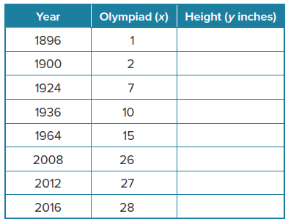

18. PHYSICS Mrs. Capwell’s physics class investigates what happens when a ball is given an initial push, rolls up, and then rolls back down an inclined plane. The class finds that y = –x² + 6x accurately predicts the ball’s position y after rolling x seconds. Graph the function. Interpret the key features of the graph in terms of the quantities.

19. ARCHITECTURE A hotel’s main entrance is in the shape of a parabolic arch. The equation
y = –x² + 10x models the arch height y, in feet, for any distance x, in feet, from one side of the arch. Graph the function. Interpret the key features of the graph in terms of the quantities.

20. SOFTBALL Olympic softball gold medalist Michele Smith pitches a curveball with a speed of 64 feet per second. If she throws the ball straight upward at this speed, the ball’s height h in feet after t seconds is given by h = –16t² + 64t. Graph the function. Interpret the key features of the graph in terms of the quantities.

Mixed Exercises
21. CONSTRUCTION Teddy is building the rectangular deck shown.
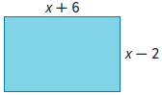
a. Write an equation representing the area of the deck y.

b. What is the equation of the axis of symmetry?

c. Graph the equation and label its vertex.

22. USE TOOLS Write a quadratic function whose graph opens up. Write an exponential function. Graph both functions on the same coordinate plane. Compare and contrast the domains and ranges of the two functions and any symmetry of the two graphs.

23. STRUCTURE Consider the quadratic function y = –x² – 2x + 2.
a. Find the equation for the axis of symmetry.

b. Find the coordinates of the vertex and determine if it is a maximum or minimum.

c. Graph the function.

Identify the axis of symmetry, the vertex, and the y-intercept of each graph. Then describe the end behavior.
24. y = 2x² – 8x + 6 25. y = x² + 4x + 6 26. y = –3x² – 12x + 3

27. STRUCTURE DeMarcus is sitting in a lifeguard’s chair at the beach. He tosses a beanbag into the air and lets it lands on the beach below him. The function h(t) = −16t² + 8t + 12 models the beanbag’s height in feet, t seconds after DeMarcus tosses it into the air.

a. Graph the function on a coordinate plane. Be sure to label the x- and y-axes and provide a scale for each axis.

b. Find the intercepts of the graph. Describe what they represent in the context of the situation.

c. What is the maximum value of the function, and what does it represent? At what time is the maximum reached?

d. What is the value of h(0.5)? Describe its meaning in the context of the situation.

e. State a reasonable domain for this function. What does it represent in the context of the situation?

28. REGULARITY Write the equation for a quadratic function that has a y-intercept of 0 and a minimum value at x = 2. Explain the steps you used to write the equation, and graph the function on a coordinate plane.

29. CREATE Write a quadratic function for which the graph has an axis of symmetry of x = $-\frac{3}{8}$. Summarize your steps.

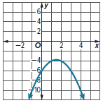
30. FIND THE ERROR Noelia thinks that the parabolas represented by the graph and the description have the same axis of symmetry. Chase disagrees. Is either correct? Explain your reasoning.

A parabola that opens downward, passing through (0, 6) and having a vertex at (2, 2)

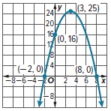
31. PERSEVERE Using the axis of symmetry, the y-intercept, and one x-intercept, write an equation for the graph shown.

32. ANALYZE The graph of a quadratic function has a vertex (2, 0). One point on the graph is (5, 9). Find another point on the graph. Explain how you found it.

33. CREATE Describe a real-world situation that involves a quadratic equation. Explain what the vertex represents.

34. ANALYZE Provide a counterexample that shows that the following statement is false. Justify your argument.
The vertex of a parabola is always the minimum of the graph.

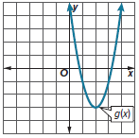
35. WRITE Use tables and graphs to compare and contrast an exponential function f(x) = ab^{x} + c, where a ≠ 0, b > 0, and b ≠ 1, a quadratic function g(x) = ax² + c, and a linear function
h(x) = ax + c. Include intercepts, portions of the graph where the functions are increasing, decreasing, positive, negative, relative maxima, relative minima, symmetries, and end behavior. Which function eventually exceeds the others?

36. ANALYZE Consider g(x) shown in the graph and f(x) = –x² + 3x – 2. Determine which function has the lesser minimum.

