Transformations of Quadratic Functions ⸱ Practice

Examples 1–3
Describe how the graph of each function is related to the graph of the parent function.
1. g(x) = –10 + x² 2. g(x) = x² + 2

3. g(x) = (x – 1)² 4. g(x) = x² – 8

5. g(x) = (x + 3)² 6. g(x) = x² + 7

7. g(x) = (x + 2.5)² 8. g(x) = (x + 5)² – 2

9. g(x) = 6 + x² 10. g(x) = –4 + (x – 3)²

11. g(x) = (x – 9.5)² 12. g(x) = (x – 1.5)² + 3.5

Examples 4 and 5
Describe the dilation in each function as it relates to the graph of the parent function.
13. g(x) = 7x² 14. g(x) = $\frac{1}{5}$x²

15. g(x) = (4x)² 16. g(x) = ${\left(\frac{1}{2}x\right)}^{2}$

17. g(x) = ${\left(\frac{5}{3}x\right)}^{2}$ 18. g(x) = 5x²

19. g(x) = $\frac{3}{4}$x² 20. g(x) = ${\left(\frac{7}{8}x\right)}^{2}$

Examples 6 and 7
Describe how the graph of each function is related to the graph of the parent function.
21. g(x) = –6x² 22. g(x) = (–9x)²

23. g(x) = $-\frac{1}{3}$x² 24. g(x) = ${\left(-\frac{2}{3}x\right)}^{2}$

25. g(x) = –2x² 26. g(x) = ${\left(-\frac{6}{5}x\right)}^{2}$

Example 8
Describe how the graph of each function is related to the graph of the parent function.
27. h(x) = –7 – x² 28. g(x) = 2(x – 3)² + 8

29. h(x) = 6 + $\frac{2}{3}$x² 30. g(x) = –5 – $\frac{4}{3}$x²

31. h(x) = 3 + $\frac{5}{2}$x² 32. g(x) = –x² + 3

Example 9
33. SPRINGS The potential energy stored in a spring is given by U_{s} = $\frac{1}{2}$kx², where k is a constant known as the spring constant, and x is the distance the spring is stretched or compressed from its initial position. How is the graph of the function for a spring where k = 10 newtons/meter related to the graph of the function for a spring where k = 2 newtons/meter?

34. PHYSICS A ball is dropped from a height of 20 feet. The function h = –16t² + 20 models the height of the ball in feet after t seconds. Compare this graph to the graph of its parent function.

35. ACCELERATION The distance d in feet a car accelerating at 6 ft/$s^{2}$ travels from the start of a race after t seconds is modeled by the function d = 3$t^{2}$. Suppose a second car begins the race at the same time 100 feet ahead of the first car and accelerating at 4 ft/$s^{2}$. The distance the second car is from the starting line after t seconds is modeled by the function d = 2t² + 100.
a. Explain how each graph is related to the graph of d = t².

b. After how many seconds will the first car pass the second car?

Example 10
Use the graph of each function to write its equation.
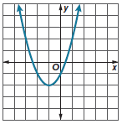
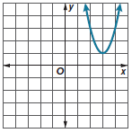
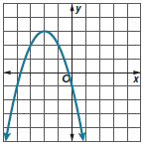
36. 37. 38.

Mixed Exercises
Describe how the graph of each function is related to the graph of the parent function.
39. g(x) = 5 – $\frac{1}{5}$x² 40. g(x) = 4(x – 1)²

41. g(x) = 0.25x² – 1.1 42. h(x) = 1.35(x + 1)² + 2.6

43. g(x) = $\frac{3}{4}$x² + $\frac{5}{6}$ 44. h(x) = 1.01x² – 6.5

STRUCTURE Use transformations to graph each quadratic function. Then describe
the transformation.
45. h(x) = −2(x + 2)² + 2 46. g(x) = ${\left(\frac{1}{2}x\right)}^{2}$ − 3 47. h(x) = $-\frac{1}{4}$(x − 1)² + 4

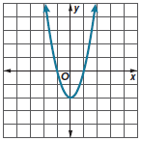
Match each function to its graph.
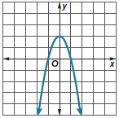
A. B.

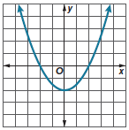
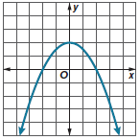
C. D.

48. f(x) = 2x² – 2 49. g(x) = $\frac{1}{2}$x² – 2

50. h(x) = – $\frac{1}{2}$x² + 2 51. j(x) = –2x² + 2

52. PRECISION Write a set of instructions that a classmate could use to transform the graph of
f(x) = x² and end up with the graph of g(x) = −10(x − 17)².

53. CONSTRUCT ARGUMENTS A function is an even function if f(−x) = f(x) for all x in the domain of the function. A function is an odd function if f(−x) = −f(x) for all x in the domain of the function. Is the parent function of a quadratic function an even function or an odd function? Justify your answer.

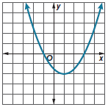
54. USE A MODEL An animator is using a coordinate plane to design a scene in a movie. In the scene, a comet enters the screen in Quadrant II, moves around the screen in a parabolic path, and leaves the screen in Quadrant I.

a. The figure shows the path of the comet. What equation represents the path?

b. The animator decides to translate the path of the comet 8 units up and 7 units left. What equation represents the new path?

Use the graph of each function to write its equation.
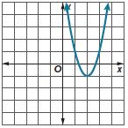
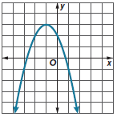
55. 56.

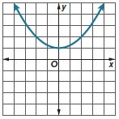
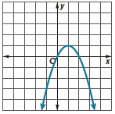
57. 58.

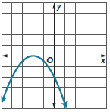
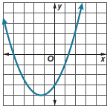
59. 60.

61. ANALYZE Are the following statements sometimes, always, or never true? Justify your argument.

a. The graph of y = x² + k has its vertex at the origin.

b. The graphs of y = ax² and its reflection across the x-axis are the same width.
c. The graph of f(x) = x² + k, where k ≥ 0, and the graph of a quadratic function g(x) with vertex at (0, –3) have the same maximum or minimum.

62. PERSEVERE Write a function of the form y = ax² + k with a graph that passes through the points (–2, 3) and (4, 15).

63. ANALYZE Determine whether all quadratic functions that are reflected across the y-axis produce the same graph. Justify your argument.

64. CREATE Write a quadratic function with a graph that opens down and is wider than the parent graph.
65. WRITE Describe how the values of a and k affect the graphical and tabular representations of the functions y = ax², y = x² + k, and y = ax² + k.

