Solving Quadratic Equations by Graphing ⸱ Practice

Examples 1–3
Solve each equation by graphing.
1. x² + 7x + 14 = 0 2. x² + 2x – 24 = 0 3. x² + 16x + 64 = 0

4. x² – 5x + 12 = 0 5. x² + 14x = –49 6. x² = 2x – 1

7. x² – 10x = –16 8. –2x² – 8x = 13 9. 2x² – 16x = –30

10. 2x² = –24x – 72 11. –3x² + 2x = 15 12. x² = –2x + 80

Example 4
13. SOCCER Claudia kicked a soccer ball off of a platform. The equation y = –x² + 3x + 12 models the height of the ball y in feet after x seconds. Approximately how long is the ball in the air?

14. TRAMPOLINE A gymnast jumped on a trampoline. The equation y = –16x² + 58x models the height of the gymnast y in feet after x seconds for one of the jumps. Approximately how long is the gymnast in the air?

Mixed Exercises
Estimate the solution(s) to each equation by graphing the related function. Round to the
nearest tenth.

15. p² + 4p + 2 = 0 16. x² + x – 3 = 0 17. d² + 6d = –3

18. h² + 1 = 4h 19. 3x² – 5x = –1 20. x² + 1 = 5x

21. FARMING In order for Mr. Moore to decide how much fertilizer to apply to his corn crop this year, he reviews records from previous years. His crop yield y depends on the amount of fertilizer he applies to his fields x according to the equation y = –x² + 4x + 12. Graph the function, and find the point at which Mr. Moore gets the highest yield possible. Then find and interpret the zero(s) of the function.

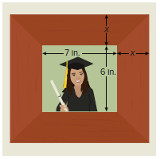
22. FRAMING A rectangular photograph is 7 inches long and 6 inches wide. The photograph is framed using a material that is x inches wide. If the area of the frame and photograph combined is 156 square inches, what is the width of the framing material?

23. WRAPPING PAPER Can a rectangular piece of wrapping paper with an
area of 81 square inches have a perimeter of 60 inches?
(Hint: Let length = 30 – width.) Explain.

24. ENGINEERING The shape of a satellite dish is often parabolic because of the reflective qualities of parabolas. Suppose a particular satellite dish is modeled
by the function 0.5x² = 2 + y.
a. Approximate the zeros of this function by graphing.

b. On the coordinate plane, translate the parabola so that there is only one zero. Label this curve A.

c. Translate the parabola so that there are no real zeros. Label this curve B.

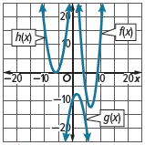
25. REASONING The three equations below are shown on the graph.
y = x² + 12x + m; y = 2x² – nx + 72; y = –x² + 3x – 10

a. Describe the solutions for each function. Then, match each graph to its related equation. Explain your reasoning.

b. How could you choose an appropriate value for m?

c. How could you choose an appropriate value for n?

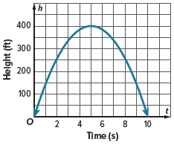
26. ROCKETS The height h of a model rocket launched from ground level into the air after t seconds can be modeled by the equation h = –16t² + 160t. The equation is graphed on the coordinate grid.

a. Where does the graph intersect the x-axis? What do these points represent?

b. How long does it take the rocket to reach its maximum height? Explain your reasoning.

27. USE TOOLS Through market research, a company finds that its profit in dollars can be modeled by the function P(x) = –50,000x² + 300,000x – 250,000, where x is the price in dollars at which they sell their product.

a. Describe how to use graphing technology to graph the function, and then provide a sketch of the graph.

b. Find the x-intercepts. What do these represent in the context of the situation?

c. Write an equation for the price at which the company should sell their product to make a profit of $150,000. Sketch a graph of the function relating to this equation and use it to solve the equation graphically.

d. Is there a price at which the company can sell their product to make a profit of $300,000? Explain your reasoning, and use a graph to support your answer.

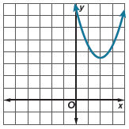
28. FIND THE ERROR Iku and Zachary are finding the number of real zeros of the function graphed at the right. Iku says that the function has no real zeros because there are no x-intercepts. Zachary says that the function has one real zero because the graph has a y-intercept. Is either of them correct? Explain your reasoning.

29. CREATE Describe a real-world situation in which a thrown object travels in the air. Write an equation that models the height of the object with respect to time, and determine how long the object travels in the air.

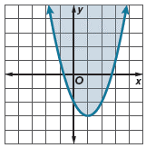
30. ANALYZE The graph shown is a quadratic inequality. Analyze the graph, and find
3 solutions with y-values greater than 2.

31. PERSEVERE Write a quadratic equation that has the roots described.

a. one double root

b. no real solutions

c. two unique real solutions

32. WRITE Explain how to approximate the roots of a quadratic equation when the roots are not integers.

