Solving Quadratic Equations by Factoring ⸱ Practice

Examples 1, 3, 5, 6
Solve each equation. Check your solutions.
1. x² = 36 2. x² = 81

3. (k + 1)² = 9 4. 81 – 4b² = 0

5. 3b(9b – 27) = 0 6. (7x + 3)(2x – 6) = 0

7. b² = –3b 8. a² = 4a

9. x² – 6x = 27 10. a² + 11a = –18

11. n² – 120 = 7n 12. d² + 56 = –18d

13. y² – 90 = 13y 14. h² + 48 = 16h

15. x² + 9x + 18 = 0 16. 4x² + 28x + 49 = 0

17. –9x² = 30x + 25 18. –x² – 12 = –8x

19. 36w² = 121 20. 100 = 25w²

21. 64x² – 1 = 0 22. 4y² – $\frac{9}{16}$ = 0

23. $\frac{1}{4}$b² = 16 24. 81 – $\frac{1}{25}$x² = 0

Example 4
25. Consider the equation c² + 10c + 9 = 0.
a. Solve the equation by factoring.

b. Use the roots to sketch the related function.

26. Consider the equation x² – 18x = –32.
a. Solve the equation by factoring.

b. Use the roots to sketch the related function.

Examples 2 and 7
27. NUMBER THEORY The product of the two consecutive positive integers is 11 more than their sum. What are the numbers?

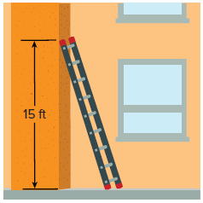
28. LADDERS A ladder is resting against a wall. The top of the ladder touches
the wall at a height of 15 feet, and the length of the ladder is one foot
more than twice its distance from the wall. Find the distance from the wall
to the bottom of the ladder. (Hint: Use the Pythagorean Theorem to solve
the problem.)

29. FREE FALL The function f (t) = –16t² + 576 represents the height of a freely falling ballast bag that was accidentally dropped from a hot air balloon 576 feet above the ground. After how many seconds t does the ballast bag hit the ground?

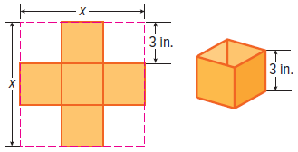
30. VOLUME Catalina can make an open-topped box out of a square piece of cardboard by cutting 3-inch squares from the corners and folding up the sides to meet. The volume of the resulting box is V = 3x² – 36x + 108, where x is the original length and width of the cardboard.

a. Factor the polynomial expression from the volume equation.

b. What is the volume of the box if the original length of each side of the cardboard
was 9 inches?

Example 8
Write a quadratic function for the given graph.
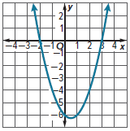
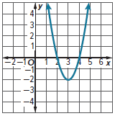
31. 32.

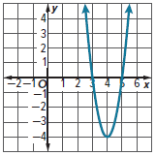
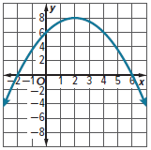
33. 34.

Example 9
Write a quadratic function that contains the given points.
35. (–9, 0), (–3, –30), (2, 0) 36. (–5, 0), (–4, 0), (3, 56)

37. (–4, 0), (2, –9), (8, 0) 38. (1, 0), (3, –18), (6, 0)

Mixed Exercises
39. CONSTRUCT ARGUMENTS Kayla says the zeros of the equation 2m² – 12m = 0 are 0 and –12. Is she correct? Explain your reasoning.

40. STRUCTURE Write an expression for the perimeter of a rectangle that has an area
A = x² + 20x + 96. Explain how you solved the problem.

Solve each equation. Check the solutions.
41. 25p² – 16 = 0 42. 4p² + 4p + 1 = 0

43. n² – $\frac{9}{25}$ = 0 44. 9y² + 18y – 12 = 6y

45. 6h² + 8h + 2 = 0 46. 16d² = 4

47. $\frac{1}{16}$y² = 81 48. 8p² – 16p = 10

49. x² + 30x + 150 = –75 50. 10b² – 15b = 8b – 12

51. y² – 16y + 64 = 81 52. (m – 4)² = 9

53. 4x² = 80x – 400 54. 9 – 64x = –81x²

55. 4c² + 4c + 1 = 9 56. x² – 16x + 64 = 4

57. STRUCTURE A triangle’s height is 10 feet more than its base. If the area of the triangle is 100 square feet, use factoring to find its dimensions.

58. REGULARITY Explain how to use the Zero Product Property to solve a quadratic equation.

59. REGULARITY Consider a quadratic equation written in standard form, ax² + bx + c = 0, where
a ≠ 1. Explain how solving an equation by factoring a trinomial where a ≠ 1 differs from solving a quadratic equation by factoring a trinomial where a = 1.

60. STRUCTURE A square has an area of 4x² + 16xy + 16y² square inches. The dimensions are binomials with positive integer coefficients. Find the perimeter of the square. Is the perimeter a multiple of (x + 2y)? Explain.

61. STRUCTURE The equation x² + qx – 12 = 6x can be solved by factoring. How can you use number relationships to predict values for q?

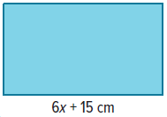
62. USE A MODEL The rectangle at the right has a perimeter of 14x + 30 centimeters and an area of 225 square centimeters. Find the dimensions of the rectangle. Explain how you solved the problem.

63. AREA A triangle has an area of 64 square feet. If the height of the triangle is 8 feet more than its base, x, what are its height and base?

64. CONSTRUCT ARGUMENTS Jarrod claims that the quadratic equation x² – 7x + 5 = 0 has no solution because the left side does not factor. Do you agree or disagree? Use a graph to justify your argument.

65. PERSEVERE Given the equation (ax + b)(ax – b) = 0, solve for x. What do you know about the values of a and b?

66. WRITE Explain how to solve the quadratic equation x² + 16x = –64.

67. FIND THE ERROR Ignatio and Samantha are solving 6x² – x = 12. Is either of them correct? Explain your reasoning.
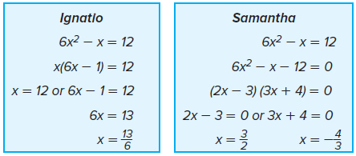

68. ANALYZE What should you consider when solving a quadratic equation that models a
real-world situation?

69. CREATE Write a perfect square trinomial equation in which the coefficient of the middle term is negative and the last term is a fraction. Solve the equation.

70. PERSEVERE Factor the polynomial x³ + x² – 6x. Make a table. Then sketch the graph of the related function.

